Phthalate animal DEHP.FinalDraft3

Weihsueh Chiu

May 18, 2017

## Loading required package: lattice

## Loading required package: survival

## Loading required package: Formula

## Loading required package: ggplot2

##   
## Attaching package: 'Hmisc'

## The following objects are masked from 'package:base':  
##   
## format.pval, round.POSIXt, trunc.POSIXt, units

## Loading required package: Matrix

## Loading 'metafor' package (version 1.9-9). For an overview   
## and introduction to the package please type: help(metafor).

## AGD animal details

## [1] "AGD log(Ratio of mean)x100 Rat"  
## [1] "Overall Effect---------------------"  
##   
## Random-Effects Model (k = 107; tau^2 estimator: REML)  
##   
## logLik deviance AIC BIC AICc   
## -337.9647 675.9294 679.9294 685.2562 680.0459   
##   
## tau^2 (estimated amount of total heterogeneity): 12.1222 (SE = 4.2087)  
## tau (square root of estimated tau^2 value): 3.4817  
## I^2 (total heterogeneity / total variability): 45.74%  
## H^2 (total variability / sampling variability): 1.84  
##   
## Test for Heterogeneity:   
## Q(df = 106) = 187.2555, p-val < .0001  
##   
## Model Results:  
##   
## estimate se zval pval ci.lb ci.ub   
## -3.9588 0.5664 -6.9893 <.0001 -5.0690 -2.8487 ***   
##   
## ---  
## Signif. codes: 0 '***' 0.001 '**' 0.01 '*' 0.05 '.' 0.1 ' ' 1

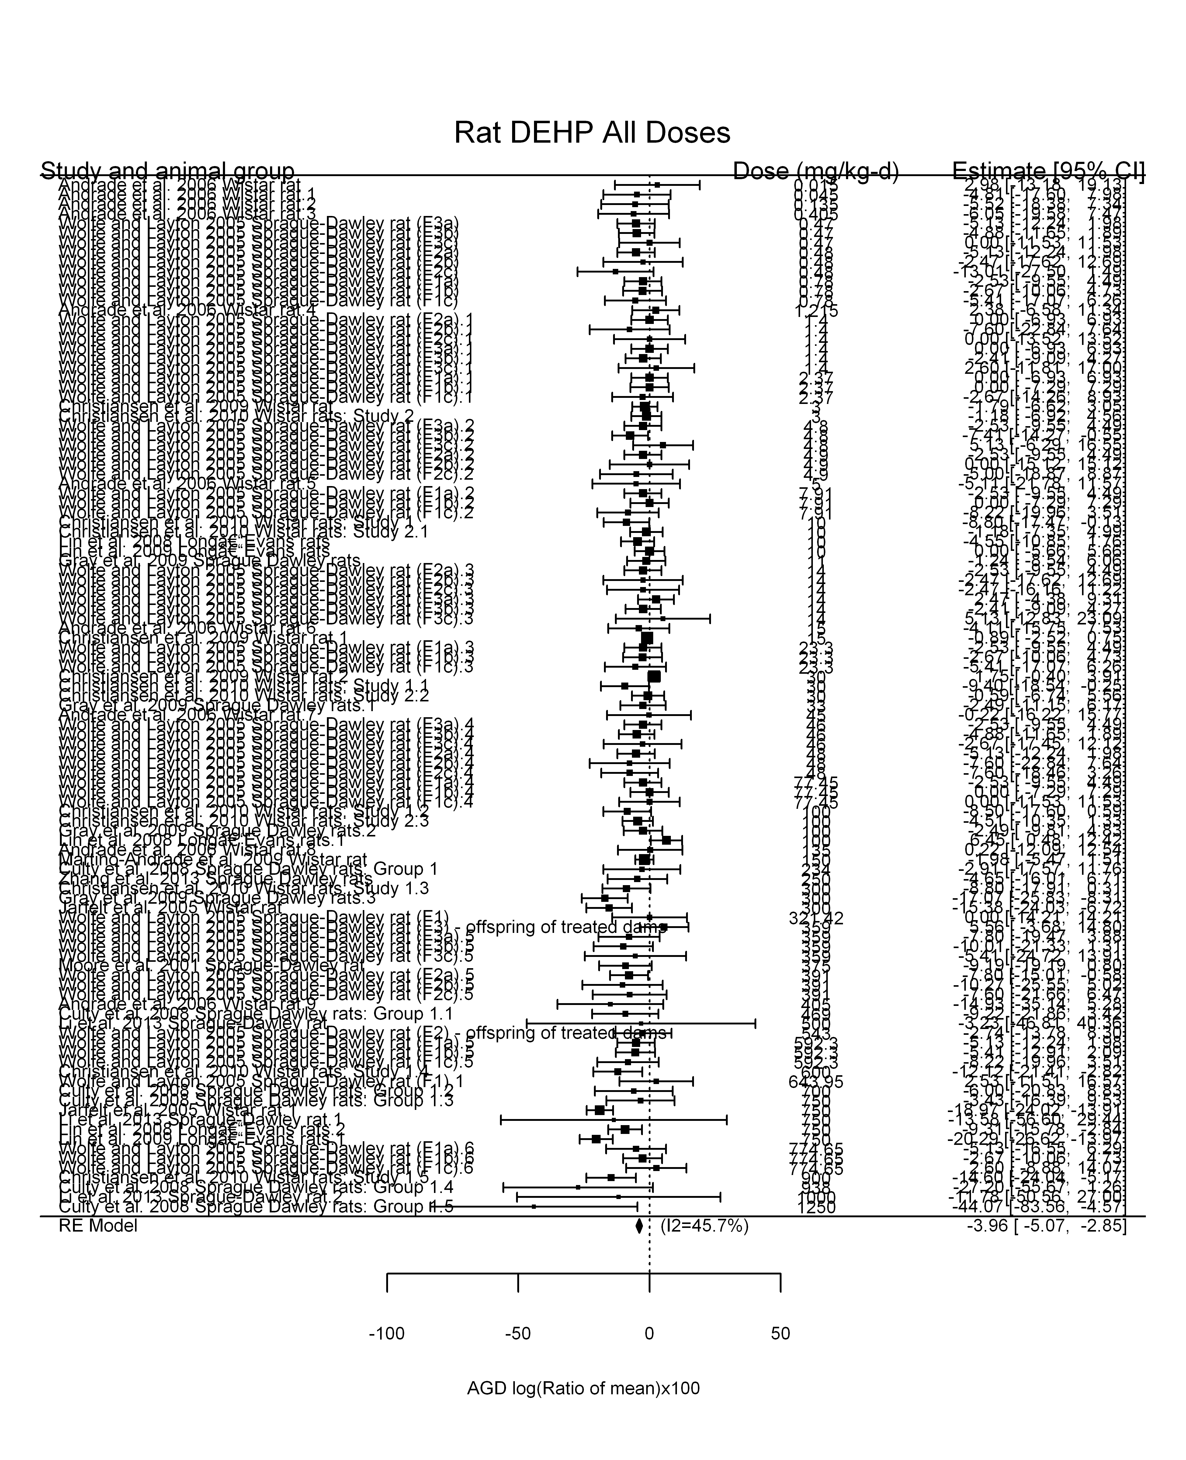

## [1] "Linear in log10(dose)---------------------"  
##   
## Mixed-Effects Model (k = 107; tau^2 estimator: REML)  
##   
## logLik deviance AIC BIC AICc   
## -328.3611 656.7223 662.7223 670.6842 662.9599   
##   
## tau^2 (estimated amount of residual heterogeneity): 9.0101 (SE = 3.6558)  
## tau (square root of estimated tau^2 value): 3.0017  
## I^2 (residual heterogeneity / unaccounted variability): 38.46%  
## H^2 (unaccounted variability / sampling variability): 1.62  
## R^2 (amount of heterogeneity accounted for): 25.67%  
##   
## Test for Residual Heterogeneity:   
## QE(df = 105) = 160.0317, p-val = 0.0004  
##   
## Test of Moderators (coefficient(s) 2):   
## QM(df = 1) = 14.6638, p-val = 0.0001  
##   
## Model Results:  
##   
## estimate se zval pval ci.lb ci.ub   
## intrcpt -1.1764 0.8895 -1.3225 0.1860 -2.9198 0.5670   
## log10(dose) -1.9742 0.5155 -3.8293 0.0001 -2.9846 -0.9637 ***  
##   
## ---  
## Signif. codes: 0 '***' 0.001 '**' 0.01 '*' 0.05 '.' 0.1 ' ' 1

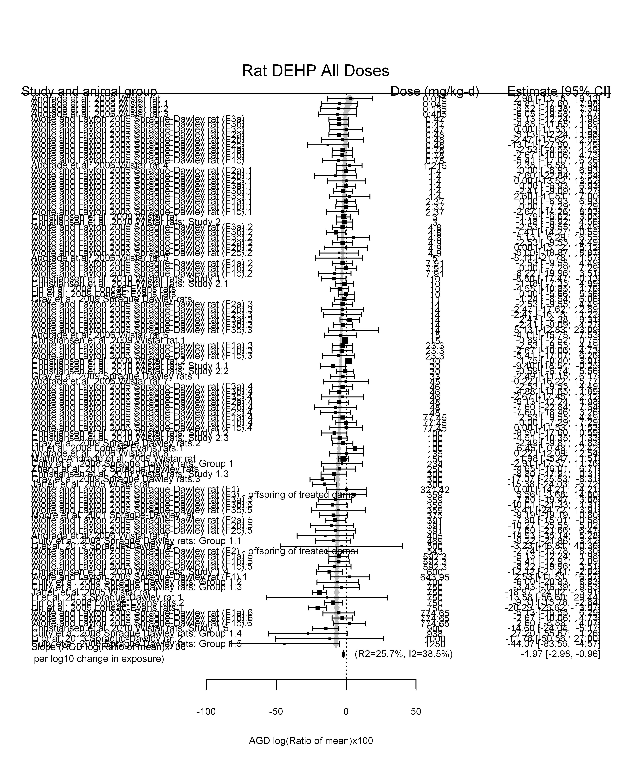

## [1] "Linear or LinearQuadratic in dose---------------------"  
##   
## Mixed-Effects Model (k = 107; tau^2 estimator: REML)  
##   
## logLik deviance AIC BIC AICc   
## -324.1745 648.3490 654.3490 662.3109 654.5867   
##   
## tau^2 (estimated amount of residual heterogeneity): 4.1134 (SE = 2.5840)  
## tau (square root of estimated tau^2 value): 2.0281  
## I^2 (residual heterogeneity / unaccounted variability): 22.94%  
## H^2 (unaccounted variability / sampling variability): 1.30  
##   
## Test for Residual Heterogeneity:   
## QE(df = 105) = 122.4645, p-val = 0.1171  
##   
## Test of Moderators (coefficient(s) 1,2):   
## QM(df = 2) = 94.4806, p-val < .0001  
##   
## Model Results:  
##   
## estimate se zval pval ci.lb ci.ub   
## dose -0.0211 0.0061 -3.4623 0.0005 -0.0330 -0.0091 ***  
## I(dose^2) 0.0000 0.0000 0.9593 0.3374 -0.0000 0.0000   
##   
## ---  
## Signif. codes: 0 '***' 0.001 '**' 0.01 '*' 0.05 '.' 0.1 ' ' 1

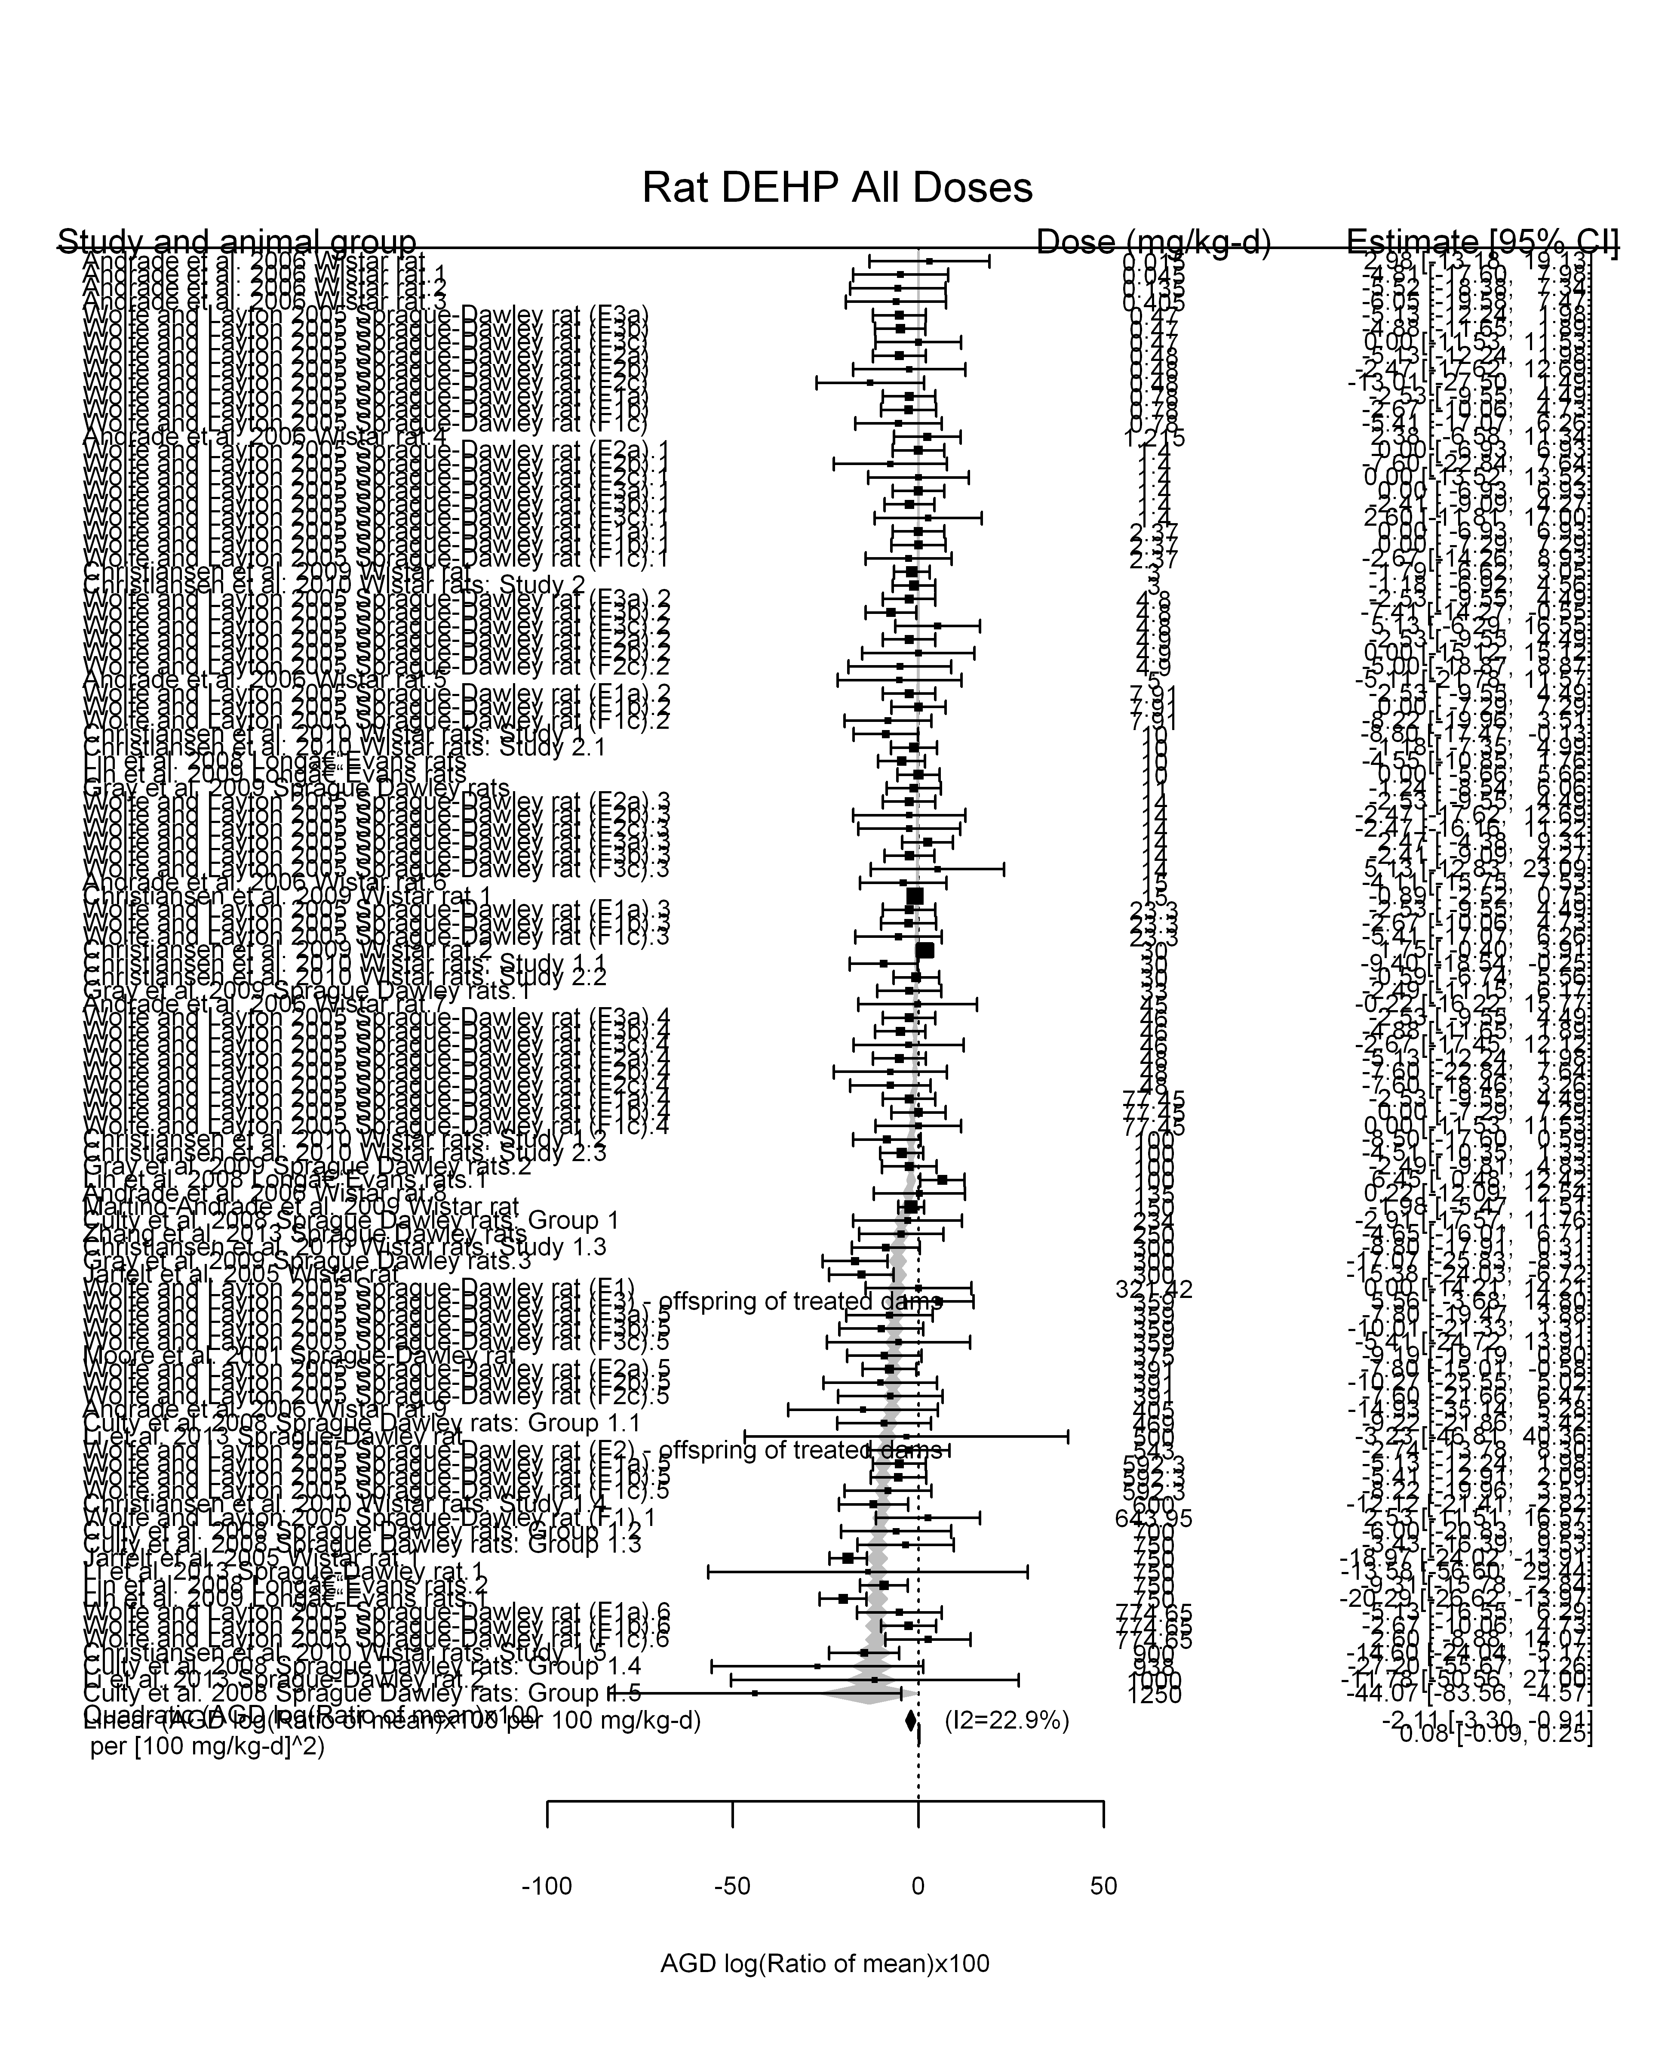

## [1] ""

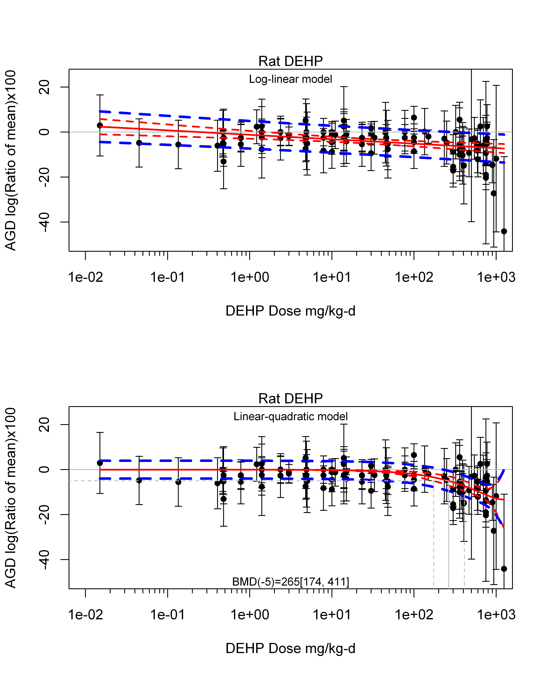

## [1] ""  
## m ci.lb ci.ub bmr  
## 1 264.8538 173.9289 411.054 -5  
## [1] "AGD log(Ratio of mean)x100 Rat Highest Dose"  
## [1] "Overall Effect---------------------"  
##   
## Random-Effects Model (k = 18; tau^2 estimator: REML)  
##   
## logLik deviance AIC BIC AICc   
## -62.5192 125.0383 129.0383 130.7048 129.8955   
##   
## tau^2 (estimated amount of total heterogeneity): 52.6455 (SE = 26.9062)  
## tau (square root of estimated tau^2 value): 7.2557  
## I^2 (total heterogeneity / total variability): 81.76%  
## H^2 (total variability / sampling variability): 5.48  
##   
## Test for Heterogeneity:   
## Q(df = 17) = 115.5261, p-val < .0001  
##   
## Model Results:  
##   
## estimate se zval pval ci.lb ci.ub   
## -8.0826 2.1569 -3.7474 0.0002 -12.3099 -3.8552 ***   
##   
## ---  
## Signif. codes: 0 '***' 0.001 '**' 0.01 '*' 0.05 '.' 0.1 ' ' 1

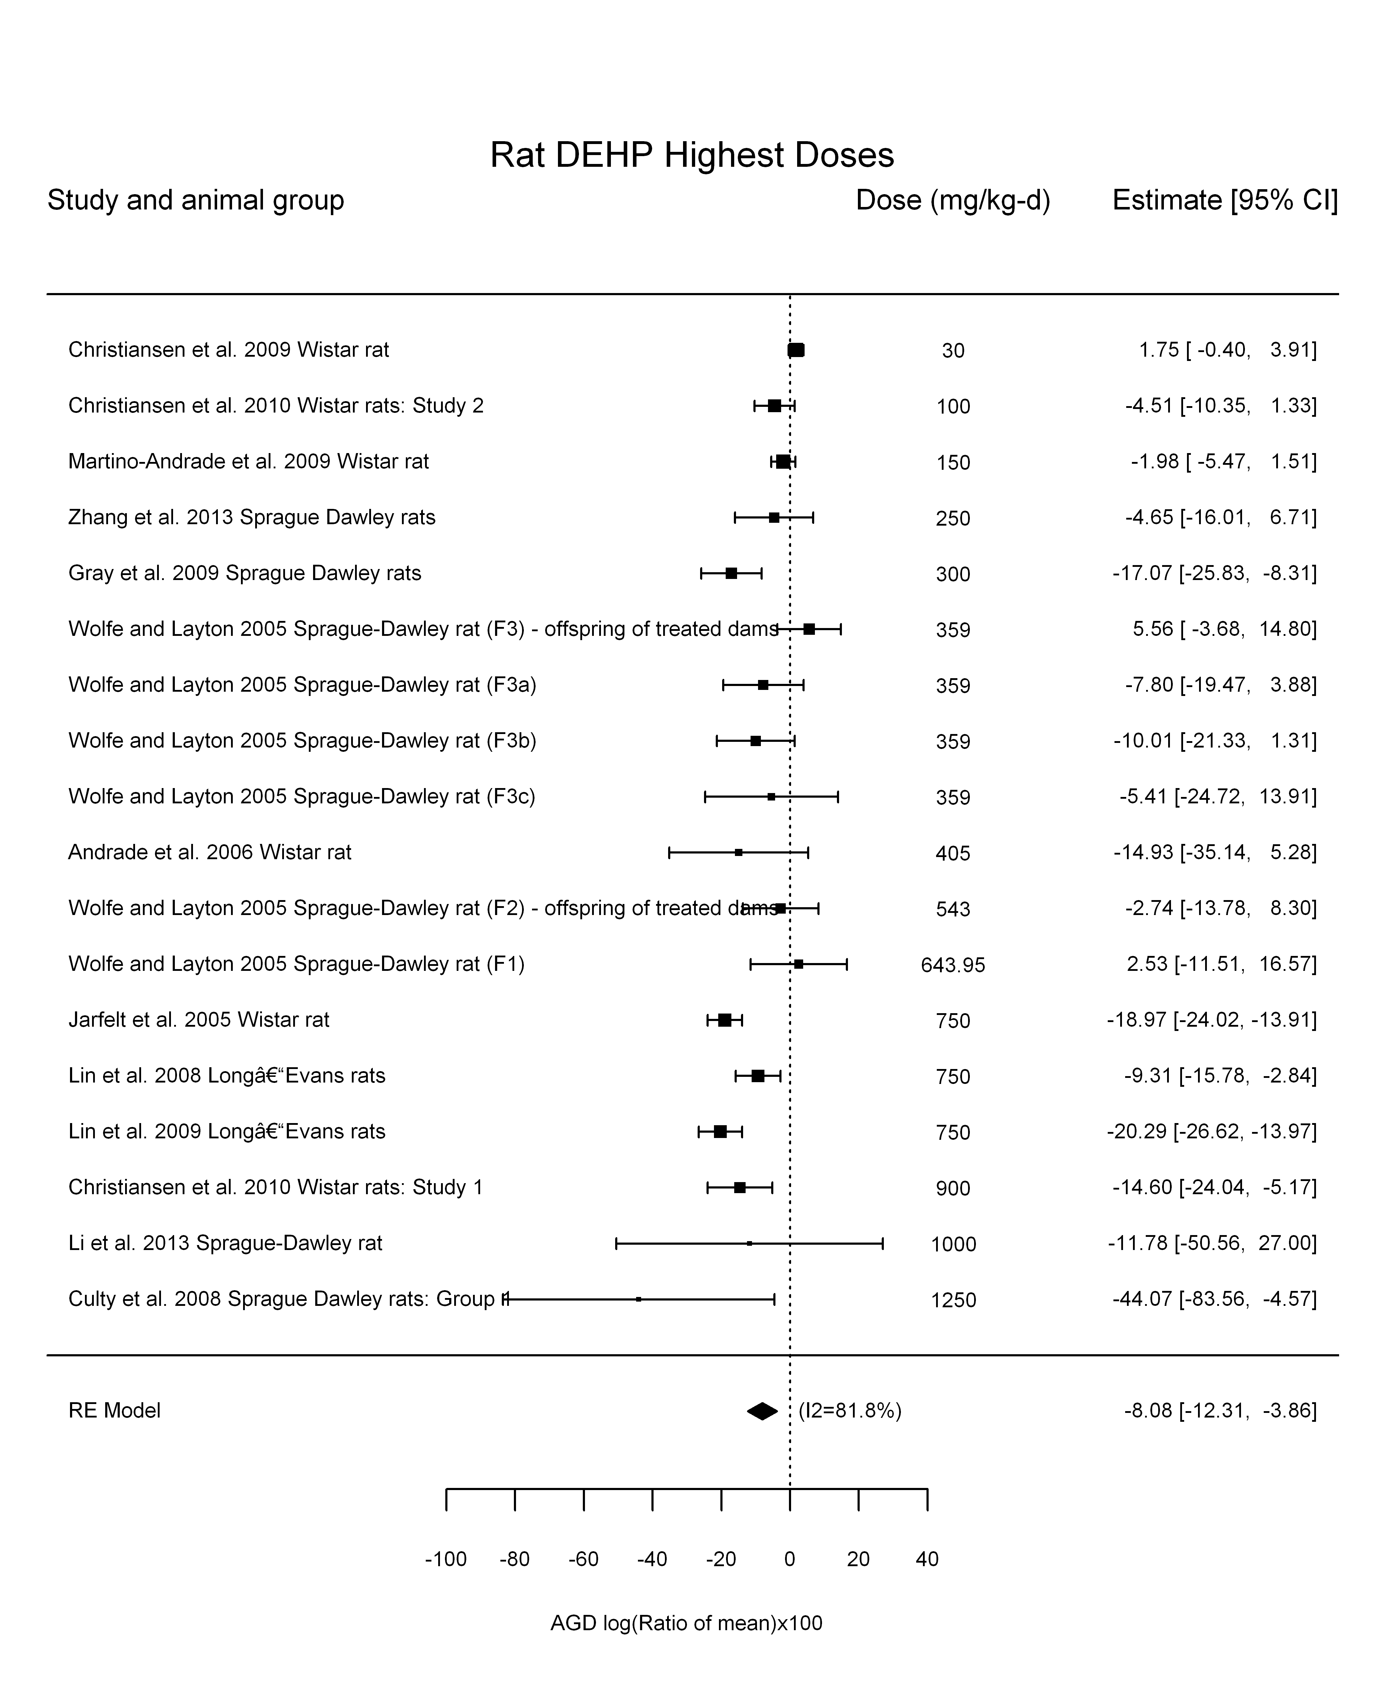

## [1] "Linear or LinearQuadratic in dose---------------------"  
##   
## Mixed-Effects Model (k = 18; tau^2 estimator: REML)  
##   
## logLik deviance AIC BIC AICc   
## -58.0566 116.1132 120.1132 121.7796 120.9703   
##   
## tau^2 (estimated amount of residual heterogeneity): 17.8236 (SE = 12.2677)  
## tau (square root of estimated tau^2 value): 4.2218  
## I^2 (residual heterogeneity / unaccounted variability): 65.26%  
## H^2 (unaccounted variability / sampling variability): 2.88  
##   
## Test for Residual Heterogeneity:   
## QE(df = 17) = 36.0642, p-val = 0.0045  
##   
## Model Results:  
##   
## estimate se zval pval ci.lb ci.ub   
## dose -0.0187 0.0029 -6.3827 <.0001 -0.0245 -0.0130 ***  
##   
## ---  
## Signif. codes: 0 '***' 0.001 '**' 0.01 '*' 0.05 '.' 0.1 ' ' 1

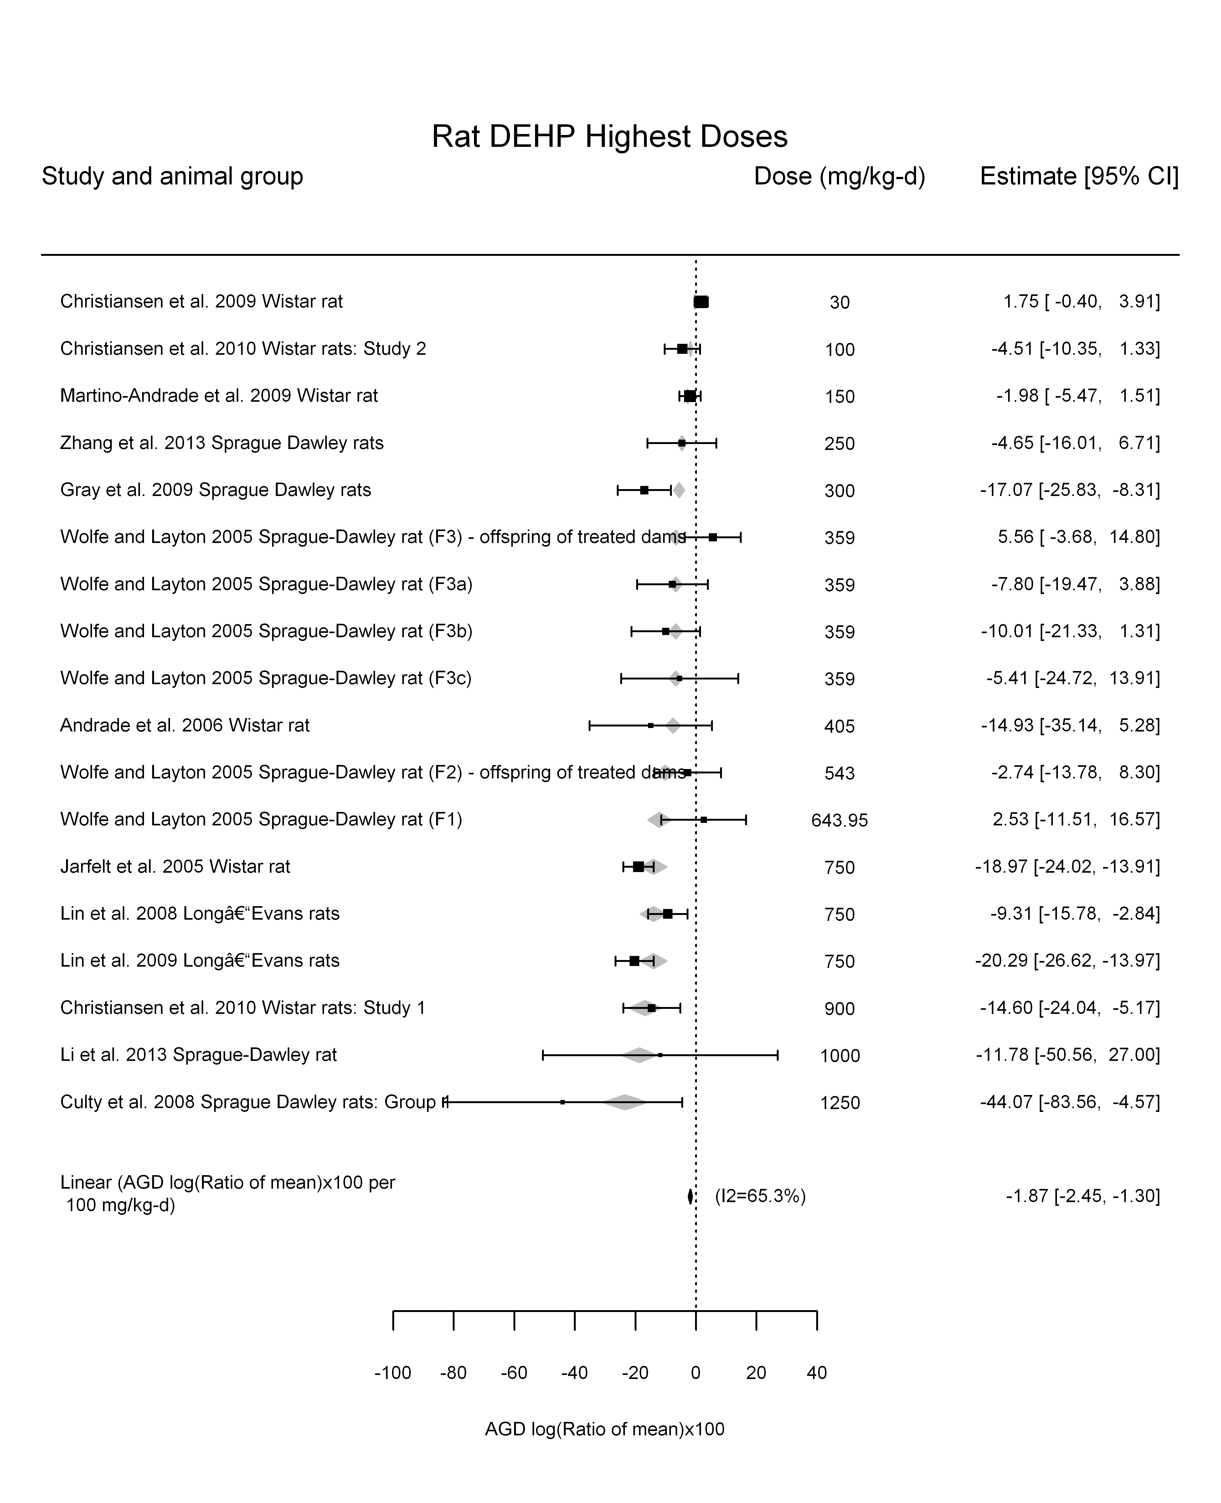

## [1] "Linear in log10(dose)---------------------"  
##   
## Mixed-Effects Model (k = 18; tau^2 estimator: REML)  
##   
## logLik deviance AIC BIC AICc   
## -56.4147 112.8294 118.8294 121.1472 120.8294   
##   
## tau^2 (estimated amount of residual heterogeneity): 27.1940 (SE = 17.7672)  
## tau (square root of estimated tau^2 value): 5.2148  
## I^2 (residual heterogeneity / unaccounted variability): 63.51%  
## H^2 (unaccounted variability / sampling variability): 2.74  
## R^2 (amount of heterogeneity accounted for): 48.35%  
##   
## Test for Residual Heterogeneity:   
## QE(df = 16) = 38.9170, p-val = 0.0011  
##   
## Test of Moderators (coefficient(s) 2):   
## QM(df = 1) = 8.7398, p-val = 0.0031  
##   
## Model Results:  
##   
## estimate se zval pval ci.lb ci.ub   
## intrcpt 20.4214 9.7375 2.0972 0.0360 1.3363 39.5065 *  
## log10(dose) -11.4441 3.8711 -2.9563 0.0031 -19.0312 -3.8569 **  
##   
## ---  
## Signif. codes: 0 '***' 0.001 '**' 0.01 '*' 0.05 '.' 0.1 ' ' 1

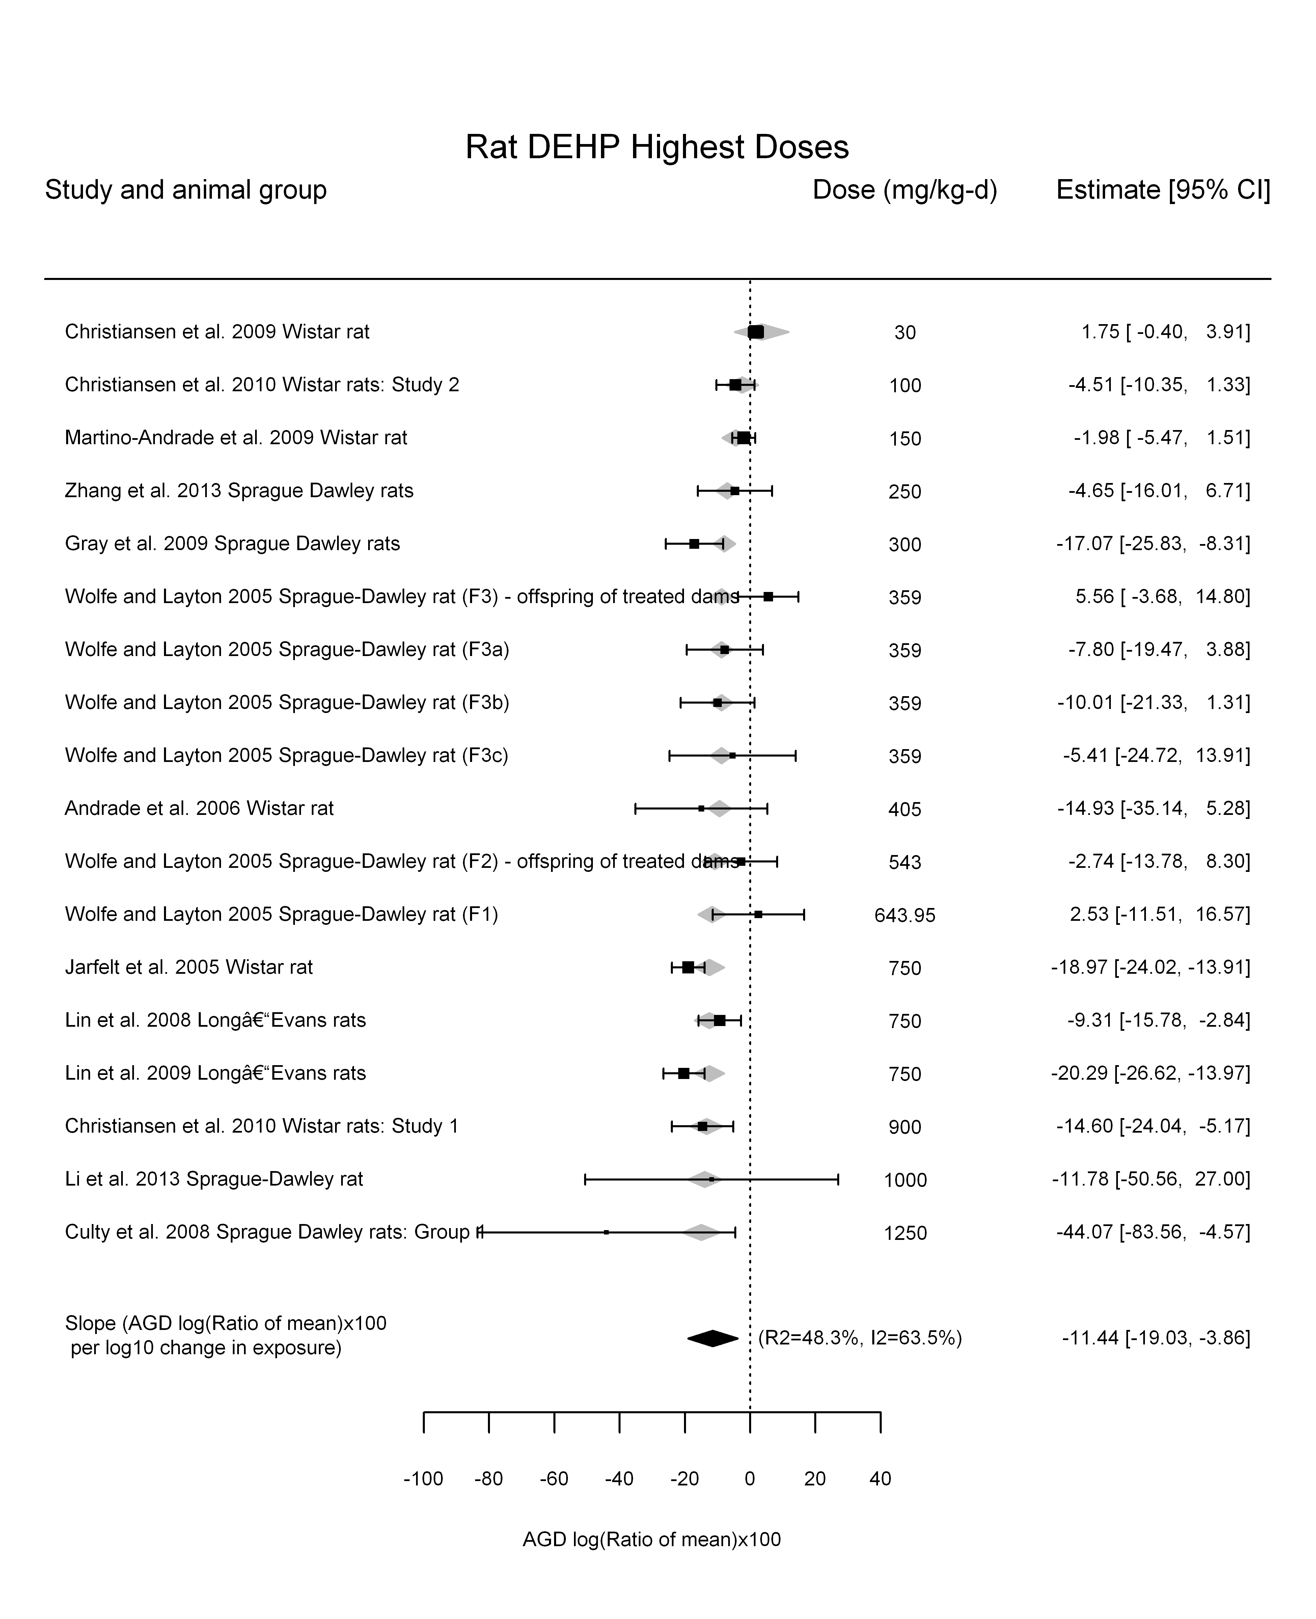

## [1] "Linear or LinearQuadratic in dose---------------------"  
##   
## Mixed-Effects Model (k = 18; tau^2 estimator: REML)  
##   
## logLik deviance AIC BIC AICc   
## -54.6155 109.2311 115.2311 117.5488 117.2311   
##   
## tau^2 (estimated amount of residual heterogeneity): 19.9306 (SE = 13.5926)  
## tau (square root of estimated tau^2 value): 4.4644  
## I^2 (residual heterogeneity / unaccounted variability): 67.35%  
## H^2 (unaccounted variability / sampling variability): 3.06  
##   
## Test for Residual Heterogeneity:   
## QE(df = 16) = 35.1824, p-val = 0.0038  
##   
## Test of Moderators (coefficient(s) 1,2):   
## QM(df = 2) = 38.4172, p-val < .0001  
##   
## Model Results:  
##   
## estimate se zval pval ci.lb ci.ub   
## dose -0.0134 0.0112 -1.1964 0.2315 -0.0353 0.0085   
## I(dose^2) -0.0000 0.0000 -0.4915 0.6231 -0.0000 0.0000   
##   
## ---  
## Signif. codes: 0 '***' 0.001 '**' 0.01 '*' 0.05 '.' 0.1 ' ' 1

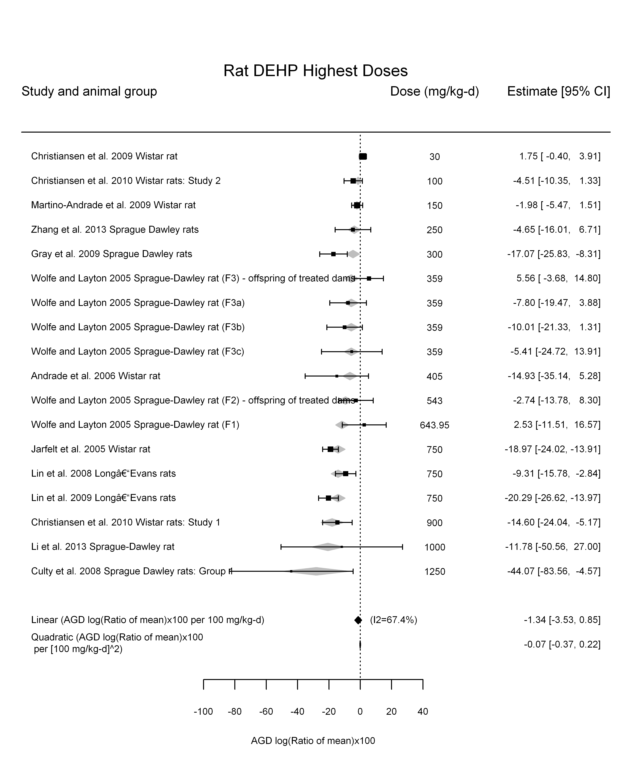

## [1] ""

## [1] ""  
## m ci.lb ci.ub bmr  
## 1 266.8192 204.1355 385.0629 -5

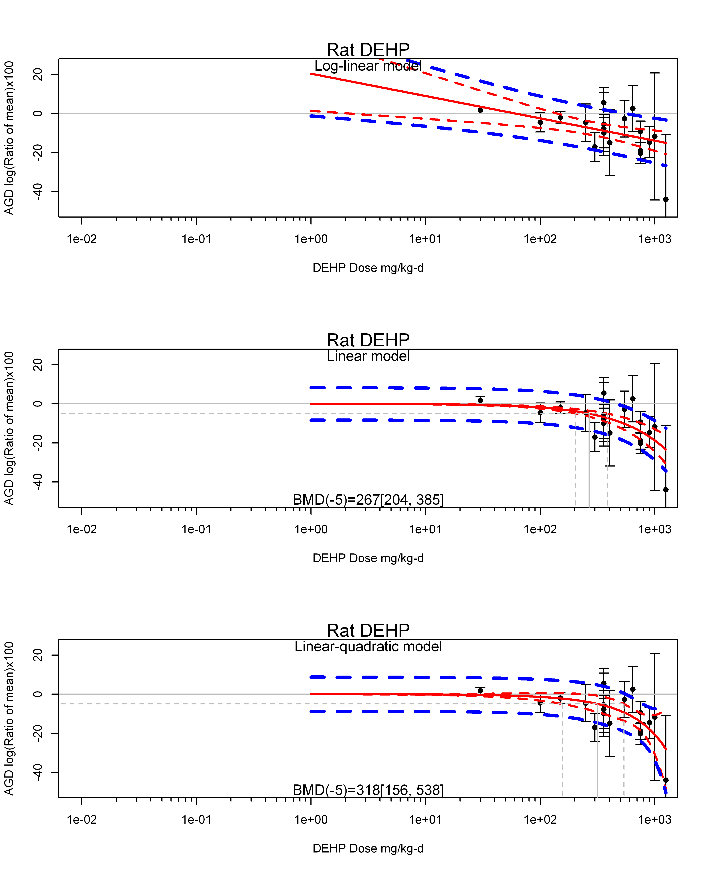

## [1] ""  
## m ci.lb ci.ub bmr  
## 1 318.1176 155.616 537.8436 -5  
## [1] "AGD log(Ratio of mean)x100 Mouse"  
## [1] "Overall Effect---------------------"  
##   
## Random-Effects Model (k = 11; tau^2 estimator: REML)  
##   
## logLik deviance AIC BIC AICc   
## -31.5630 63.1261 67.1261 67.7312 68.8404   
##   
## tau^2 (estimated amount of total heterogeneity): 15.5124 (SE = 11.0952)  
## tau (square root of estimated tau^2 value): 3.9386  
## I^2 (total heterogeneity / total variability): 82.39%  
## H^2 (total variability / sampling variability): 5.68  
##   
## Test for Heterogeneity:   
## Q(df = 10) = 42.3710, p-val < .0001  
##   
## Model Results:  
##   
## estimate se zval pval ci.lb ci.ub   
## -1.5743 1.5512 -1.0149 0.3102 -4.6145 1.4660   
##   
## ---  
## Signif. codes: 0 '***' 0.001 '**' 0.01 '*' 0.05 '.' 0.1 ' ' 1

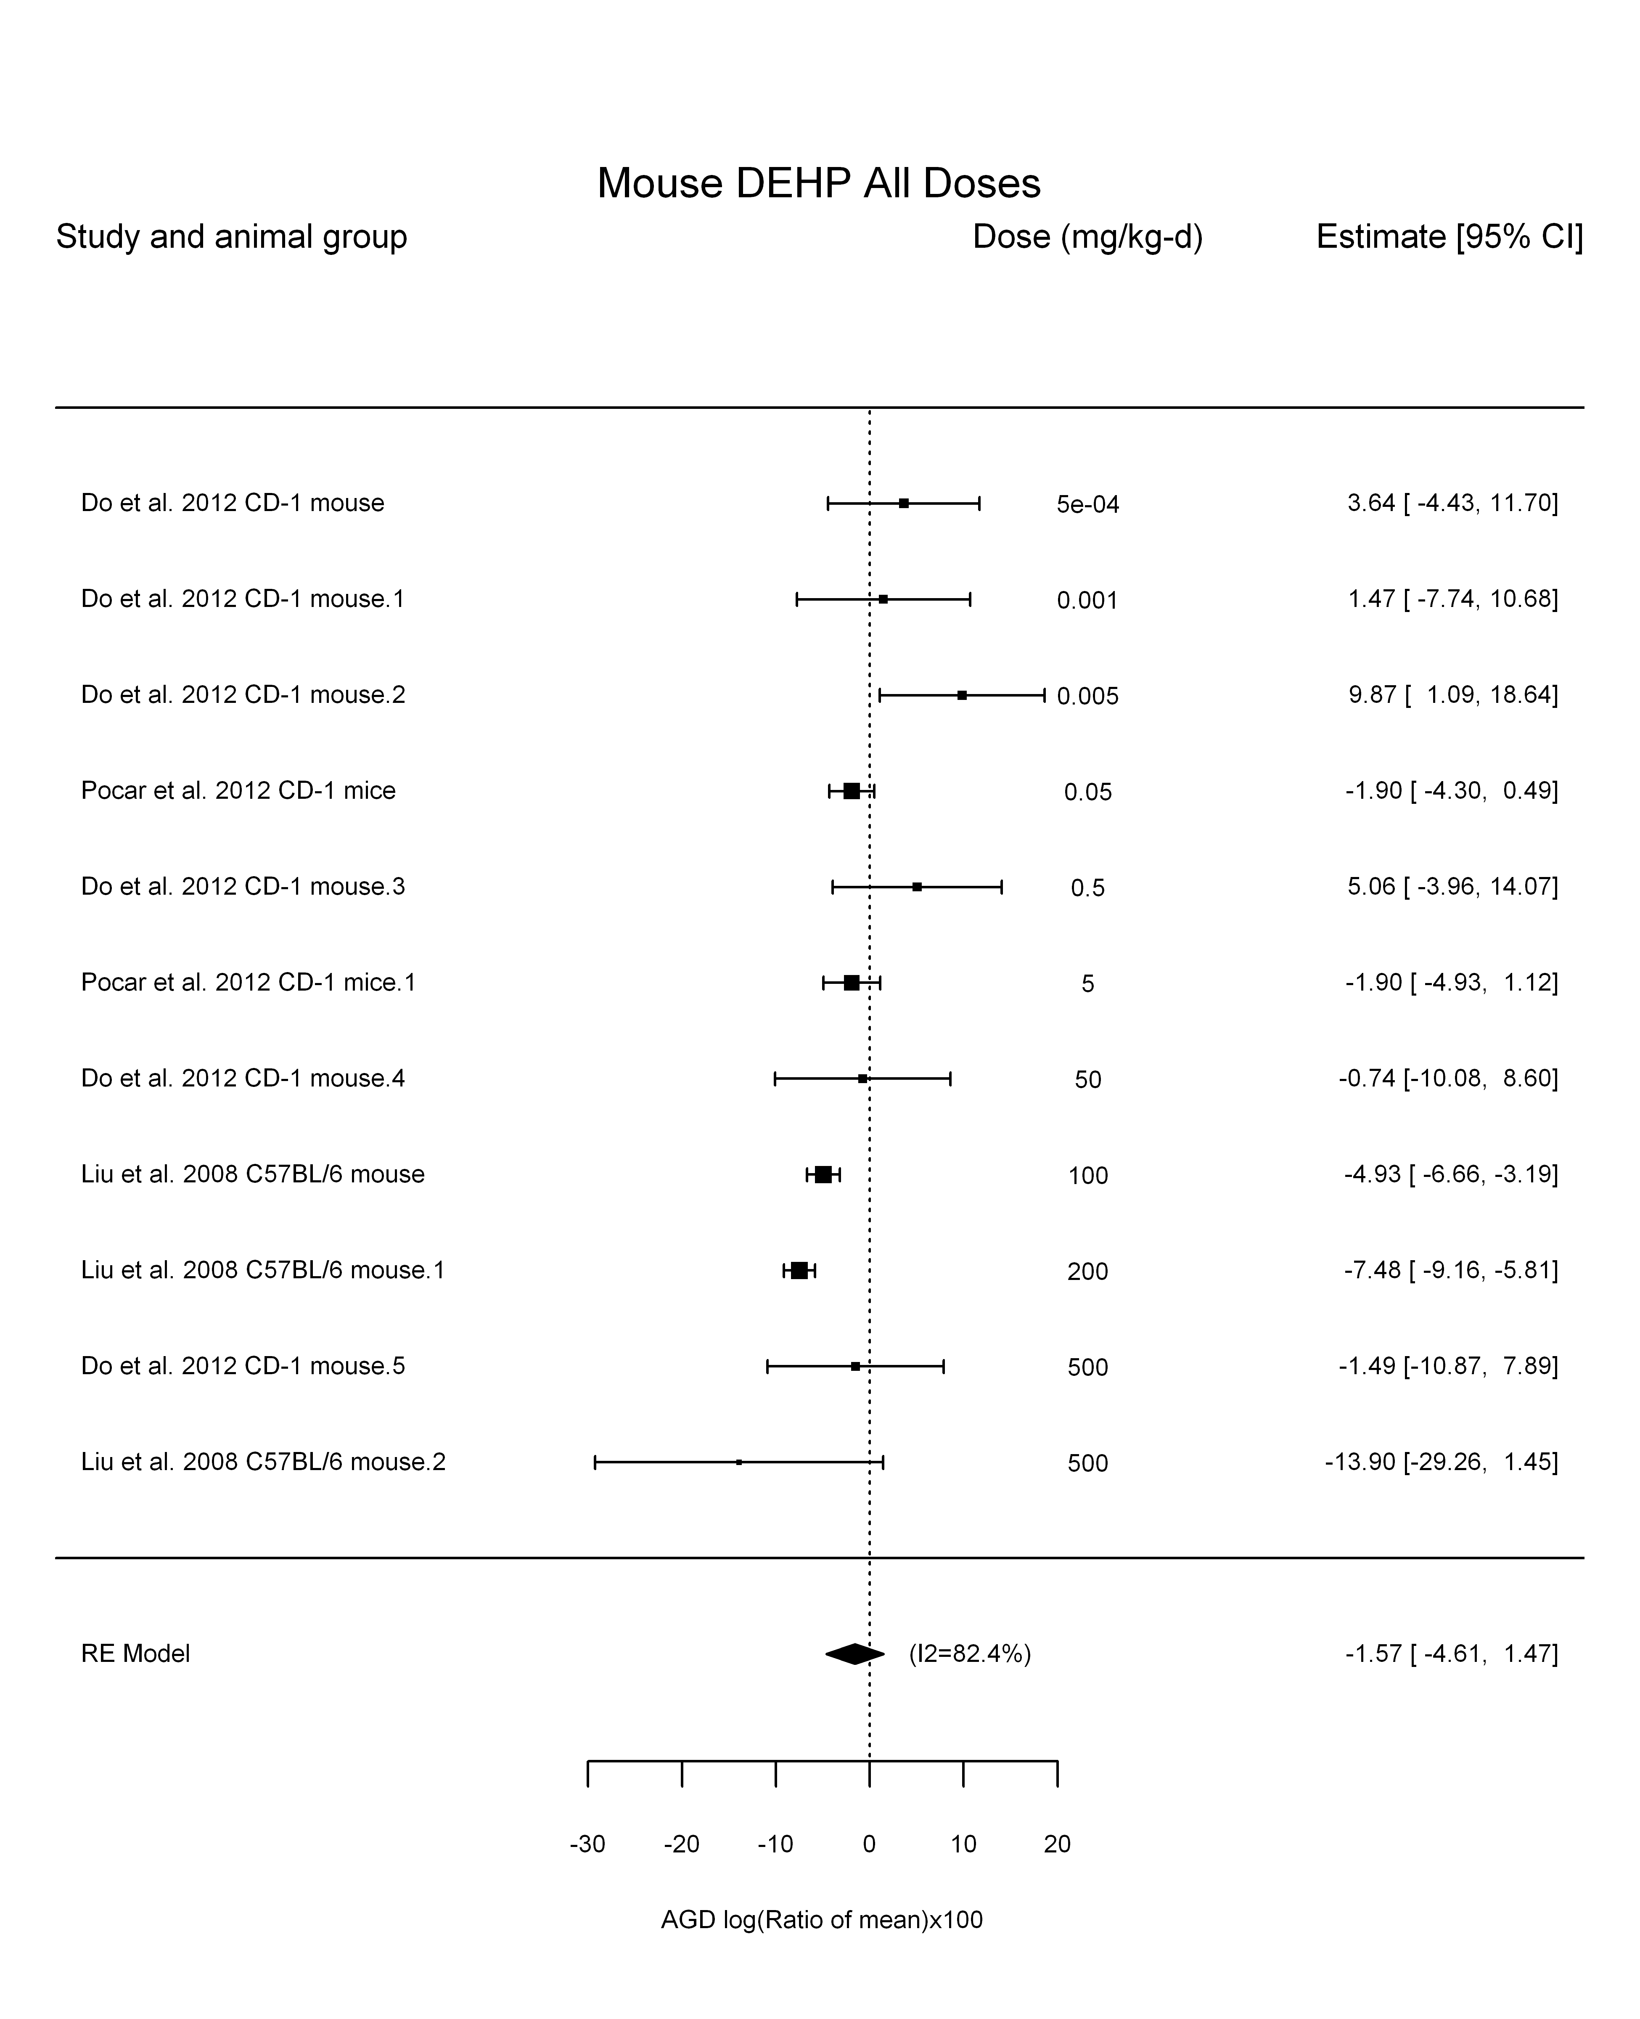

## [1] "Linear in log10(dose)---------------------"  
##   
## Mixed-Effects Model (k = 11; tau^2 estimator: REML)  
##   
## logLik deviance AIC BIC AICc   
## -24.9197 49.8394 55.8394 56.4311 60.6394   
##   
## tau^2 (estimated amount of residual heterogeneity): 2.5496 (SE = 3.3682)  
## tau (square root of estimated tau^2 value): 1.5967  
## I^2 (residual heterogeneity / unaccounted variability): 40.12%  
## H^2 (unaccounted variability / sampling variability): 1.67  
## R^2 (amount of heterogeneity accounted for): 83.56%  
##   
## Test for Residual Heterogeneity:   
## QE(df = 9) = 14.8646, p-val = 0.0947  
##   
## Test of Moderators (coefficient(s) 2):   
## QM(df = 1) = 13.6116, p-val = 0.0002  
##   
## Model Results:  
##   
## estimate se zval pval ci.lb ci.ub   
## intrcpt -1.7929 0.9307 -1.9265 0.0540 -3.6170 0.0311 .  
## log10(dose) -1.7678 0.4792 -3.6894 0.0002 -2.7069 -0.8287 ***  
##   
## ---  
## Signif. codes: 0 '***' 0.001 '**' 0.01 '*' 0.05 '.' 0.1 ' ' 1

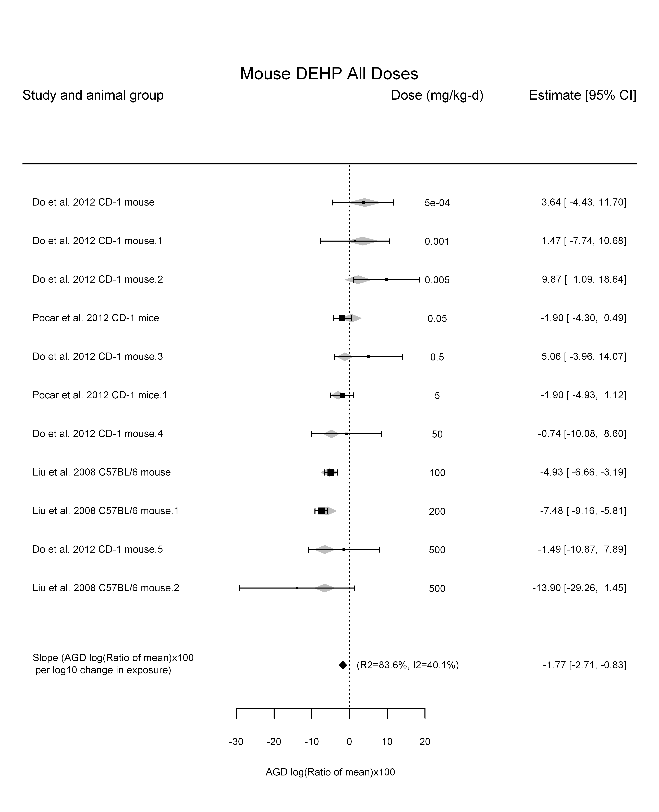

## [1] "Linear or LinearQuadratic in dose---------------------"  
##   
## Mixed-Effects Model (k = 11; tau^2 estimator: REML)  
##   
## logLik deviance AIC BIC AICc   
## -24.4405 48.8811 54.8811 55.4727 59.6811   
##   
## tau^2 (estimated amount of residual heterogeneity): 0.0000 (SE = 0.9679)  
## tau (square root of estimated tau^2 value): 0.0004  
## I^2 (residual heterogeneity / unaccounted variability): 0.00%  
## H^2 (unaccounted variability / sampling variability): 1.00  
##   
## Test for Residual Heterogeneity:   
## QE(df = 9) = 12.5223, p-val = 0.1854  
##   
## Test of Moderators (coefficient(s) 1,2):   
## QM(df = 2) = 109.4781, p-val < .0001  
##   
## Model Results:  
##   
## estimate se zval pval ci.lb ci.ub   
## dose -0.0571 0.0074 -7.7606 <.0001 -0.0715 -0.0427 ***  
## I(dose^2) 0.0001 0.0000 3.5241 0.0004 0.0000 0.0001 ***  
##   
## ---  
## Signif. codes: 0 '***' 0.001 '**' 0.01 '*' 0.05 '.' 0.1 ' ' 1

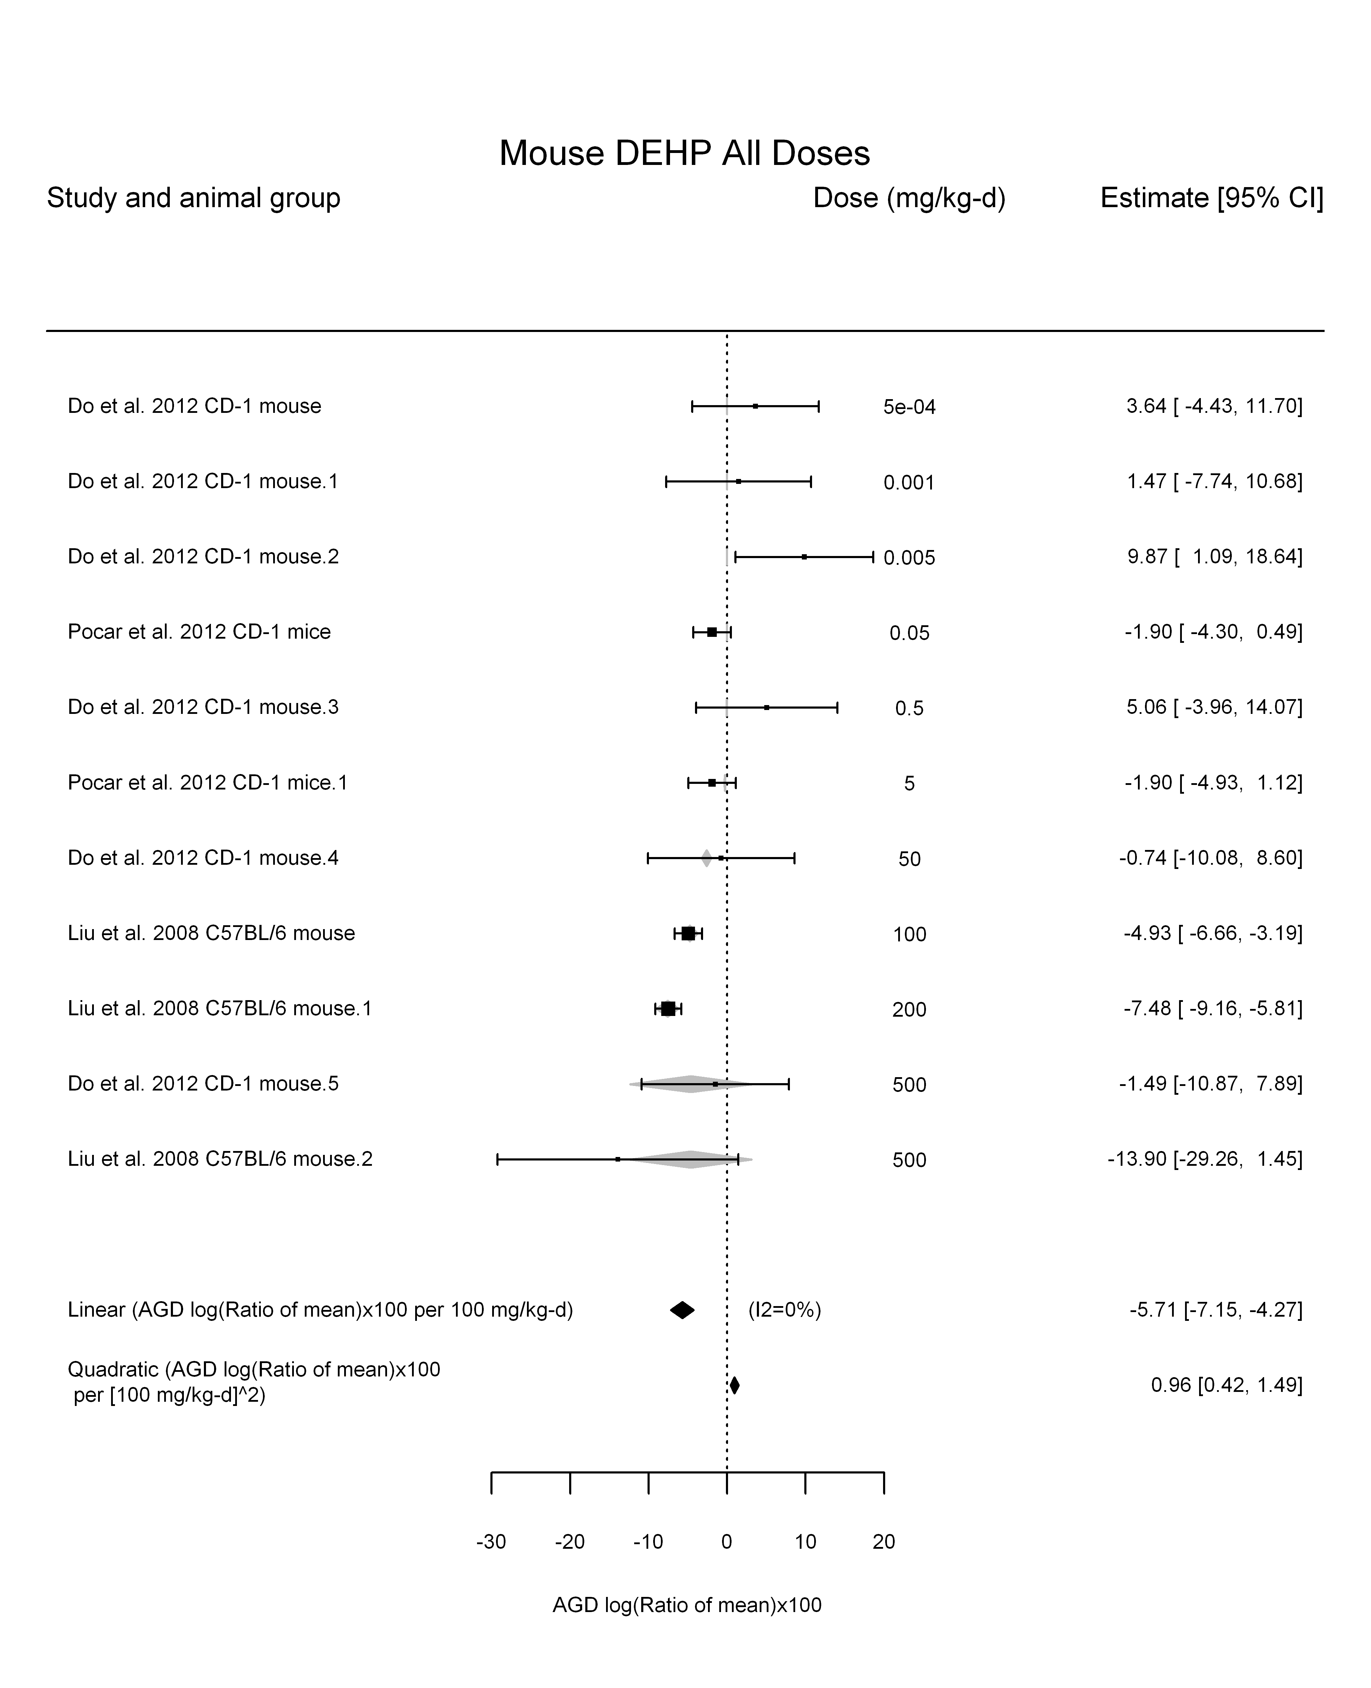

## [1] ""

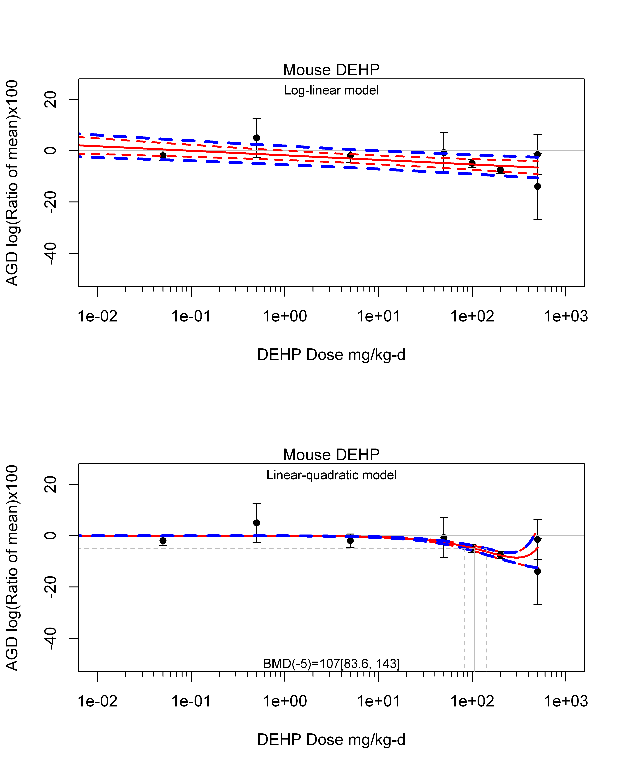

## [1] ""  
## m ci.lb ci.ub bmr  
## 1 106.6289 83.61003 143.3543 -5  
## [1] "AGD log(Ratio of mean)x100 Mouse Highest Dose"  
## [1] "Overall Effect---------------------"  
##   
## Random-Effects Model (k = 3; tau^2 estimator: REML)  
##   
## logLik deviance AIC BIC AICc   
## -6.1233 12.2466 16.2466 13.6329 28.2466   
##   
## tau^2 (estimated amount of total heterogeneity): 0.0000 (SE = 15.9107)  
## tau (square root of estimated tau^2 value): 0.0011  
## I^2 (total heterogeneity / total variability): 0.00%  
## H^2 (total variability / sampling variability): 1.00  
##   
## Test for Heterogeneity:   
## Q(df = 2) = 2.2870, p-val = 0.3187  
##   
## Model Results:  
##   
## estimate se zval pval ci.lb ci.ub   
## -2.2747 1.4437 -1.5756 0.1151 -5.1042 0.5549   
##   
## ---  
## Signif. codes: 0 '***' 0.001 '**' 0.01 '*' 0.05 '.' 0.1 ' ' 1

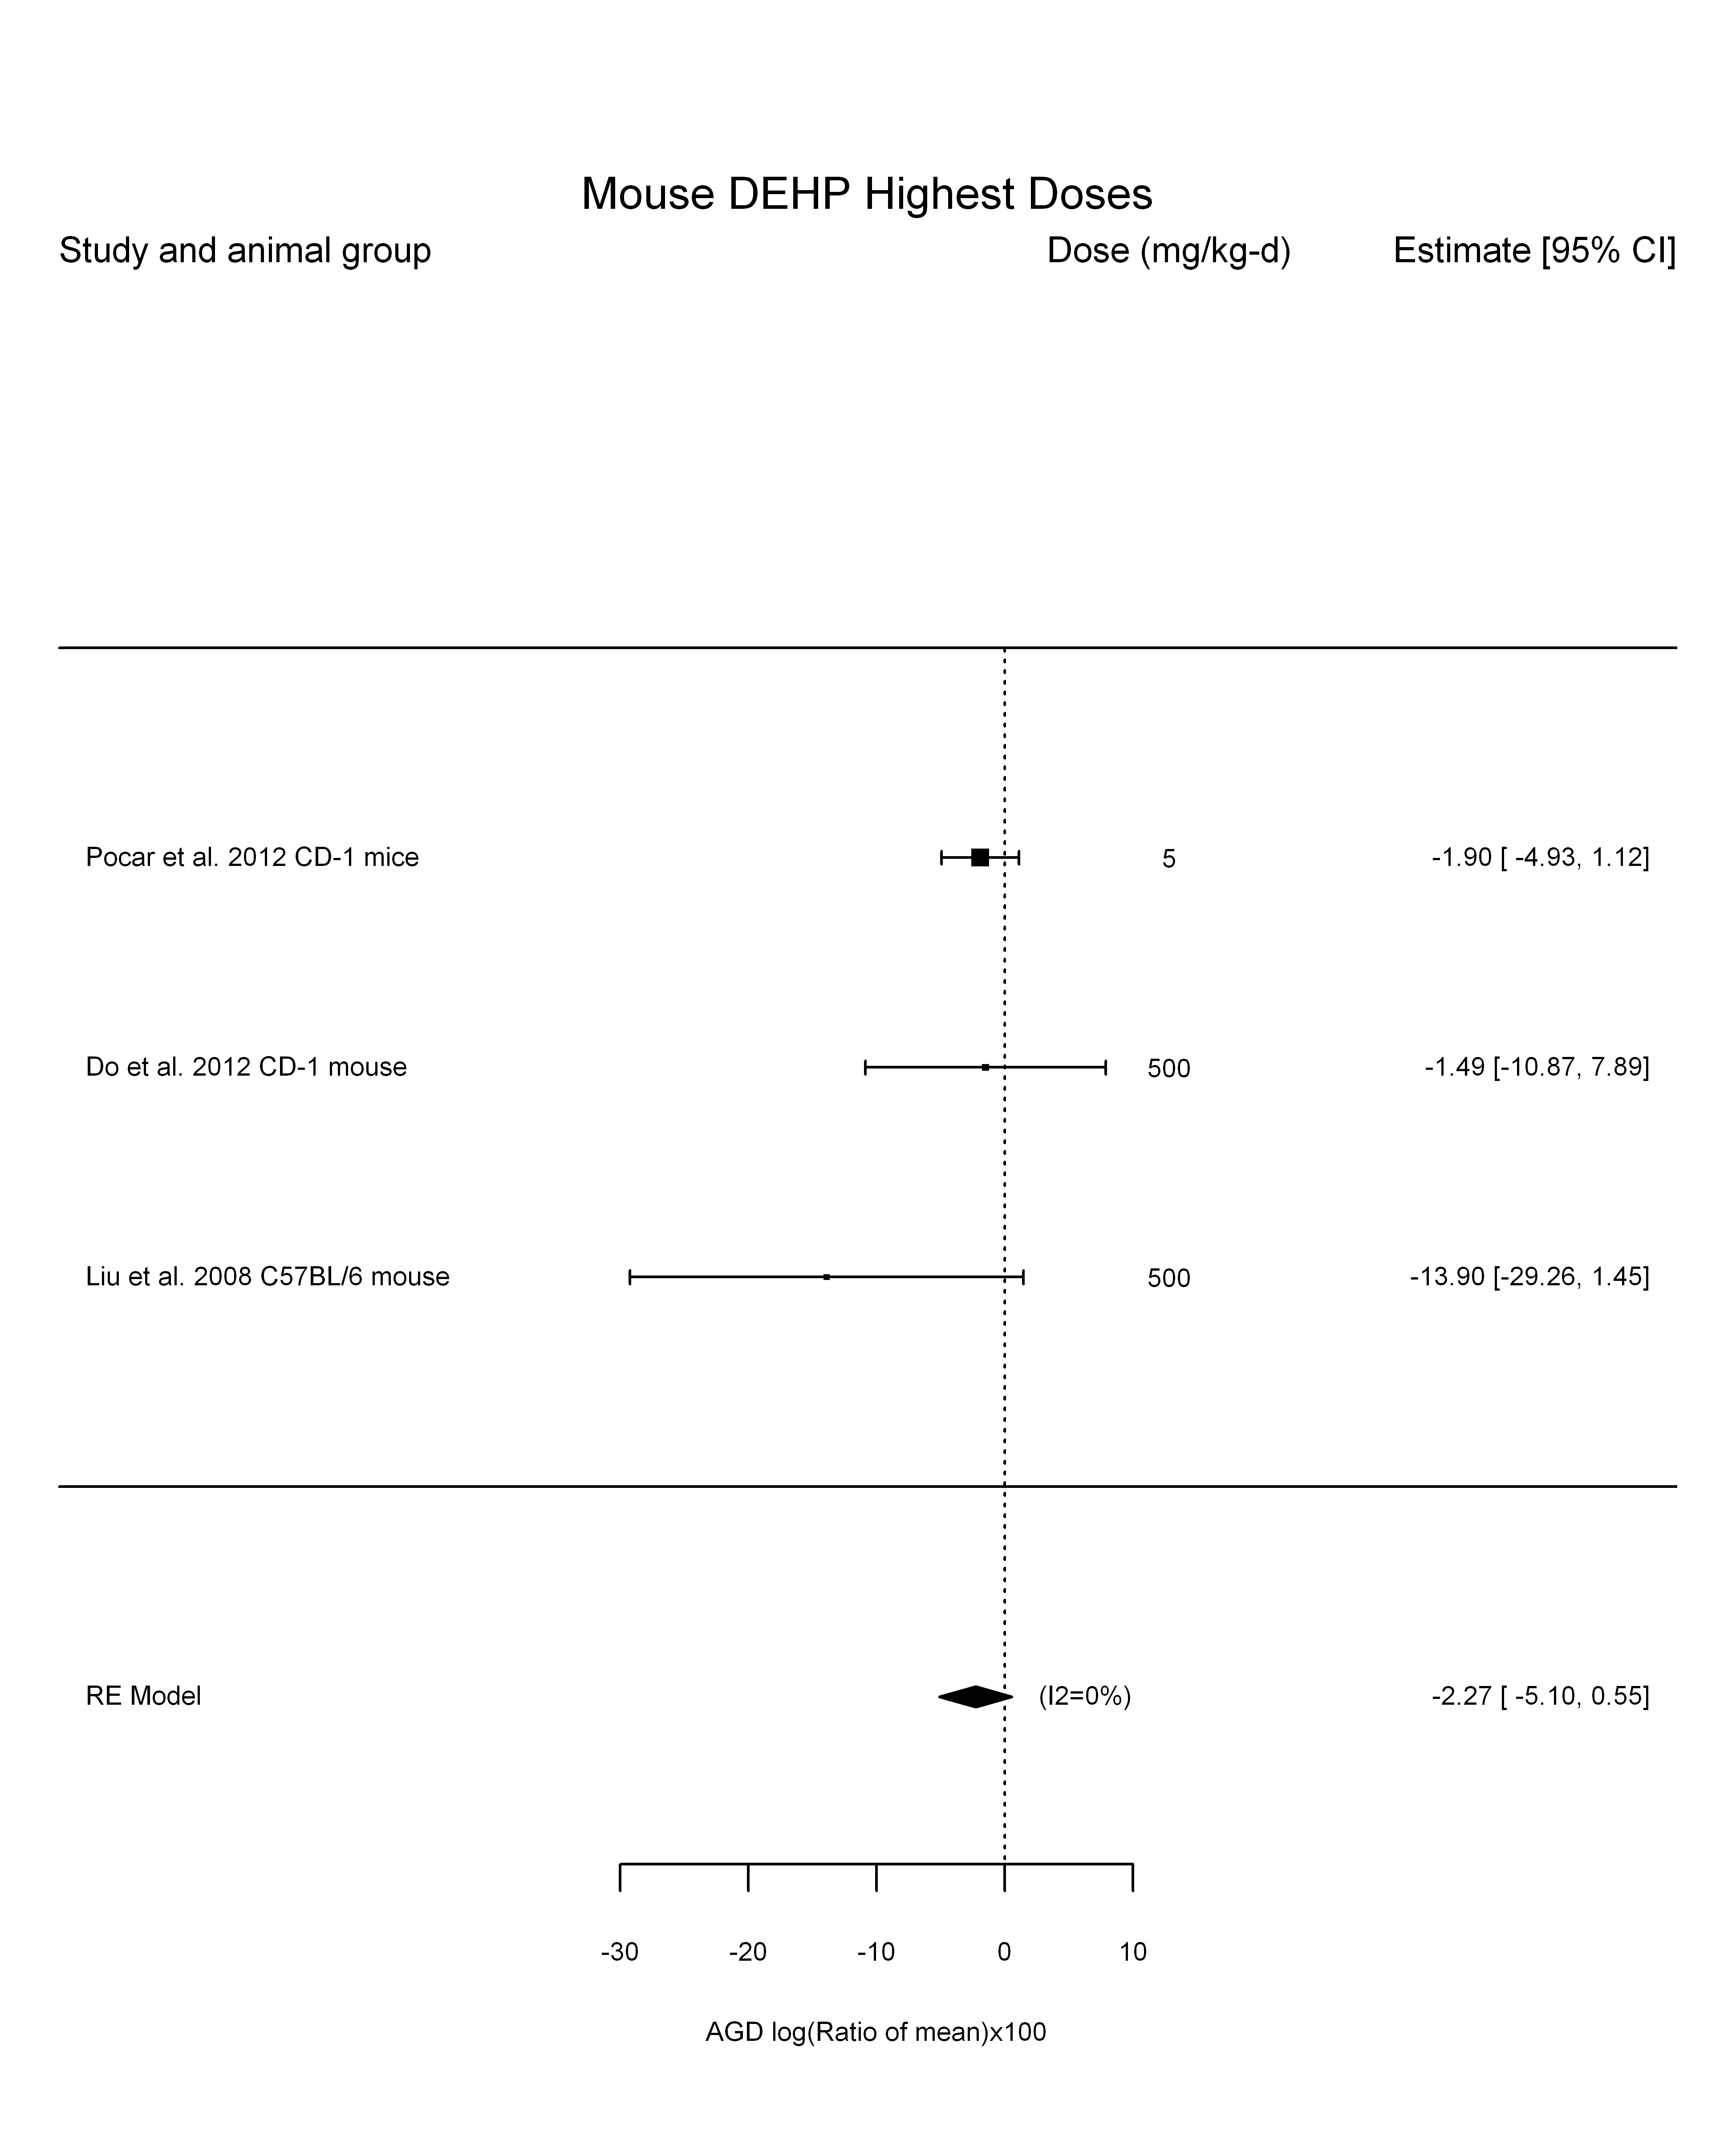

## [1] "Linear or LinearQuadratic in dose---------------------"  
##   
## Mixed-Effects Model (k = 3; tau^2 estimator: REML)  
##   
## logLik deviance AIC BIC AICc   
## -5.7292 11.4583 15.4583 12.8446 27.4583   
##   
## tau^2 (estimated amount of residual heterogeneity): 1.3097 (SE = 5.2038)  
## tau (square root of estimated tau^2 value): 1.1444  
## I^2 (residual heterogeneity / unaccounted variability): 22.50%  
## H^2 (unaccounted variability / sampling variability): 1.29  
##   
## Test for Residual Heterogeneity:   
## QE(df = 2) = 3.2728, p-val = 0.1947  
##   
## Model Results:  
##   
## estimate se zval pval ci.lb ci.ub   
## dose -0.0101 0.0084 -1.2058 0.2279 -0.0265 0.0063   
##   
## ---  
## Signif. codes: 0 '***' 0.001 '**' 0.01 '*' 0.05 '.' 0.1 ' ' 1

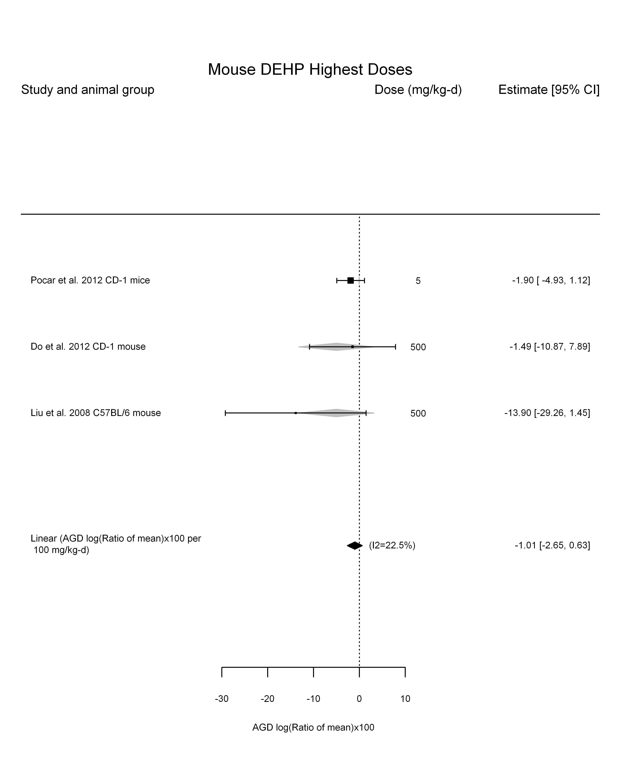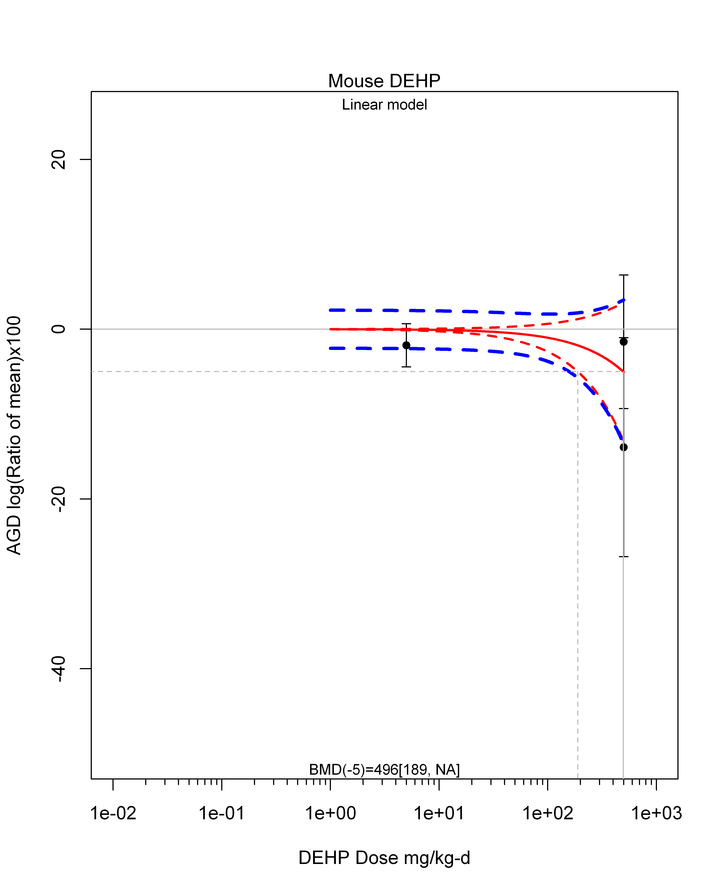

## [1] ""  
## m ci.lb ci.ub bmr  
## 1 496.1421 188.9698 NA -5

## AGD with subgroups

## [1] "Overall"

##   
## Random-Effects Model (k = 107; tau^2 estimator: REML)  
##   
## tau^2 (estimated amount of total heterogeneity): 12.1222 (SE = 4.2087)  
## tau (square root of estimated tau^2 value): 3.4817  
## I^2 (total heterogeneity / total variability): 45.74%  
## H^2 (total variability / sampling variability): 1.84  
##   
## Test for Heterogeneity:   
## Q(df = 106) = 187.2555, p-val < .0001  
##   
## Model Results:  
##   
## estimate se zval pval ci.lb ci.ub   
## -3.9588 0.5664 -6.9893 <.0001 -5.0690 -2.8487 ***   
##   
## ---  
## Signif. codes: 0 '***' 0.001 '**' 0.01 '*' 0.05 '.' 0.1 ' ' 1

## [1] "Leave one out"

##   
## Random-Effects Model (k = 104; tau^2 estimator: REML)  
##   
## tau^2 (estimated amount of total heterogeneity): 11.0893 (SE = 4.1345)  
## tau (square root of estimated tau^2 value): 3.3301  
## I^2 (total heterogeneity / total variability): 43.19%  
## H^2 (total variability / sampling variability): 1.76  
##   
## Test for Heterogeneity:   
## Q(df = 103) = 173.8020, p-val < .0001  
##   
## Model Results:  
##   
## estimate se zval pval ci.lb ci.ub   
## -4.0202 0.5680 -7.0779 <.0001 -5.1335 -2.9070 ***   
##   
## ---  
## Signif. codes: 0 '***' 0.001 '**' 0.01 '*' 0.05 '.' 0.1 ' ' 1   
##   
## pred se ci.lb ci.ub cr.lb cr.ub  
## -4.0202 0.5680 -5.1335 -2.9070 -10.6413 2.6008  
##   
## Random-Effects Model (k = 105; tau^2 estimator: REML)  
##   
## tau^2 (estimated amount of total heterogeneity): 8.8420 (SE = 3.6744)  
## tau (square root of estimated tau^2 value): 2.9735  
## I^2 (total heterogeneity / total variability): 37.79%  
## H^2 (total variability / sampling variability): 1.61  
##   
## Test for Heterogeneity:   
## Q(df = 104) = 156.8614, p-val = 0.0006  
##   
## Model Results:  
##   
## estimate se zval pval ci.lb ci.ub   
## -3.7210 0.5387 -6.9076 <.0001 -4.7768 -2.6652 ***   
##   
## ---  
## Signif. codes: 0 '***' 0.001 '**' 0.01 '*' 0.05 '.' 0.1 ' ' 1   
##   
## pred se ci.lb ci.ub cr.lb cr.ub  
## -3.7210 0.5387 -4.7768 -2.6652 -9.6439 2.2019  
##   
## Random-Effects Model (k = 46; tau^2 estimator: REML)  
##   
## tau^2 (estimated amount of total heterogeneity): 28.8570 (SE = 10.4985)  
## tau (square root of estimated tau^2 value): 5.3719  
## I^2 (total heterogeneity / total variability): 72.75%  
## H^2 (total variability / sampling variability): 3.67  
##   
## Test for Heterogeneity:   
## Q(df = 45) = 156.9458, p-val < .0001  
##   
## Model Results:  
##   
## estimate se zval pval ci.lb ci.ub   
## -5.5850 1.0883 -5.1318 <.0001 -7.7181 -3.4520 ***   
##   
## ---  
## Signif. codes: 0 '***' 0.001 '**' 0.01 '*' 0.05 '.' 0.1 ' ' 1   
##   
## pred se ci.lb ci.ub cr.lb cr.ub  
## -5.5850 1.0883 -7.7181 -3.4520 -16.3276 5.1575  
##   
## Random-Effects Model (k = 103; tau^2 estimator: REML)  
##   
## tau^2 (estimated amount of total heterogeneity): 11.7899 (SE = 4.2425)  
## tau (square root of estimated tau^2 value): 3.4336  
## I^2 (total heterogeneity / total variability): 45.13%  
## H^2 (total variability / sampling variability): 1.82  
##   
## Test for Heterogeneity:   
## Q(df = 102) = 176.9060, p-val < .0001  
##   
## Model Results:  
##   
## estimate se zval pval ci.lb ci.ub   
## -3.8865 0.5760 -6.7478 <.0001 -5.0154 -2.7576 ***   
##   
## ---  
## Signif. codes: 0 '***' 0.001 '**' 0.01 '*' 0.05 '.' 0.1 ' ' 1   
##   
## pred se ci.lb ci.ub cr.lb cr.ub  
## -3.8865 0.5760 -5.0154 -2.7576 -10.7104 2.9373  
##   
## Random-Effects Model (k = 101; tau^2 estimator: REML)  
##   
## tau^2 (estimated amount of total heterogeneity): 12.3512 (SE = 4.2716)  
## tau (square root of estimated tau^2 value): 3.5144  
## I^2 (total heterogeneity / total variability): 47.34%  
## H^2 (total variability / sampling variability): 1.90  
##   
## Test for Heterogeneity:   
## Q(df = 100) = 179.0901, p-val < .0001  
##   
## Model Results:  
##   
## estimate se zval pval ci.lb ci.ub   
## -3.8621 0.5756 -6.7102 <.0001 -4.9902 -2.7340 ***   
##   
## ---  
## Signif. codes: 0 '***' 0.001 '**' 0.01 '*' 0.05 '.' 0.1 ' ' 1   
##   
## pred se ci.lb ci.ub cr.lb cr.ub  
## -3.8621 0.5756 -4.9902 -2.7340 -10.8420 3.1178  
##   
## Random-Effects Model (k = 106; tau^2 estimator: REML)  
##   
## tau^2 (estimated amount of total heterogeneity): 12.2638 (SE = 4.2433)  
## tau (square root of estimated tau^2 value): 3.5020  
## I^2 (total heterogeneity / total variability): 46.16%  
## H^2 (total variability / sampling variability): 1.86  
##   
## Test for Heterogeneity:   
## Q(df = 105) = 187.1597, p-val < .0001  
##   
## Model Results:  
##   
## estimate se zval pval ci.lb ci.ub   
## -3.9559 0.5699 -6.9415 <.0001 -5.0729 -2.8390 ***   
##   
## ---  
## Signif. codes: 0 '***' 0.001 '**' 0.01 '*' 0.05 '.' 0.1 ' ' 1   
##   
## pred se ci.lb ci.ub cr.lb cr.ub  
## -3.9559 0.5699 -5.0729 -2.8390 -10.9100 2.9981  
##   
## Random-Effects Model (k = 106; tau^2 estimator: REML)  
##   
## tau^2 (estimated amount of total heterogeneity): 12.1452 (SE = 4.2259)  
## tau (square root of estimated tau^2 value): 3.4850  
## I^2 (total heterogeneity / total variability): 45.89%  
## H^2 (total variability / sampling variability): 1.85  
##   
## Test for Heterogeneity:   
## Q(df = 105) = 185.7075, p-val < .0001  
##   
## Model Results:  
##   
## estimate se zval pval ci.lb ci.ub   
## -3.9148 0.5691 -6.8794 <.0001 -5.0301 -2.7994 ***   
##   
## ---  
## Signif. codes: 0 '***' 0.001 '**' 0.01 '*' 0.05 '.' 0.1 ' ' 1   
##   
## pred se ci.lb ci.ub cr.lb cr.ub  
## -3.9148 0.5691 -5.0301 -2.7994 -10.8357 3.0062  
##   
## Random-Effects Model (k = 104; tau^2 estimator: REML)  
##   
## tau^2 (estimated amount of total heterogeneity): 12.1535 (SE = 4.2146)  
## tau (square root of estimated tau^2 value): 3.4862  
## I^2 (total heterogeneity / total variability): 46.49%  
## H^2 (total variability / sampling variability): 1.87  
##   
## Test for Heterogeneity:   
## Q(df = 103) = 186.8135, p-val < .0001  
##   
## Model Results:  
##   
## estimate se zval pval ci.lb ci.ub   
## -3.9472 0.5673 -6.9575 <.0001 -5.0592 -2.8353 ***   
##   
## ---  
## Signif. codes: 0 '***' 0.001 '**' 0.01 '*' 0.05 '.' 0.1 ' ' 1   
##   
## pred se ci.lb ci.ub cr.lb cr.ub  
## -3.9472 0.5673 -5.0592 -2.8353 -10.8699 2.9754  
##   
## Random-Effects Model (k = 97; tau^2 estimator: REML)  
##   
## tau^2 (estimated amount of total heterogeneity): 12.9087 (SE = 4.4154)  
## tau (square root of estimated tau^2 value): 3.5929  
## I^2 (total heterogeneity / total variability): 48.97%  
## H^2 (total variability / sampling variability): 1.96  
##   
## Test for Heterogeneity:   
## Q(df = 96) = 183.1427, p-val < .0001  
##   
## Model Results:  
##   
## estimate se zval pval ci.lb ci.ub   
## -4.0447 0.5910 -6.8435 <.0001 -5.2031 -2.8863 ***   
##   
## ---  
## Signif. codes: 0 '***' 0.001 '**' 0.01 '*' 0.05 '.' 0.1 ' ' 1   
##   
## pred se ci.lb ci.ub cr.lb cr.ub  
## -4.0447 0.5910 -5.2031 -2.8863 -11.1813 3.0918  
##   
## Random-Effects Model (k = 104; tau^2 estimator: REML)  
##   
## tau^2 (estimated amount of total heterogeneity): 11.7529 (SE = 4.4417)  
## tau (square root of estimated tau^2 value): 3.4283  
## I^2 (total heterogeneity / total variability): 37.58%  
## H^2 (total variability / sampling variability): 1.60  
##   
## Test for Heterogeneity:   
## Q(df = 103) = 155.2445, p-val = 0.0007  
##   
## Model Results:  
##   
## estimate se zval pval ci.lb ci.ub   
## -4.2277 0.5826 -7.2570 <.0001 -5.3695 -3.0859 ***   
##   
## ---  
## Signif. codes: 0 '***' 0.001 '**' 0.01 '*' 0.05 '.' 0.1 ' ' 1   
##   
## pred se ci.lb ci.ub cr.lb cr.ub  
## -4.2277 0.5826 -5.3695 -3.0859 -11.0433 2.5879  
##   
## Random-Effects Model (k = 97; tau^2 estimator: REML)  
##   
## tau^2 (estimated amount of total heterogeneity): 12.4602 (SE = 4.5622)  
## tau (square root of estimated tau^2 value): 3.5299  
## I^2 (total heterogeneity / total variability): 46.25%  
## H^2 (total variability / sampling variability): 1.86  
##   
## Test for Heterogeneity:   
## Q(df = 96) = 168.7985, p-val < .0001  
##   
## Model Results:  
##   
## estimate se zval pval ci.lb ci.ub   
## -3.6932 0.6065 -6.0898 <.0001 -4.8818 -2.5046 ***   
##   
## ---  
## Signif. codes: 0 '***' 0.001 '**' 0.01 '*' 0.05 '.' 0.1 ' ' 1   
##   
## pred se ci.lb ci.ub cr.lb cr.ub  
## -3.6932 0.6065 -4.8818 -2.5046 -10.7131 3.3266  
##   
## Random-Effects Model (k = 106; tau^2 estimator: REML)  
##   
## tau^2 (estimated amount of total heterogeneity): 12.4637 (SE = 4.3504)  
## tau (square root of estimated tau^2 value): 3.5304  
## I^2 (total heterogeneity / total variability): 45.56%  
## H^2 (total variability / sampling variability): 1.84  
##   
## Test for Heterogeneity:   
## Q(df = 105) = 186.9992, p-val < .0001  
##   
## Model Results:  
##   
## estimate se zval pval ci.lb ci.ub   
## -4.0057 0.5760 -6.9546 <.0001 -5.1346 -2.8768 ***   
##   
## ---  
## Signif. codes: 0 '***' 0.001 '**' 0.01 '*' 0.05 '.' 0.1 ' ' 1   
##   
## pred se ci.lb ci.ub cr.lb cr.ub  
## -4.0057 0.5760 -5.1346 -2.8768 -11.0166 3.0052  
##   
## Random-Effects Model (k = 105; tau^2 estimator: REML)  
##   
## tau^2 (estimated amount of total heterogeneity): 6.7231 (SE = 3.2363)  
## tau (square root of estimated tau^2 value): 2.5929  
## I^2 (total heterogeneity / total variability): 31.65%  
## H^2 (total variability / sampling variability): 1.46  
##   
## Test for Heterogeneity:   
## Q(df = 104) = 138.9820, p-val = 0.0125  
##   
## Model Results:  
##   
## estimate se zval pval ci.lb ci.ub   
## -3.4370 0.5116 -6.7177 <.0001 -4.4397 -2.4342 ***   
##   
## ---  
## Signif. codes: 0 '***' 0.001 '**' 0.01 '*' 0.05 '.' 0.1 ' ' 1   
##   
## pred se ci.lb ci.ub cr.lb cr.ub  
## -3.4370 0.5116 -4.4397 -2.4342 -8.6169 1.7430

## [1] "LE"

##   
## Random-Effects Model (k = 5; tau^2 estimator: REML)  
##   
## tau^2 (estimated amount of total heterogeneity): 91.9582 (SE = 71.9835)  
## tau (square root of estimated tau^2 value): 9.5895  
## I^2 (total heterogeneity / total variability): 90.38%  
## H^2 (total variability / sampling variability): 10.40  
##   
## Test for Heterogeneity:   
## Q(df = 4) = 41.3244, p-val < .0001  
##   
## Model Results:  
##   
## estimate se zval pval ci.lb ci.ub   
## -5.4859 4.5122 -1.2158 0.2241 -14.3297 3.3580   
##   
## ---  
## Signif. codes: 0 '***' 0.001 '**' 0.01 '*' 0.05 '.' 0.1 ' ' 1

## [1] "SD"

##   
## Random-Effects Model (k = 76; tau^2 estimator: REML)  
##   
## tau^2 (estimated amount of total heterogeneity): 0 (SE = 3.1041)  
## tau (square root of estimated tau^2 value): 0  
## I^2 (total heterogeneity / total variability): 0.00%  
## H^2 (total variability / sampling variability): 1.00  
##   
## Test for Heterogeneity:   
## Q(df = 75) = 50.2584, p-val = 0.9875  
##   
## Model Results:  
##   
## estimate se zval pval ci.lb ci.ub   
## -3.2743 0.5424 -6.0370 <.0001 -4.3373 -2.2112 ***   
##   
## ---  
## Signif. codes: 0 '***' 0.001 '**' 0.01 '*' 0.05 '.' 0.1 ' ' 1

## [1] "W"

##   
## Random-Effects Model (k = 26; tau^2 estimator: REML)  
##   
## tau^2 (estimated amount of total heterogeneity): 24.4499 (SE = 11.7094)  
## tau (square root of estimated tau^2 value): 4.9447  
## I^2 (total heterogeneity / total variability): 75.25%  
## H^2 (total variability / sampling variability): 4.04  
##   
## Test for Heterogeneity:   
## Q(df = 25) = 91.2229, p-val < .0001  
##   
## Model Results:  
##   
## estimate se zval pval ci.lb ci.ub   
## -5.1119 1.3029 -3.9235 <.0001 -7.6655 -2.5583 ***   
##   
## ---  
## Signif. codes: 0 '***' 0.001 '**' 0.01 '*' 0.05 '.' 0.1 ' ' 1

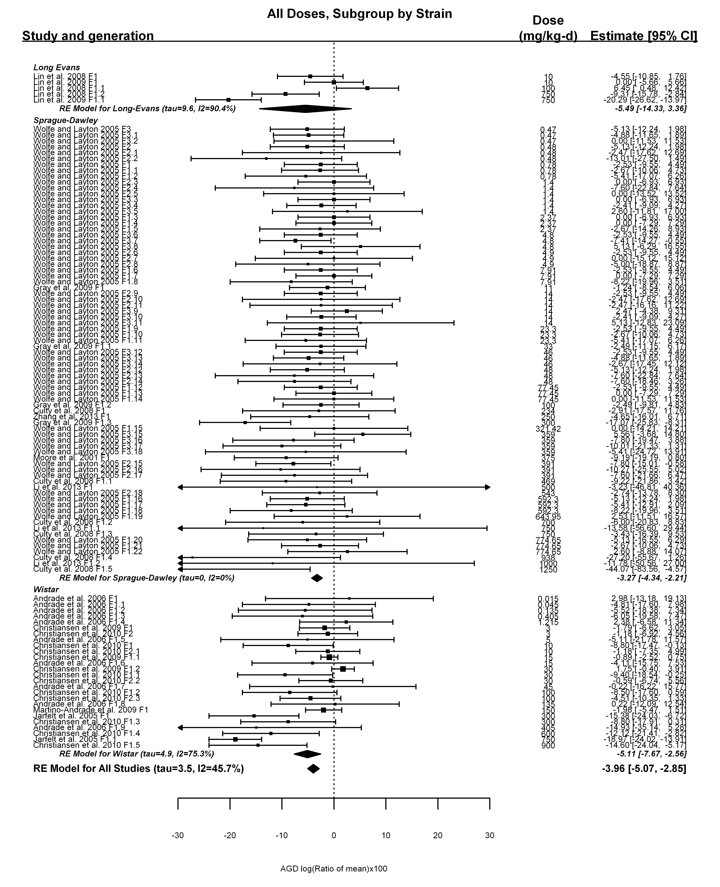

## [1] "Trend log10 dose"

##   
## Mixed-Effects Model (k = 107; tau^2 estimator: REML)  
##   
## tau^2 (estimated amount of residual heterogeneity): 9.0101 (SE = 3.6558)  
## tau (square root of estimated tau^2 value): 3.0017  
## I^2 (residual heterogeneity / unaccounted variability): 38.46%  
## H^2 (unaccounted variability / sampling variability): 1.62  
## R^2 (amount of heterogeneity accounted for): 25.67%  
##   
## Test for Residual Heterogeneity:   
## QE(df = 105) = 160.0317, p-val = 0.0004  
##   
## Test of Moderators (coefficient(s) 2):   
## QM(df = 1) = 14.6638, p-val = 0.0001  
##   
## Model Results:  
##   
## estimate se zval pval ci.lb ci.ub   
## intrcpt -1.1764 0.8895 -1.3225 0.1860 -2.9198 0.5670   
## log10(dose) -1.9742 0.5155 -3.8293 0.0001 -2.9846 -0.9637 ***  
##   
## ---  
## Signif. codes: 0 '***' 0.001 '**' 0.01 '*' 0.05 '.' 0.1 ' ' 1

## [1] "LE"

##   
## Mixed-Effects Model (k = 5; tau^2 estimator: REML)  
##   
## tau^2 (estimated amount of residual heterogeneity): 77.1219 (SE = 70.9735)  
## tau (square root of estimated tau^2 value): 8.7819  
## I^2 (residual heterogeneity / unaccounted variability): 88.76%  
## H^2 (unaccounted variability / sampling variability): 8.90  
## R^2 (amount of heterogeneity accounted for): 16.13%  
##   
## Test for Residual Heterogeneity:   
## QE(df = 3) = 26.7669, p-val < .0001  
##   
## Test of Moderators (coefficient(s) 2):   
## QM(df = 1) = 1.6853, p-val = 0.1942  
##   
## Model Results:  
##   
## estimate se zval pval ci.lb ci.ub   
## intrcpt 7.0810 10.5339 0.6722 0.5014 -13.5650 27.7270   
## log10(dose) -6.4584 4.9748 -1.2982 0.1942 -16.2089 3.2921   
##   
## ---  
## Signif. codes: 0 '***' 0.001 '**' 0.01 '*' 0.05 '.' 0.1 ' ' 1

## [1] "SD"

##   
## Mixed-Effects Model (k = 76; tau^2 estimator: REML)  
##   
## tau^2 (estimated amount of residual heterogeneity): 0 (SE = 3.1376)  
## tau (square root of estimated tau^2 value): 0  
## I^2 (residual heterogeneity / unaccounted variability): 0.00%  
## H^2 (unaccounted variability / sampling variability): 1.00  
## R^2 (amount of heterogeneity accounted for): NA%  
##   
## Test for Residual Heterogeneity:   
## QE(df = 74) = 47.2570, p-val = 0.9935  
##   
## Test of Moderators (coefficient(s) 2):   
## QM(df = 1) = 3.0014, p-val = 0.0832  
##   
## Model Results:  
##   
## estimate se zval pval ci.lb ci.ub   
## intrcpt -2.1239 0.8573 -2.4773 0.0132 -3.8043 -0.4436 *  
## log10(dose) -0.9189 0.5304 -1.7325 0.0832 -1.9585 0.1207 .  
##   
## ---  
## Signif. codes: 0 '***' 0.001 '**' 0.01 '*' 0.05 '.' 0.1 ' ' 1

## [1] "W"

##   
## Mixed-Effects Model (k = 26; tau^2 estimator: REML)  
##   
## tau^2 (estimated amount of residual heterogeneity): 15.5210 (SE = 8.7636)  
## tau (square root of estimated tau^2 value): 3.9397  
## I^2 (residual heterogeneity / unaccounted variability): 65.66%  
## H^2 (unaccounted variability / sampling variability): 2.91  
## R^2 (amount of heterogeneity accounted for): 36.52%  
##   
## Test for Residual Heterogeneity:   
## QE(df = 24) = 65.9079, p-val < .0001  
##   
## Test of Moderators (coefficient(s) 2):   
## QM(df = 1) = 8.7628, p-val = 0.0031  
##   
## Model Results:  
##   
## estimate se zval pval ci.lb ci.ub   
## intrcpt -0.5564 1.8648 -0.2984 0.7654 -4.2114 3.0985   
## log10(dose) -3.1362 1.0595 -2.9602 0.0031 -5.2128 -1.0597 **  
##   
## ---  
## Signif. codes: 0 '***' 0.001 '**' 0.01 '*' 0.05 '.' 0.1 ' ' 1

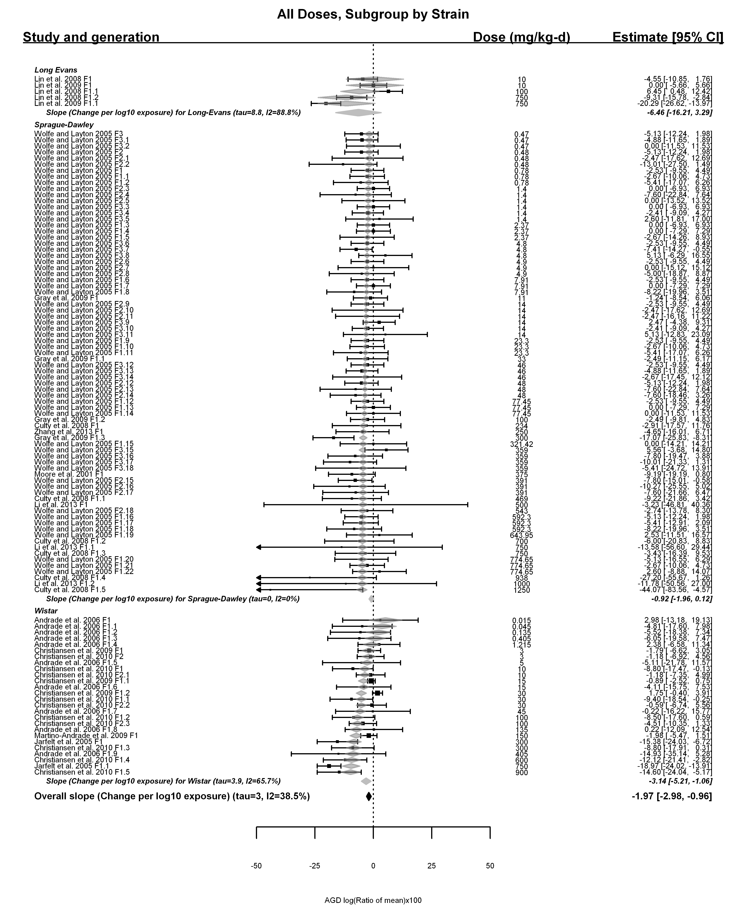

## [1] "Linear or LinearQuadratic"

##   
## Mixed-Effects Model (k = 107; tau^2 estimator: REML)  
##   
## tau^2 (estimated amount of residual heterogeneity): 4.1134 (SE = 2.5840)  
## tau (square root of estimated tau^2 value): 2.0281  
## I^2 (residual heterogeneity / unaccounted variability): 22.94%  
## H^2 (unaccounted variability / sampling variability): 1.30  
##   
## Test for Residual Heterogeneity:   
## QE(df = 105) = 122.4645, p-val = 0.1171  
##   
## Test of Moderators (coefficient(s) 1,2):   
## QM(df = 2) = 94.4806, p-val < .0001  
##   
## Model Results:  
##   
## estimate se zval pval ci.lb ci.ub   
## dose100 -2.1087 0.6090 -3.4623 0.0005 -3.3024 -0.9150 ***  
## I(dose100^2) 0.0834 0.0869 0.9593 0.3374 -0.0870 0.2537   
##   
## ---  
## Signif. codes: 0 '***' 0.001 '**' 0.01 '*' 0.05 '.' 0.1 ' ' 1

## [1] "LE"

##   
## Mixed-Effects Model (k = 5; tau^2 estimator: REML)  
##   
## tau^2 (estimated amount of residual heterogeneity): 27.1921 (SE = 26.0301)  
## tau (square root of estimated tau^2 value): 5.2146  
## I^2 (residual heterogeneity / unaccounted variability): 73.98%  
## H^2 (unaccounted variability / sampling variability): 3.84  
##   
## Test for Residual Heterogeneity:   
## QE(df = 4) = 15.1090, p-val = 0.0045  
##   
## Model Results:  
##   
## estimate se zval pval ci.lb ci.ub   
## dose100 -1.9047 0.5773 -3.2996 0.0010 -3.0362 -0.7733 ***  
##   
## ---  
## Signif. codes: 0 '***' 0.001 '**' 0.01 '*' 0.05 '.' 0.1 ' ' 1

## [1] "SD"

##   
## Mixed-Effects Model (k = 76; tau^2 estimator: REML)  
##   
## tau^2 (estimated amount of residual heterogeneity): 0 (SE = 3.1106)  
## tau (square root of estimated tau^2 value): 0  
## I^2 (residual heterogeneity / unaccounted variability): 0.00%  
## H^2 (unaccounted variability / sampling variability): 1.00  
##   
## Test for Residual Heterogeneity:   
## QE(df = 74) = 58.9500, p-val = 0.8992  
##   
## Test of Moderators (coefficient(s) 1,2):   
## QM(df = 2) = 27.7533, p-val < .0001  
##   
## Model Results:  
##   
## estimate se zval pval ci.lb ci.ub   
## dose100 -2.3951 0.7053 -3.3960 0.0007 -3.7774 -1.0128 ***  
## I(dose100^2) 0.2242 0.1071 2.0936 0.0363 0.0143 0.4342 *  
##   
## ---  
## Signif. codes: 0 '***' 0.001 '**' 0.01 '*' 0.05 '.' 0.1 ' ' 1

## [1] "W"

##   
## Mixed-Effects Model (k = 26; tau^2 estimator: REML)  
##   
## tau^2 (estimated amount of residual heterogeneity): 1.9143 (SE = 2.4478)  
## tau (square root of estimated tau^2 value): 1.3836  
## I^2 (residual heterogeneity / unaccounted variability): 22.04%  
## H^2 (unaccounted variability / sampling variability): 1.28  
##   
## Test for Residual Heterogeneity:   
## QE(df = 24) = 25.3669, p-val = 0.3860  
##   
## Test of Moderators (coefficient(s) 1,2):   
## QM(df = 2) = 71.9484, p-val < .0001  
##   
## Model Results:  
##   
## estimate se zval pval ci.lb ci.ub   
## dose100 -3.5821 1.0151 -3.5288 0.0004 -5.5717 -1.5926 ***  
## I(dose100^2) 0.1768 0.1383 1.2780 0.2013 -0.0943 0.4478   
##   
## ---  
## Signif. codes: 0 '***' 0.001 '**' 0.01 '*' 0.05 '.' 0.1 ' ' 1

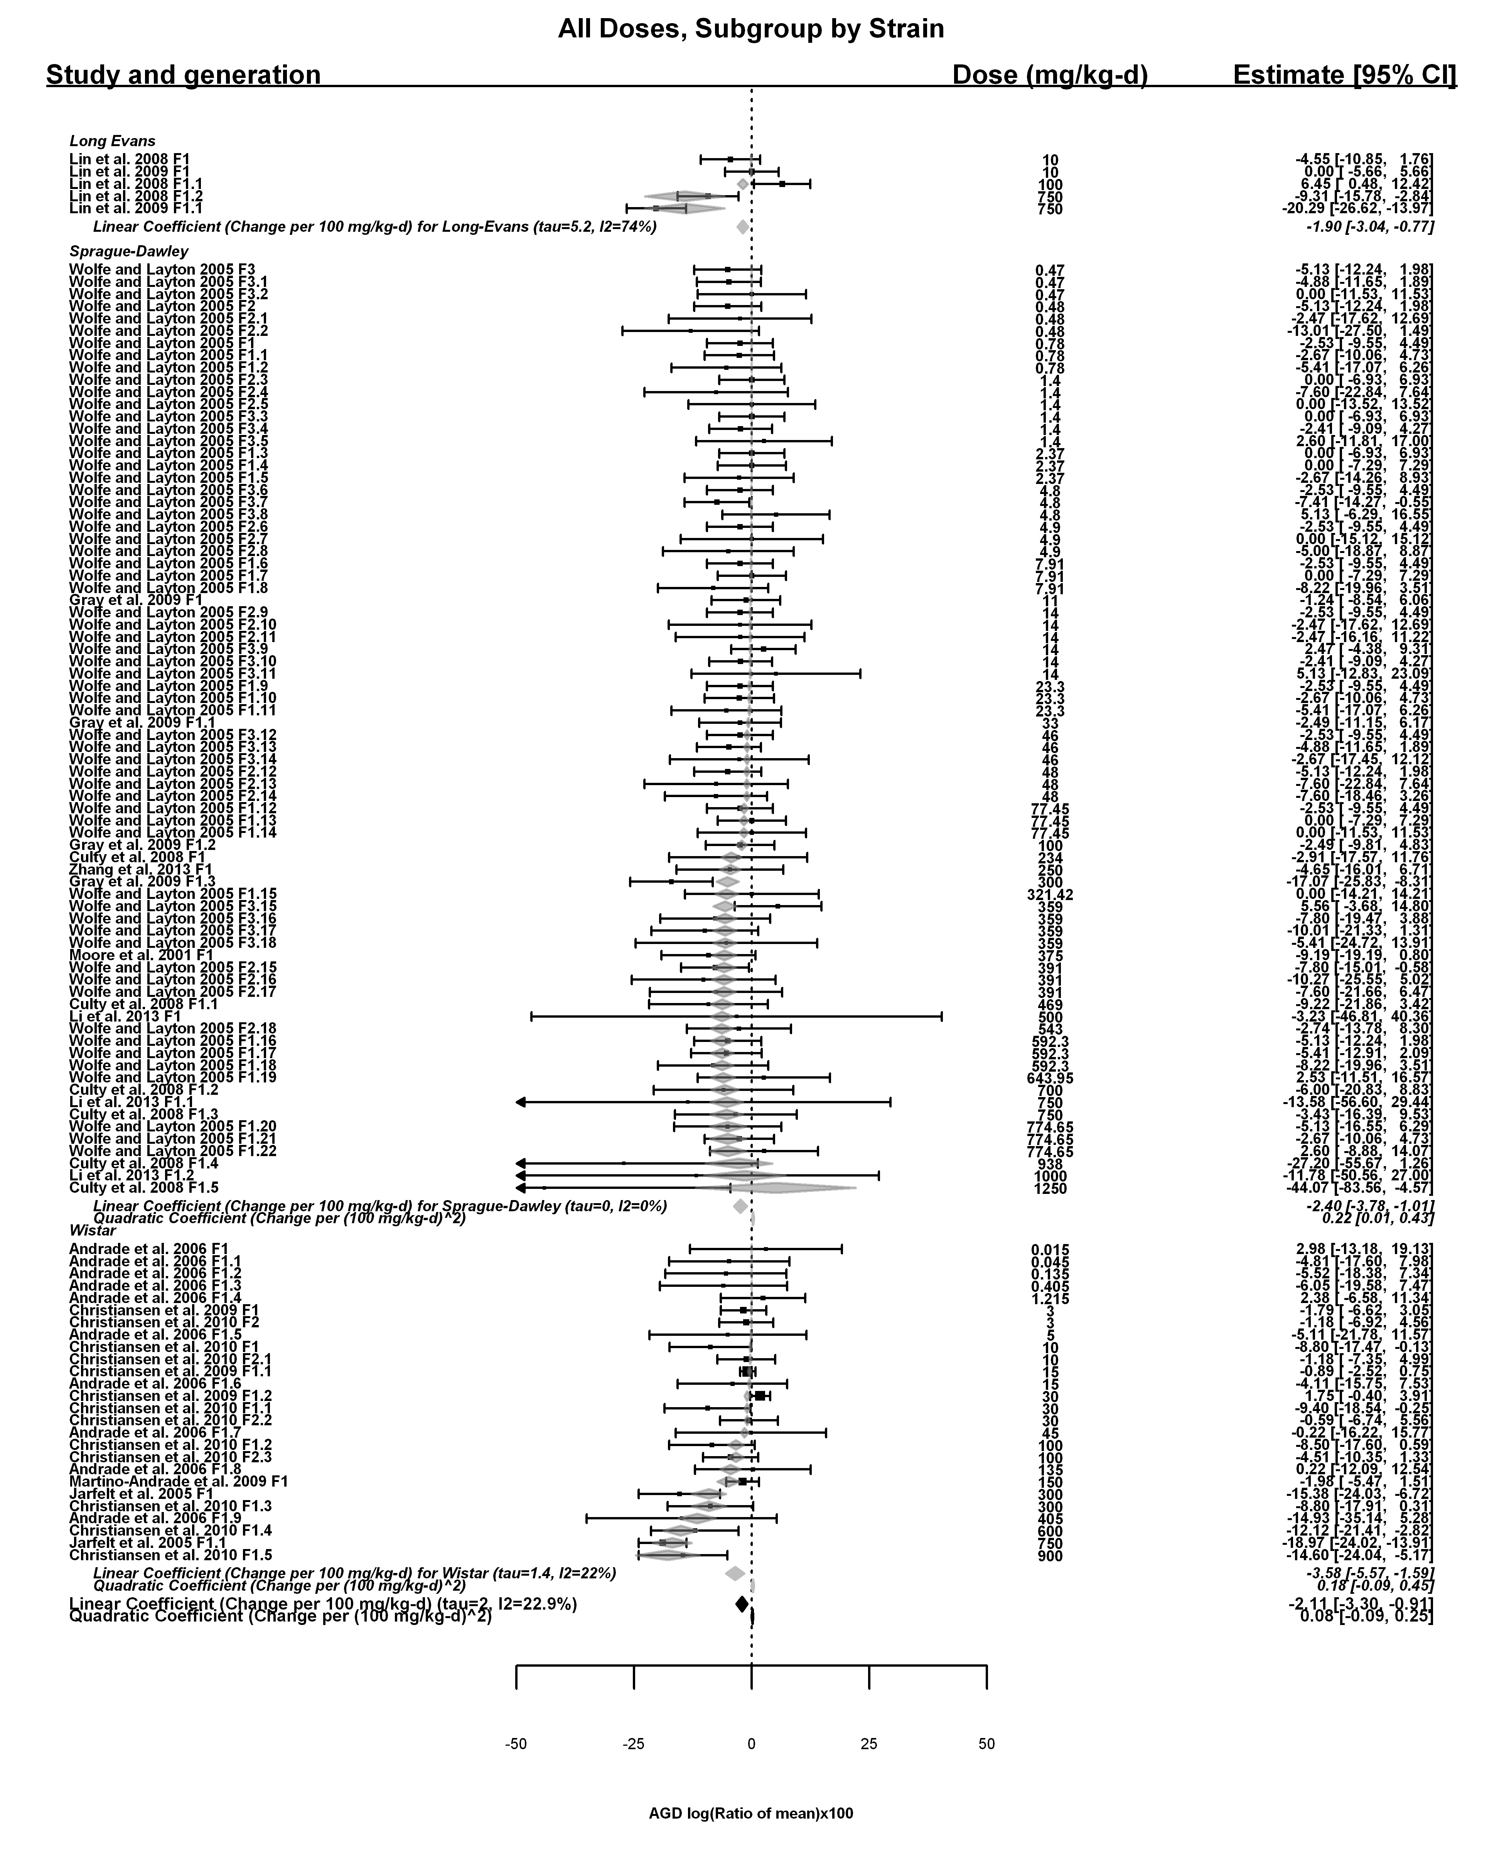

## [1] ""

## m ci.lb ci.ub bmr  
## 1 270.8709 178.0243 417.9423 -5.1

## [1] ""

## m ci.lb ci.ub bmr  
## 1 267.7514 167.9747 659.4883 -5.1

## [1] ""

## m ci.lb ci.ub bmr  
## 1 293.6799 165.7237 NA -5.1

## [1] ""

## m ci.lb ci.ub bmr  
## 1 154.0889 99.23772 281.527 -5.1

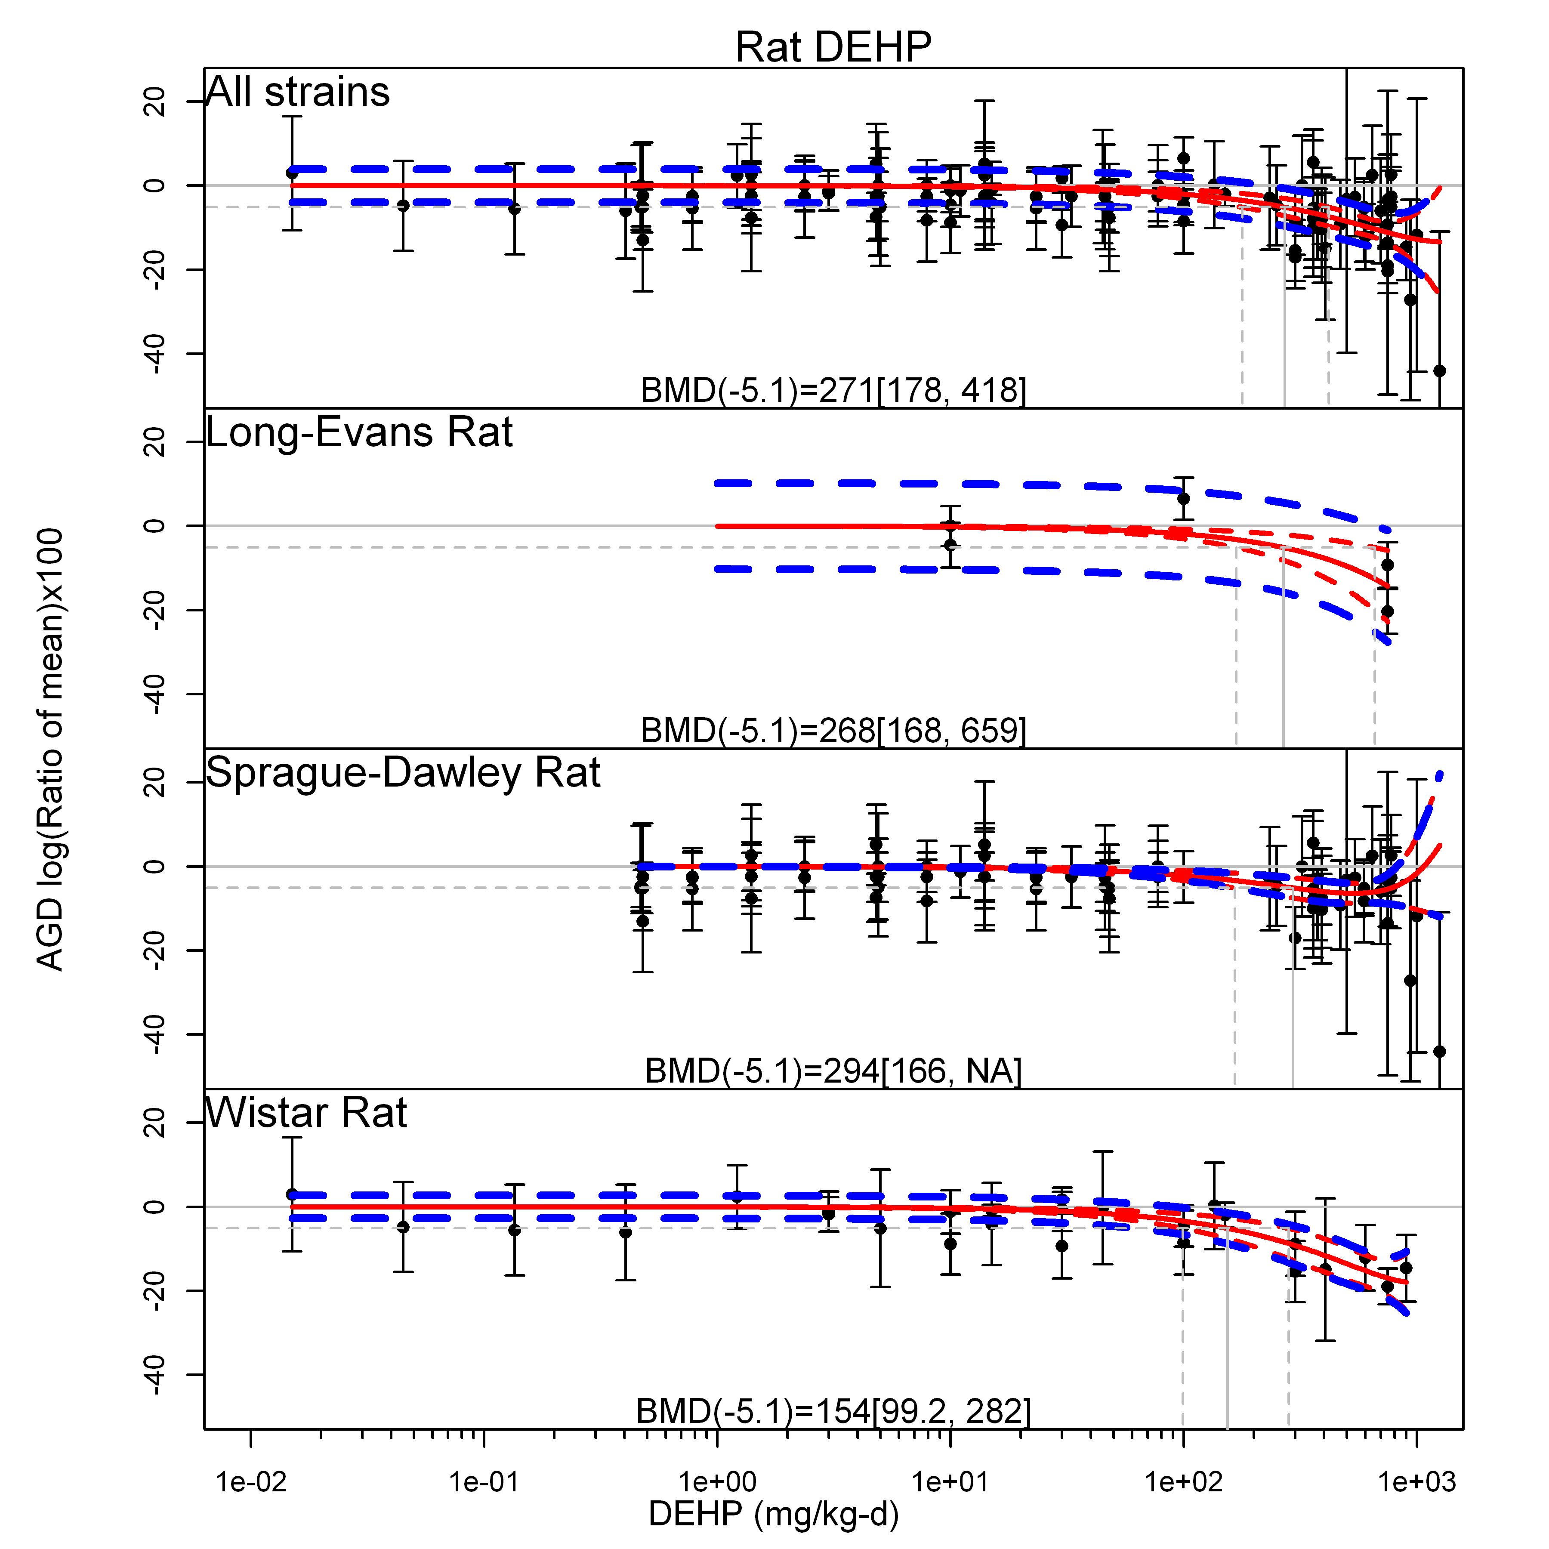

## T animal details

## [1] "Fetal testes T log(Ratio of mean)x100 Rat"  
## [1] "Overall---------------------"  
##   
## Random-Effects Model (k = 34; tau^2 estimator: REML)  
##   
## logLik deviance AIC BIC AICc   
## -191.2360 382.4719 386.4719 389.4649 386.8719   
##   
## tau^2 (estimated amount of total heterogeneity): 5892.3665 (SE = 1539.1523)  
## tau (square root of estimated tau^2 value): 76.7618  
## I^2 (total heterogeneity / total variability): 98.49%  
## H^2 (total variability / sampling variability): 66.03  
##   
## Test for Heterogeneity:   
## Q(df = 33) = 894.2912, p-val < .0001  
##   
## Model Results:  
##   
## estimate se zval pval ci.lb ci.ub   
## -110.1373 13.5679 -8.1175 <.0001 -136.7299 -83.5447 ***   
##   
## ---  
## Signif. codes: 0 '***' 0.001 '**' 0.01 '*' 0.05 '.' 0.1 ' ' 1

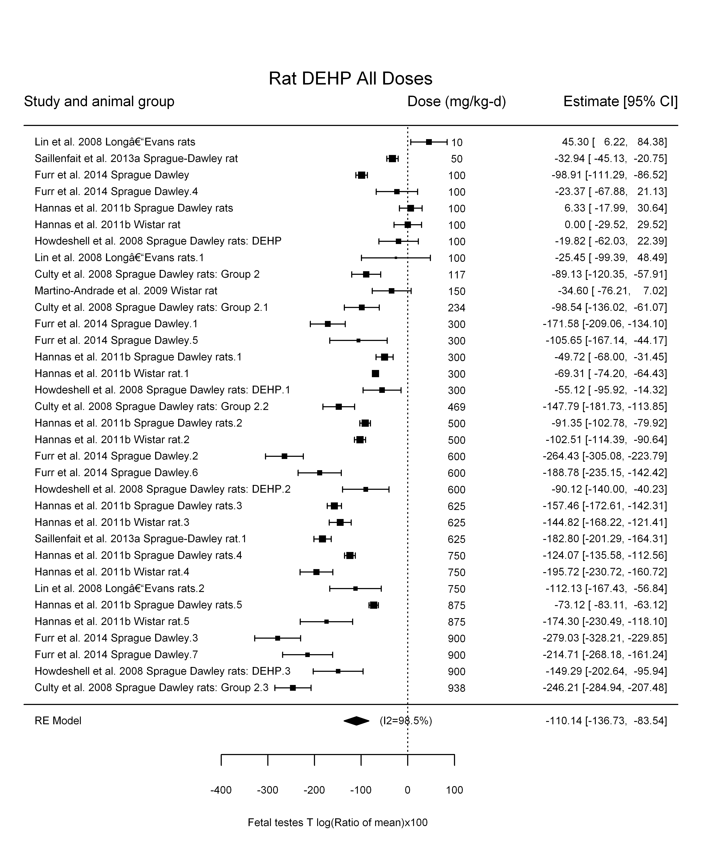

## [1] "Trend in log10(dose)---------------------"  
##   
## Mixed-Effects Model (k = 34; tau^2 estimator: REML)  
##   
## logLik deviance AIC BIC AICc   
## -171.2674 342.5348 348.5348 352.9320 349.3920   
##   
## tau^2 (estimated amount of residual heterogeneity): 2278.8316 (SE = 652.8308)  
## tau (square root of estimated tau^2 value): 47.7371  
## I^2 (residual heterogeneity / unaccounted variability): 96.06%  
## H^2 (unaccounted variability / sampling variability): 25.39  
## R^2 (amount of heterogeneity accounted for): 61.33%  
##   
## Test for Residual Heterogeneity:   
## QE(df = 32) = 575.3838, p-val < .0001  
##   
## Test of Moderators (coefficient(s) 2):   
## QM(df = 1) = 46.4497, p-val < .0001  
##   
## Model Results:  
##   
## estimate se zval pval ci.lb ci.ub   
## intrcpt 221.6650 49.3595 4.4908 <.0001 124.9221 318.4079 ***  
## log10(dose) -132.8275 19.4893 -6.8154 <.0001 -171.0259 -94.6291 ***  
##   
## ---  
## Signif. codes: 0 '***' 0.001 '**' 0.01 '*' 0.05 '.' 0.1 ' ' 1

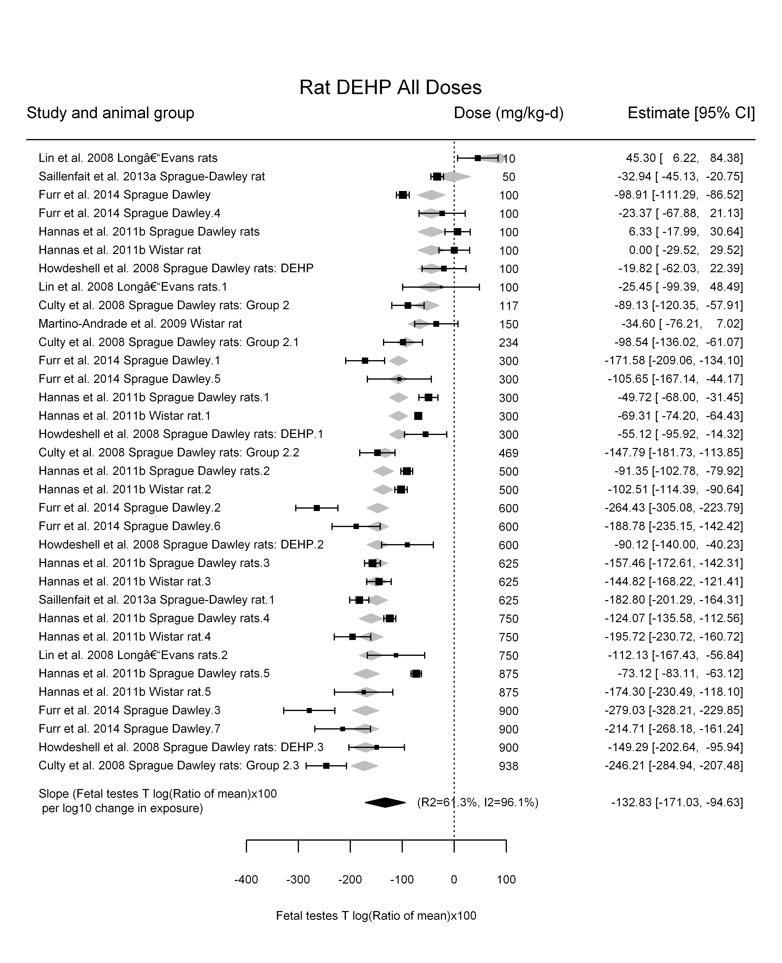

## [1] "Linear---------------------"  
##   
## Mixed-Effects Model (k = 34; tau^2 estimator: REML)  
##   
## logLik deviance AIC BIC AICc   
## -176.9590 353.9180 357.9180 360.9110 358.3180   
##   
## tau^2 (estimated amount of residual heterogeneity): 2354.0365 (SE = 661.1852)  
## tau (square root of estimated tau^2 value): 48.5184  
## I^2 (residual heterogeneity / unaccounted variability): 96.55%  
## H^2 (unaccounted variability / sampling variability): 29.01  
##   
## Test for Residual Heterogeneity:   
## QE(df = 33) = 808.8381, p-val < .0001  
##   
## Model Results:  
##   
## estimate se zval pval ci.lb ci.ub   
## dose -0.2301 0.0165 -13.9355 <.0001 -0.2624 -0.1977 ***  
##   
## ---  
## Signif. codes: 0 '***' 0.001 '**' 0.01 '*' 0.05 '.' 0.1 ' ' 1

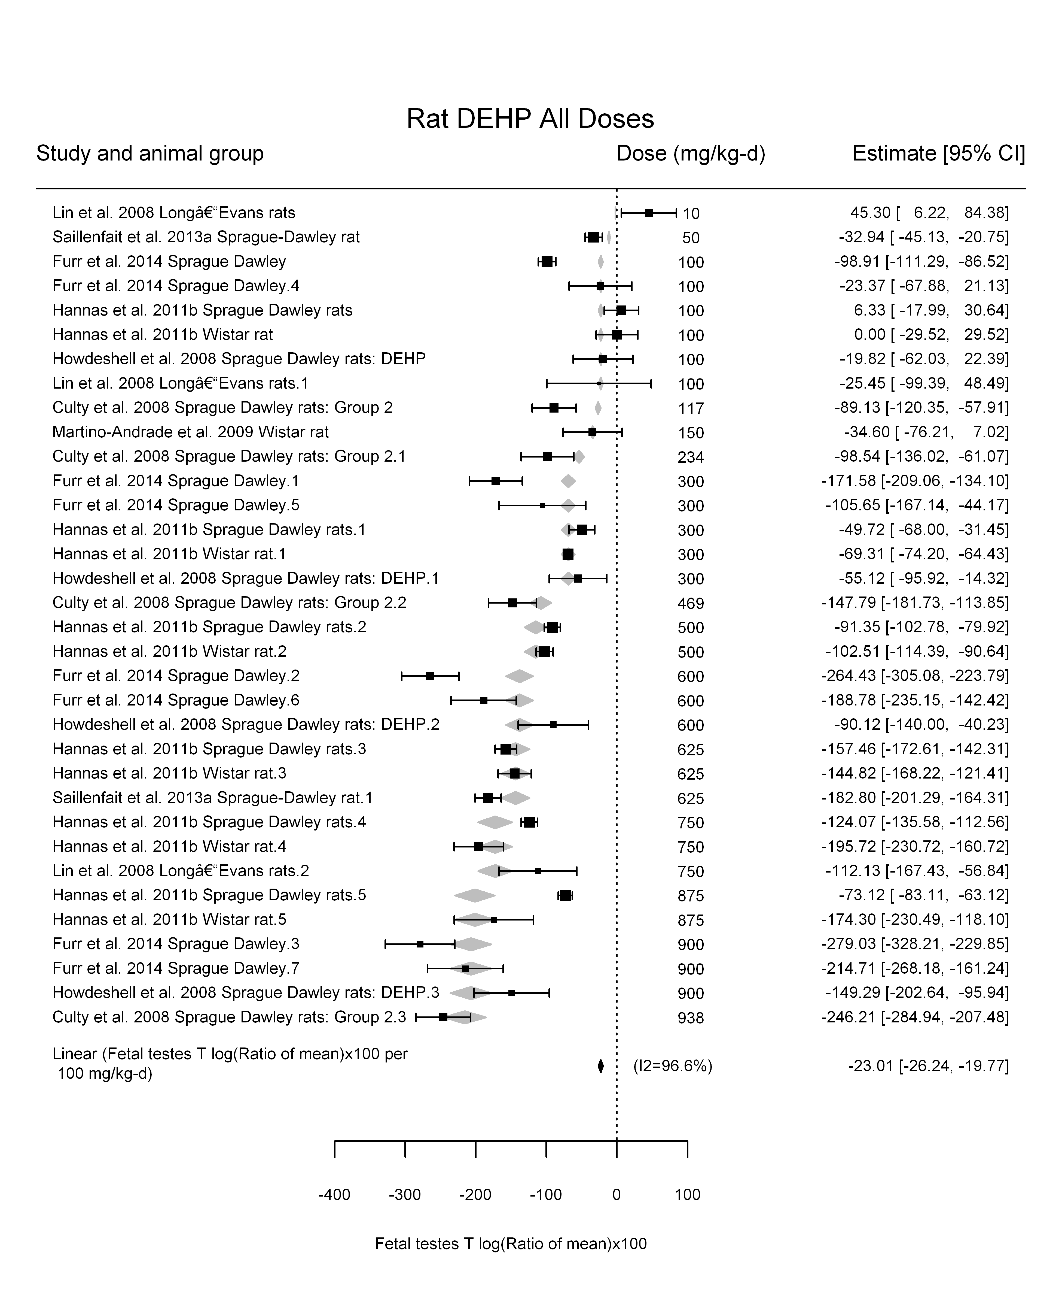

## [1] "LinearQuadratic---------------------"  
##   
## Mixed-Effects Model (k = 34; tau^2 estimator: REML)  
##   
## logLik deviance AIC BIC AICc   
## -170.5776 341.1552 347.1552 351.5524 348.0123   
##   
## tau^2 (estimated amount of residual heterogeneity): 2182.5721 (SE = 627.8910)  
## tau (square root of estimated tau^2 value): 46.7180  
## I^2 (residual heterogeneity / unaccounted variability): 95.49%  
## H^2 (unaccounted variability / sampling variability): 22.16  
##   
## Test for Residual Heterogeneity:   
## QE(df = 32) = 559.3346, p-val < .0001  
##   
## Test of Moderators (coefficient(s) 1,2):   
## QM(df = 2) = 210.2190, p-val < .0001  
##   
## Model Results:  
##   
## estimate se zval pval ci.lb ci.ub   
## dose -0.3423 0.0652 -5.2462 <.0001 -0.4702 -0.2144 ***  
## I(dose^2) 0.0002 0.0001 1.7758 0.0758 -0.0000 0.0003 .  
##   
## ---  
## Signif. codes: 0 '***' 0.001 '**' 0.01 '*' 0.05 '.' 0.1 ' ' 1

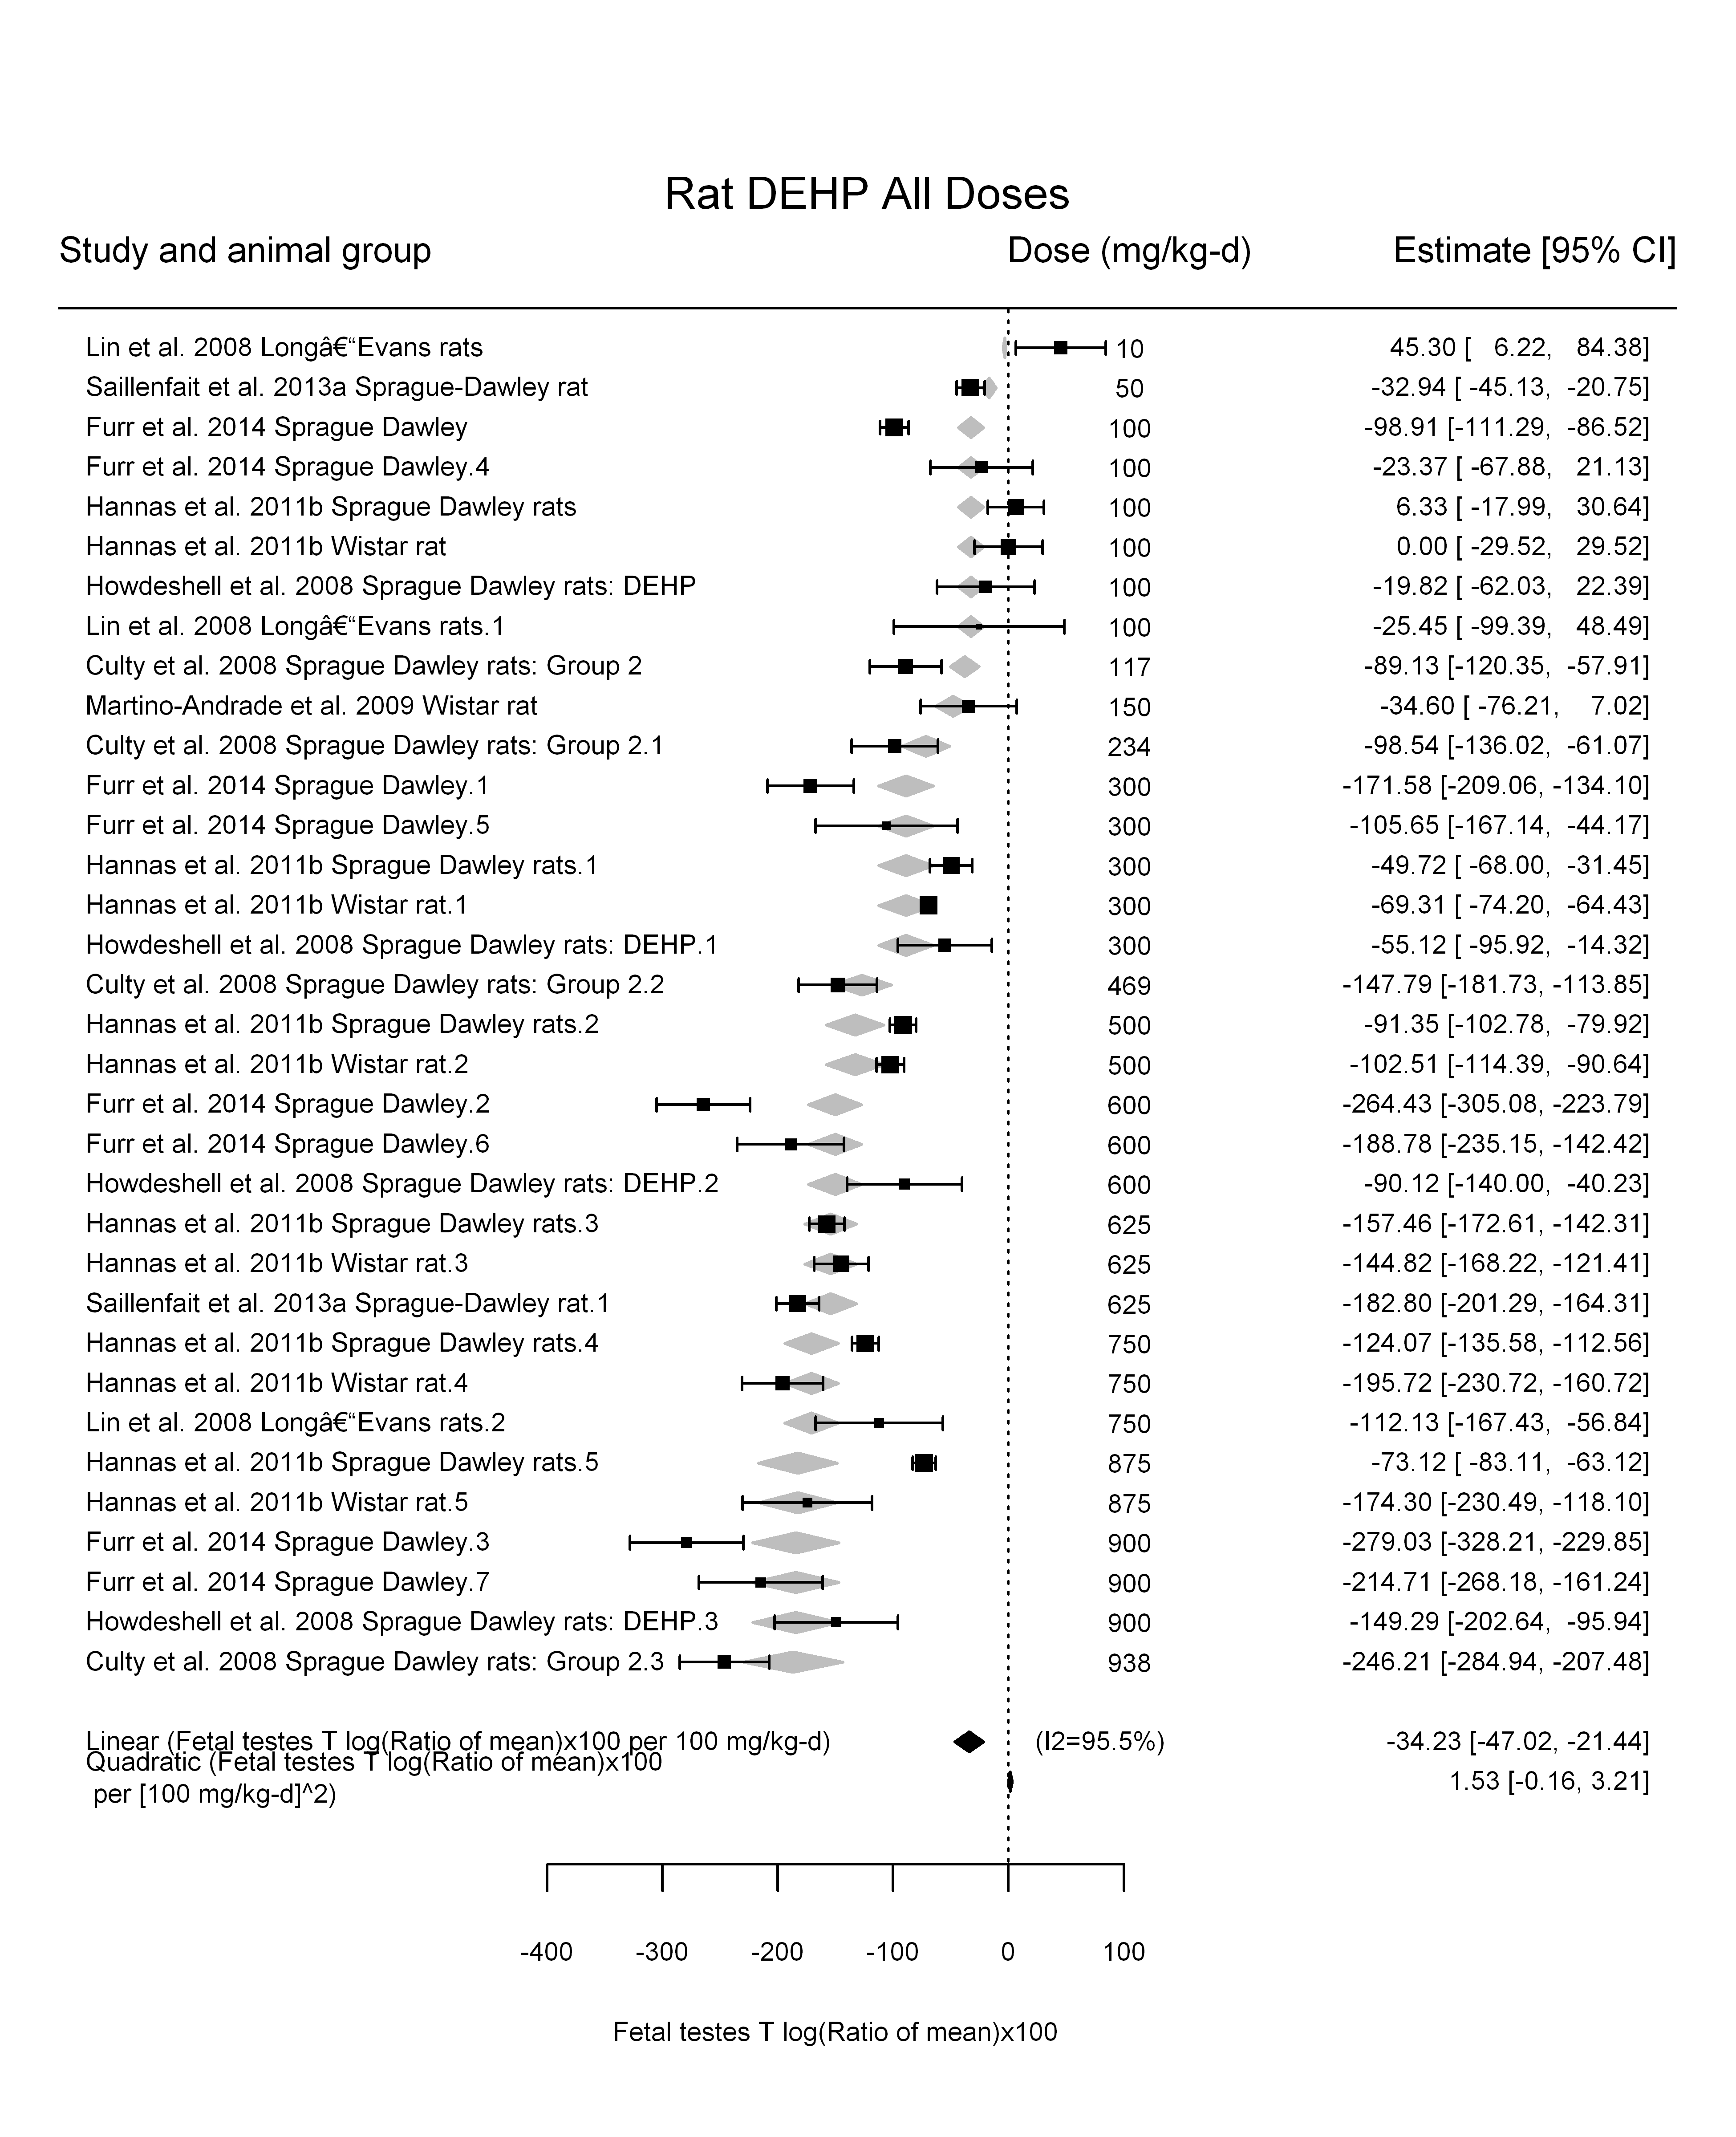

## [1] ""

## [1] ""  
## m ci.lb ci.ub bmr  
## 1 21.73342 19.05364 25.29041 -5  
## m ci.lb ci.ub bmr  
## 1 217.3342 190.5362 252.9043 -50

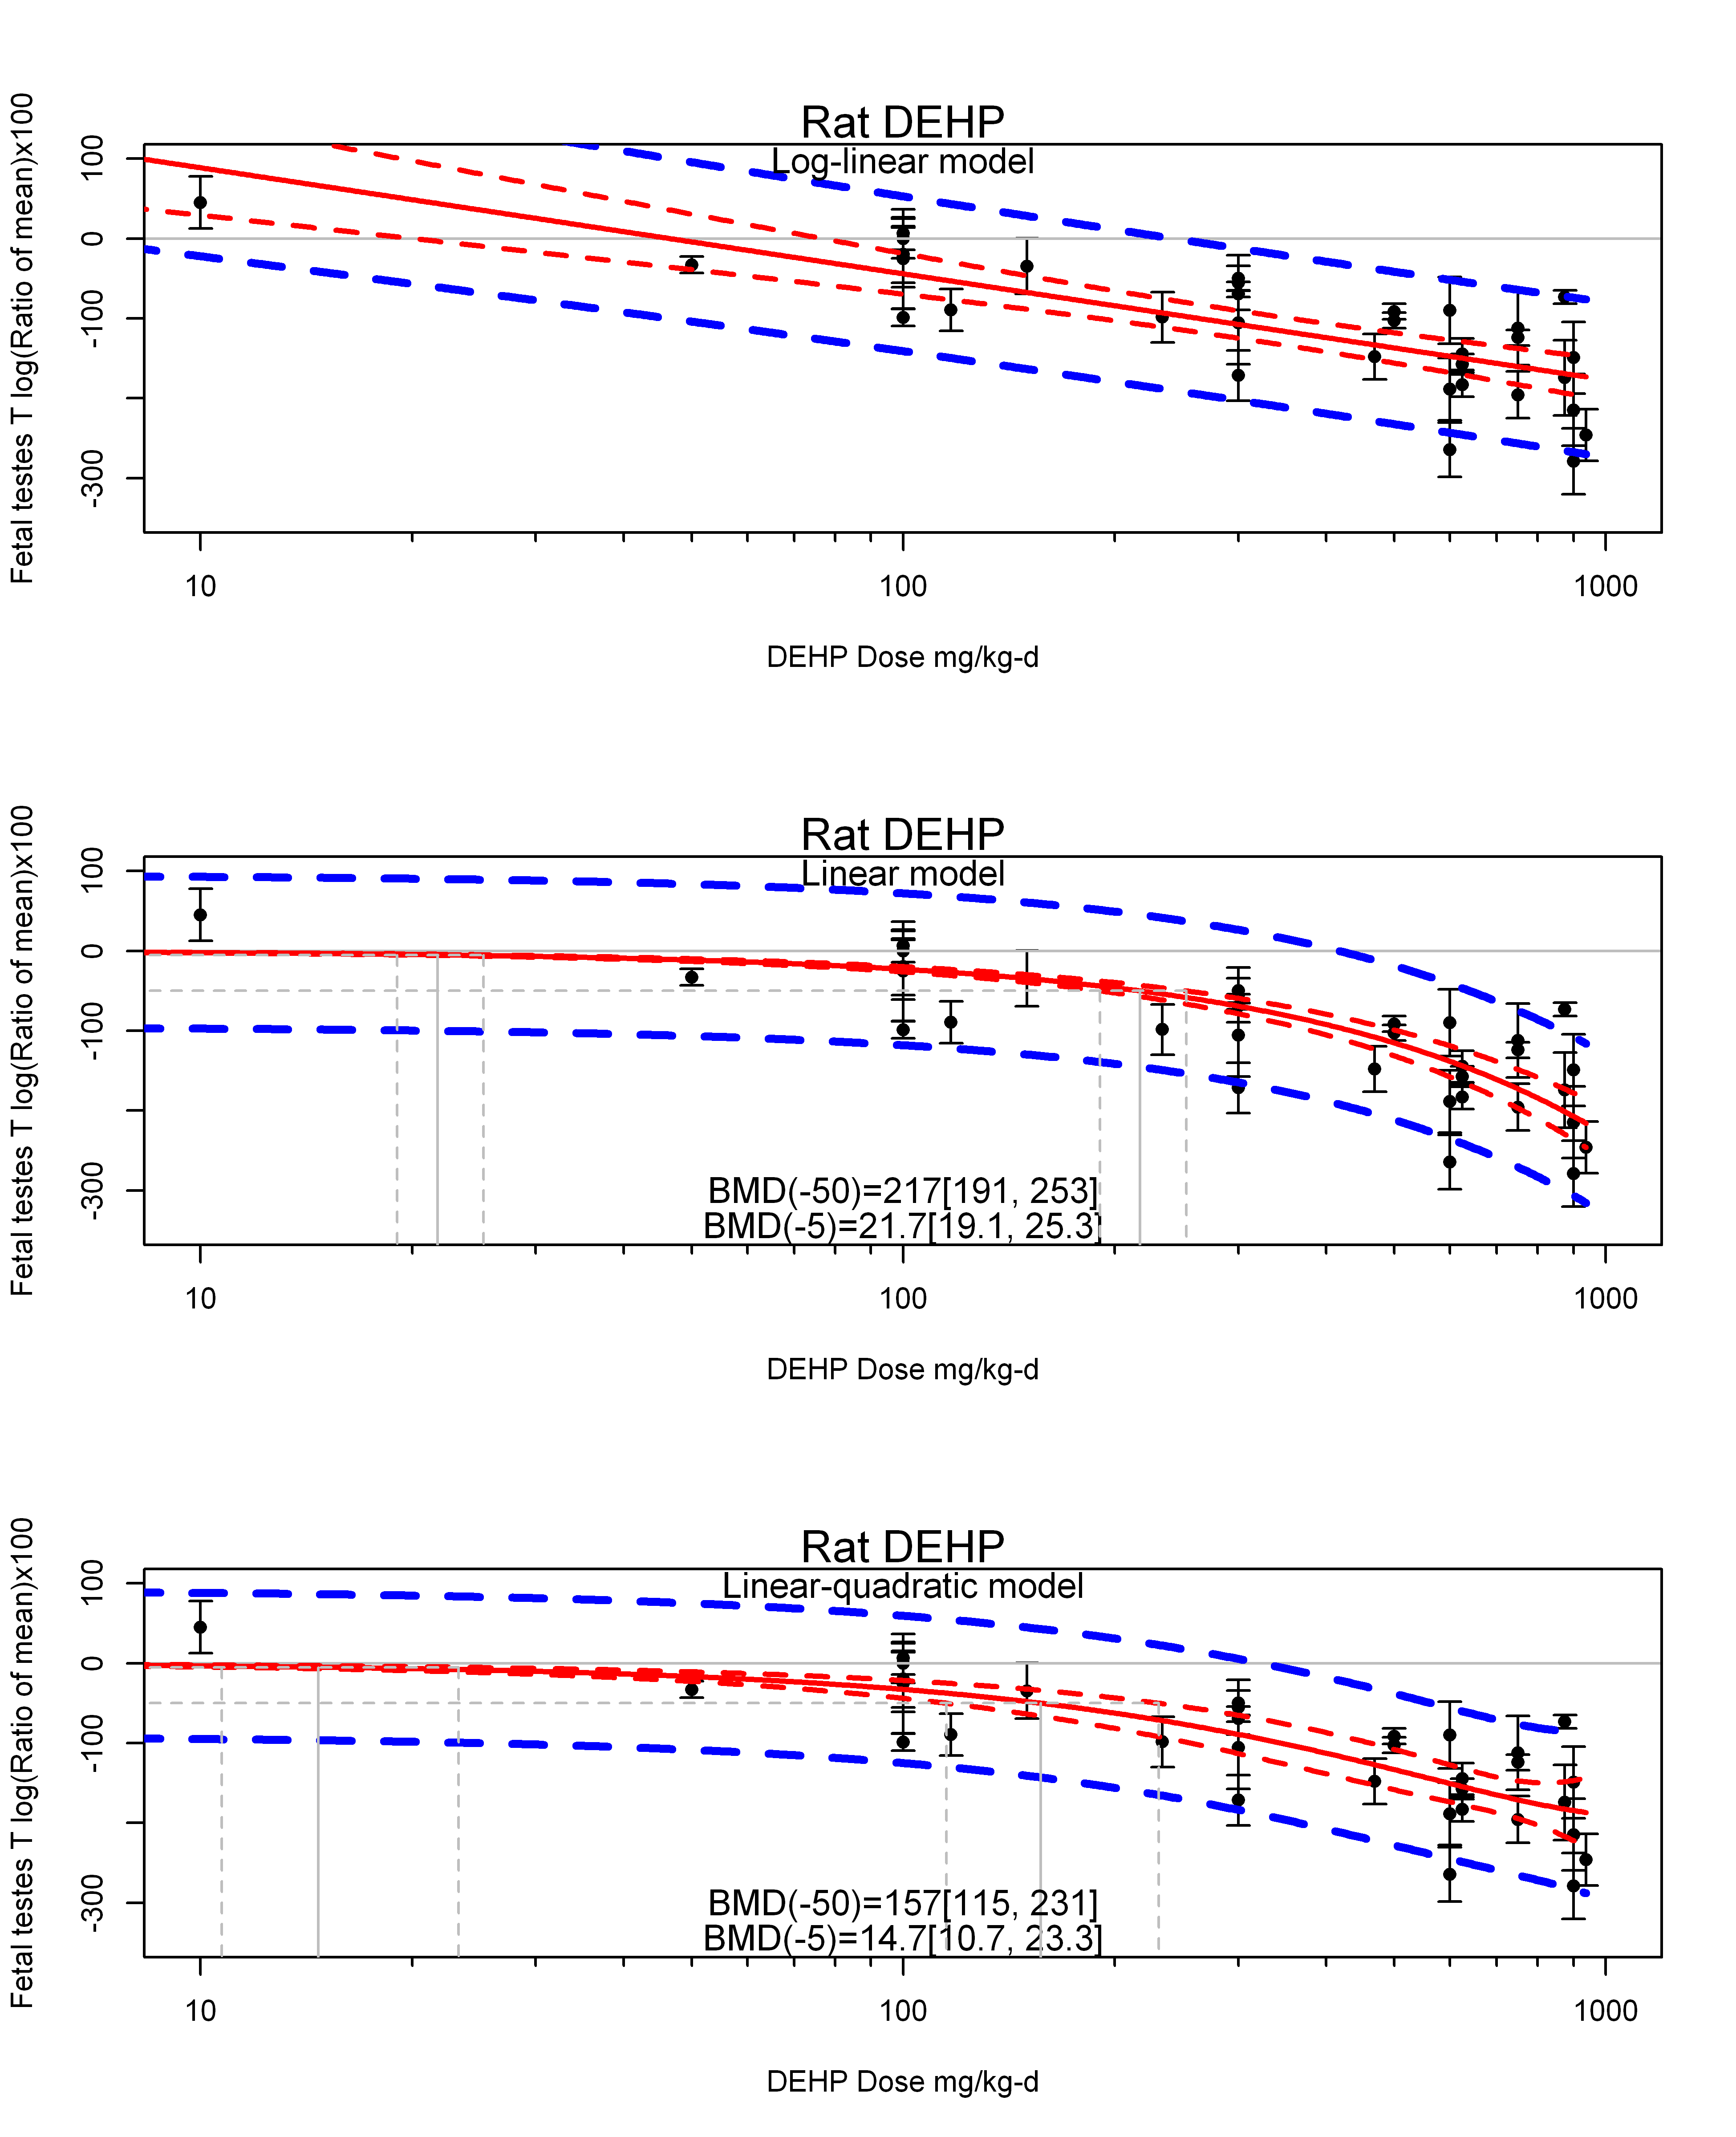

## [1] ""  
## m ci.lb ci.ub bmr  
## 1 14.7044 10.71196 23.29375 -5  
## m ci.lb ci.ub bmr  
## 1 157.0854 115.2512 231.0818 -50  
## [1] "Fetal testes T log(Ratio of mean)x100 Rat Highest Dose"  
## [1] "Overall---------------------"  
##   
## Random-Effects Model (k = 9; tau^2 estimator: REML)  
##   
## logLik deviance AIC BIC AICc   
## -46.4282 92.8563 96.8563 97.0152 99.2563   
##   
## tau^2 (estimated amount of total heterogeneity): 5986.5558 (SE = 3245.3374)  
## tau (square root of estimated tau^2 value): 77.3728  
## I^2 (total heterogeneity / total variability): 96.29%  
## H^2 (total variability / sampling variability): 26.94  
##   
## Test for Heterogeneity:   
## Q(df = 8) = 238.9493, p-val < .0001  
##   
## Model Results:  
##   
## estimate se zval pval ci.lb ci.ub   
## -162.1002 26.8633 -6.0343 <.0001 -214.7514 -109.4491 ***   
##   
## ---  
## Signif. codes: 0 '***' 0.001 '**' 0.01 '*' 0.05 '.' 0.1 ' ' 1

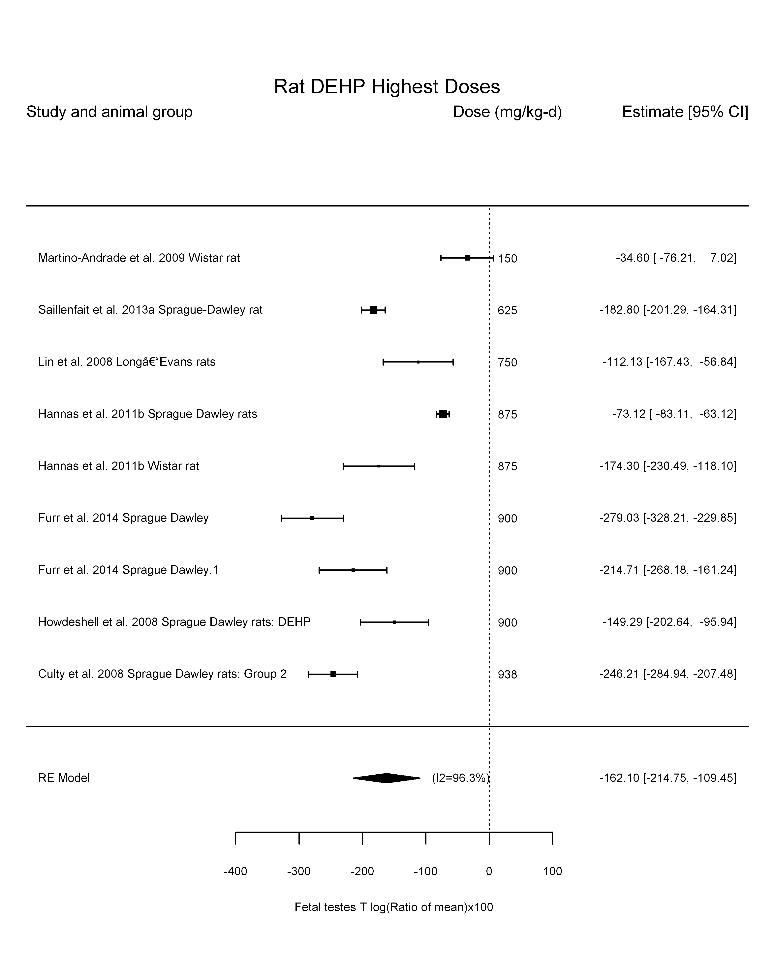

## [1] "Trend in log10(dose)---------------------"  
##   
## Mixed-Effects Model (k = 9; tau^2 estimator: REML)  
##   
## logLik deviance AIC BIC AICc   
## -39.3888 78.7776 84.7776 84.6153 92.7776   
##   
## tau^2 (estimated amount of residual heterogeneity): 4171.2912 (SE = 2498.3998)  
## tau (square root of estimated tau^2 value): 64.5855  
## I^2 (residual heterogeneity / unaccounted variability): 94.51%  
## H^2 (unaccounted variability / sampling variability): 18.22  
## R^2 (amount of heterogeneity accounted for): 30.32%  
##   
## Test for Residual Heterogeneity:   
## QE(df = 7) = 238.2361, p-val < .0001  
##   
## Test of Moderators (coefficient(s) 2):   
## QM(df = 1) = 4.2941, p-val = 0.0382  
##   
## Model Results:  
##   
## estimate se zval pval ci.lb ci.ub   
## intrcpt 392.8275 268.5992 1.4625 0.1436 -133.6173 919.2723   
## log10(dose) -195.3819 94.2866 -2.0722 0.0382 -380.1803 -10.5835 *  
##   
## ---  
## Signif. codes: 0 '***' 0.001 '**' 0.01 '*' 0.05 '.' 0.1 ' ' 1

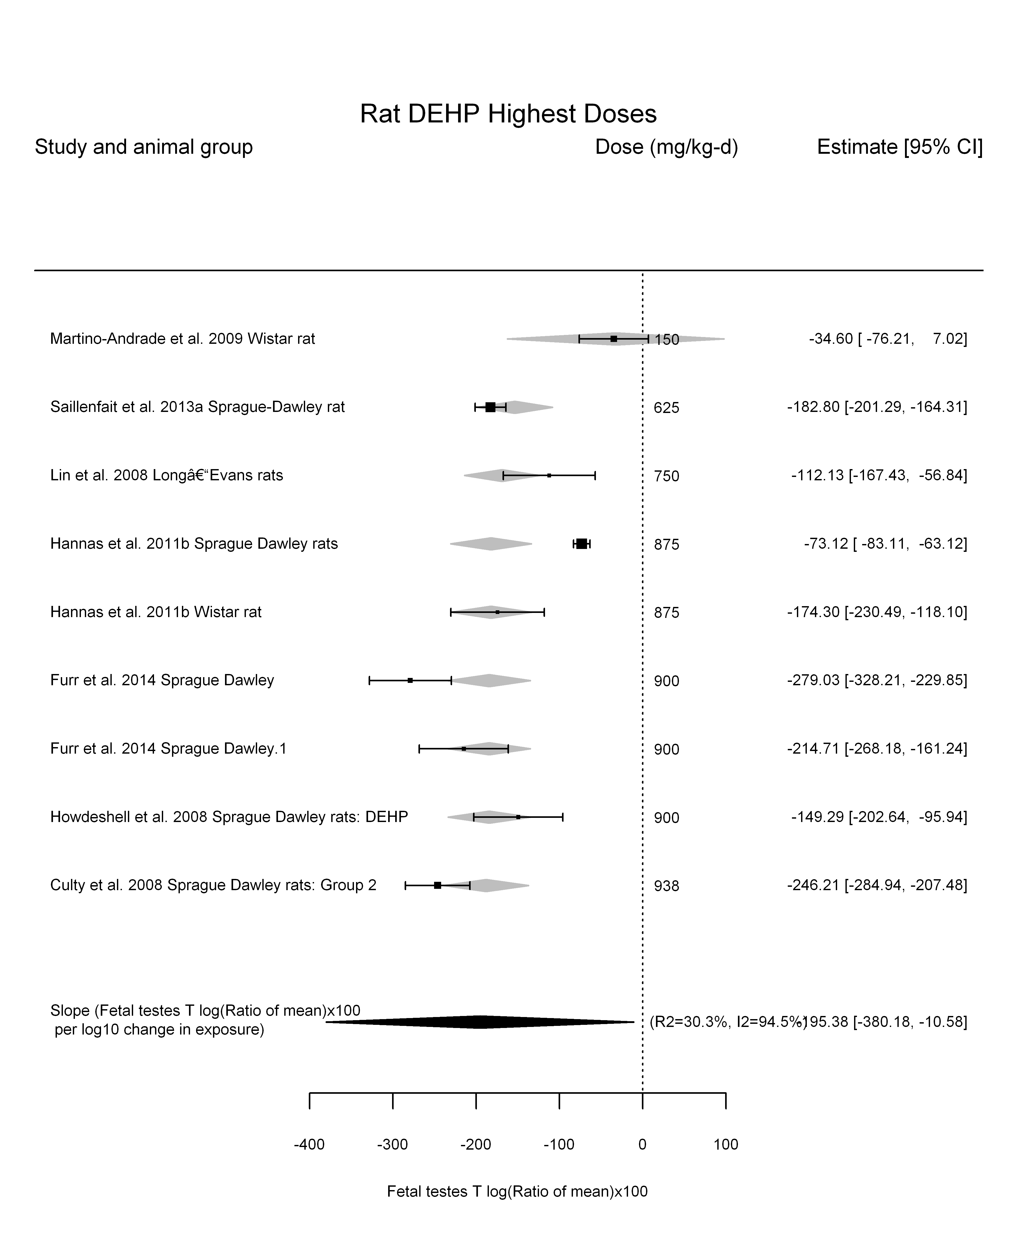

## [1] "Linear---------------------"  
##   
## Mixed-Effects Model (k = 9; tau^2 estimator: REML)  
##   
## logLik deviance AIC BIC AICc   
## -44.4476 88.8951 92.8951 93.0540 95.2951   
##   
## tau^2 (estimated amount of residual heterogeneity): 3619.9062 (SE = 2055.1794)  
## tau (square root of estimated tau^2 value): 60.1657  
## I^2 (residual heterogeneity / unaccounted variability): 93.59%  
## H^2 (unaccounted variability / sampling variability): 15.60  
##   
## Test for Residual Heterogeneity:   
## QE(df = 8) = 279.7300, p-val < .0001  
##   
## Model Results:  
##   
## estimate se zval pval ci.lb ci.ub   
## dose -0.2103 0.0267 -7.8728 <.0001 -0.2626 -0.1579 ***  
##   
## ---  
## Signif. codes: 0 '***' 0.001 '**' 0.01 '*' 0.05 '.' 0.1 ' ' 1

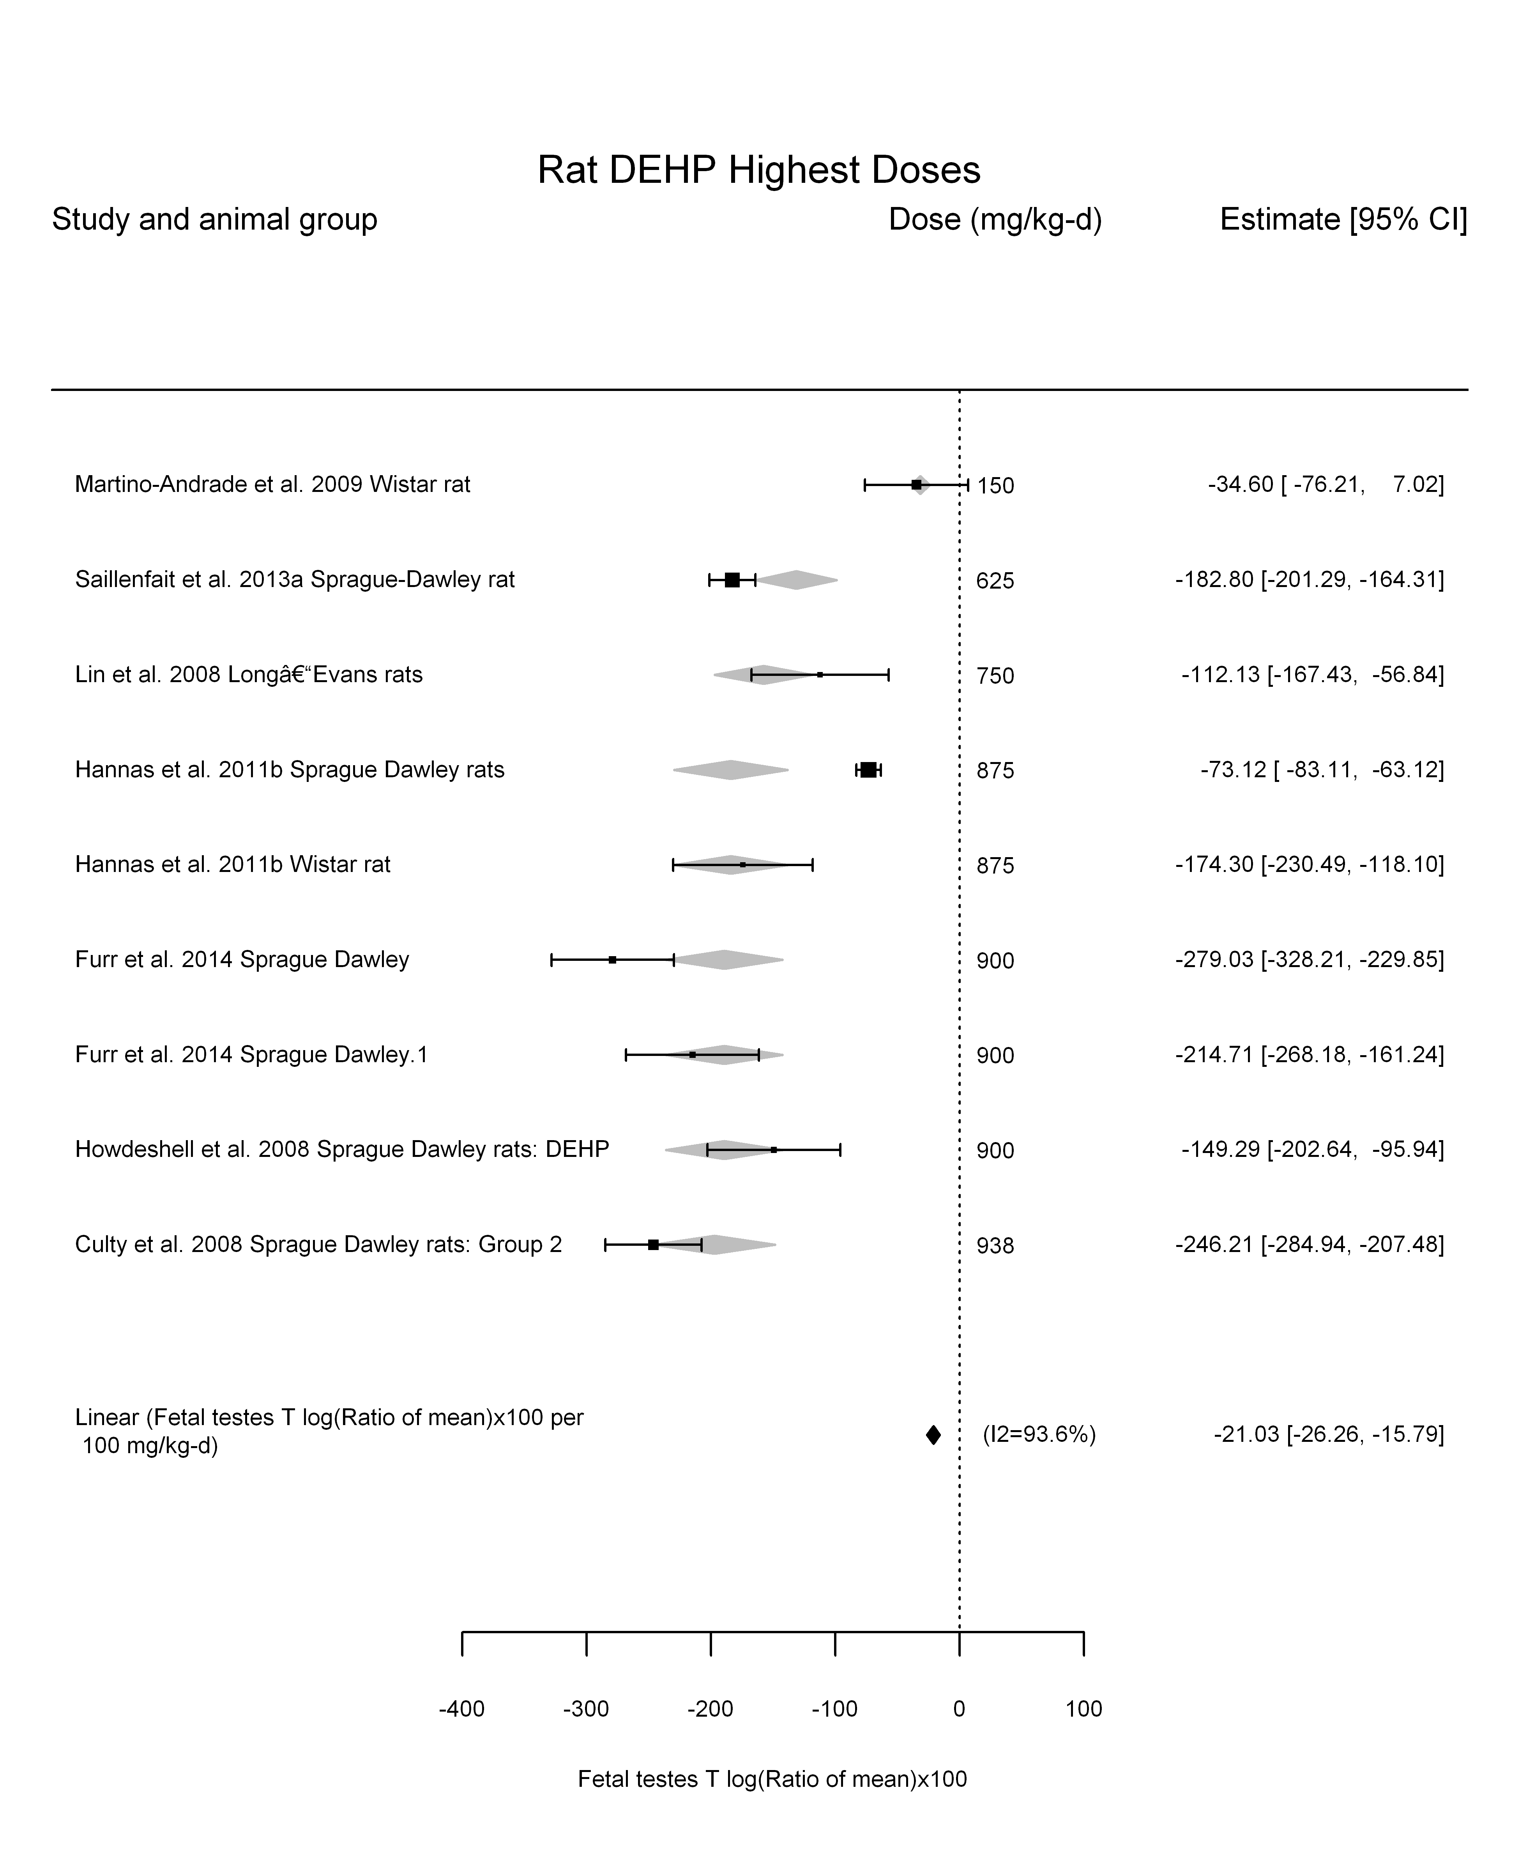

## [1] "LinearQuadratic---------------------"  
##   
## Mixed-Effects Model (k = 9; tau^2 estimator: REML)  
##   
## logLik deviance AIC BIC AICc   
## -39.3550 78.7100 84.7100 84.5477 92.7100   
##   
## tau^2 (estimated amount of residual heterogeneity): 4168.8060 (SE = 2507.5741)  
## tau (square root of estimated tau^2 value): 64.5663  
## I^2 (residual heterogeneity / unaccounted variability): 92.67%  
## H^2 (unaccounted variability / sampling variability): 13.65  
##   
## Test for Residual Heterogeneity:   
## QE(df = 7) = 202.0997, p-val < .0001  
##   
## Test of Moderators (coefficient(s) 1,2):   
## QM(df = 2) = 54.7938, p-val < .0001  
##   
## Model Results:  
##   
## estimate se zval pval ci.lb ci.ub   
## dose -0.2187 0.2622 -0.8340 0.4043 -0.7327 0.2953   
## I(dose^2) 0.0000 0.0003 0.0318 0.9747 -0.0006 0.0006   
##   
## ---  
## Signif. codes: 0 '***' 0.001 '**' 0.01 '*' 0.05 '.' 0.1 ' ' 1

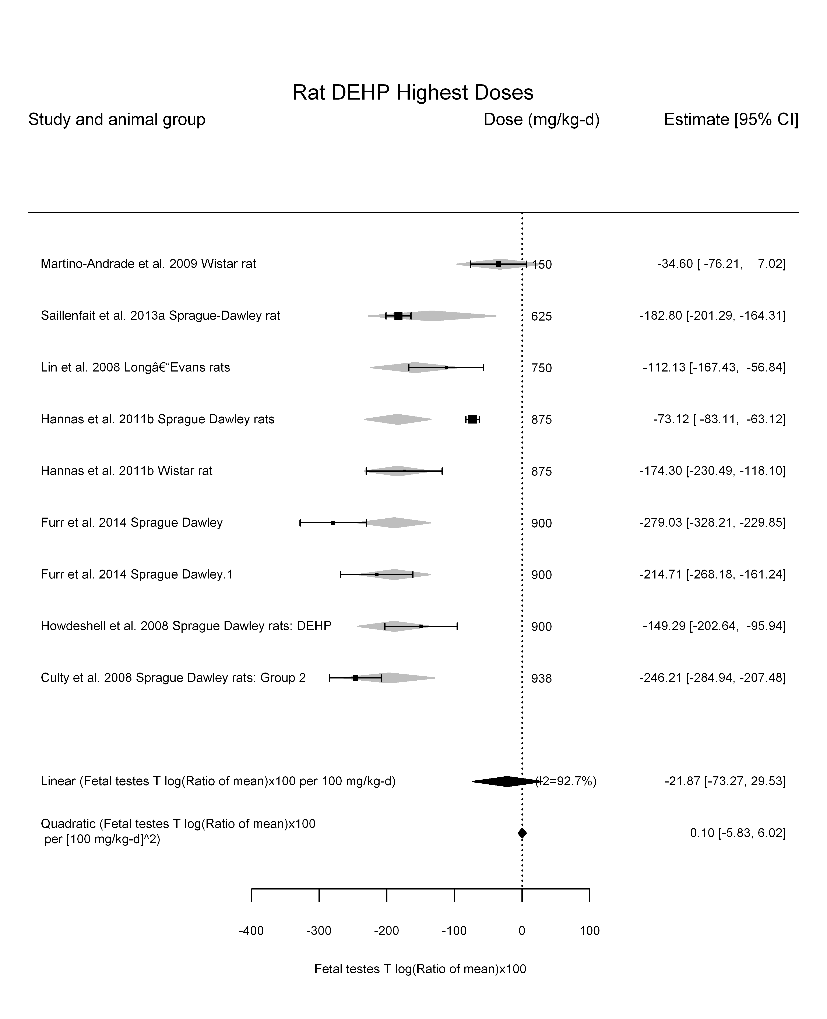

## [1] ""

## [1] ""  
## m ci.lb ci.ub bmr  
## 1 23.77941 19.03954 31.66172 -5  
## m ci.lb ci.ub bmr  
## 1 237.7943 190.395 316.6171 -50

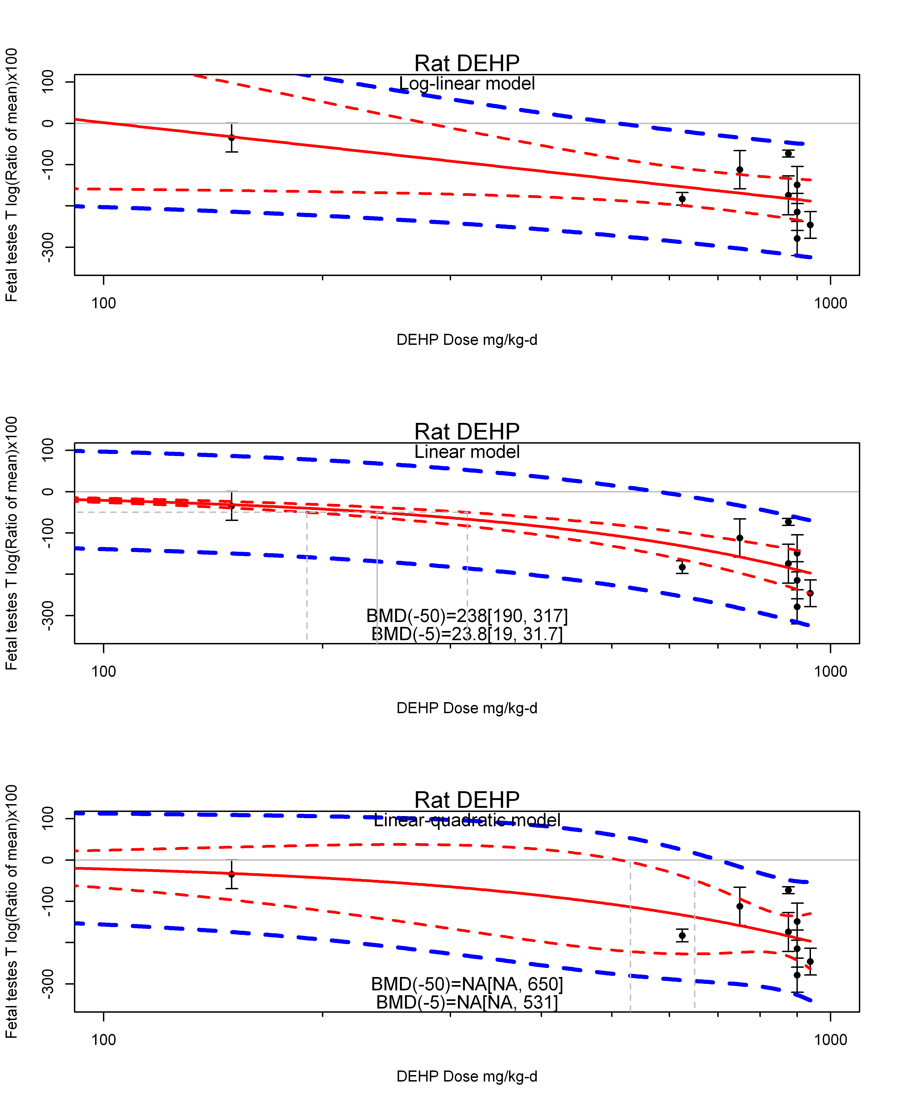

## [1] ""  
## m ci.lb ci.ub bmr  
## 1 NA NA 530.6378 -5  
## m ci.lb ci.ub bmr  
## 1 NA NA 650.2206 -50  
## [1] "Fetal testes T log(Ratio of mean)x100 Mouse"  
## [1] "Overall---------------------"  
##   
## Random-Effects Model (k = 6; tau^2 estimator: REML)  
##   
## logLik deviance AIC BIC AICc   
## -22.7751 45.5502 49.5502 48.7691 55.5502   
##   
## tau^2 (estimated amount of total heterogeneity): 33.0487 (SE = 357.2424)  
## tau (square root of estimated tau^2 value): 5.7488  
## I^2 (total heterogeneity / total variability): 5.83%  
## H^2 (total variability / sampling variability): 1.06  
##   
## Test for Heterogeneity:   
## Q(df = 5) = 4.9460, p-val = 0.4225  
##   
## Model Results:  
##   
## estimate se zval pval ci.lb ci.ub   
## 1.7656 9.7130 0.1818 0.8558 -17.2716 20.8028   
##   
## ---  
## Signif. codes: 0 '***' 0.001 '**' 0.01 '*' 0.05 '.' 0.1 ' ' 1

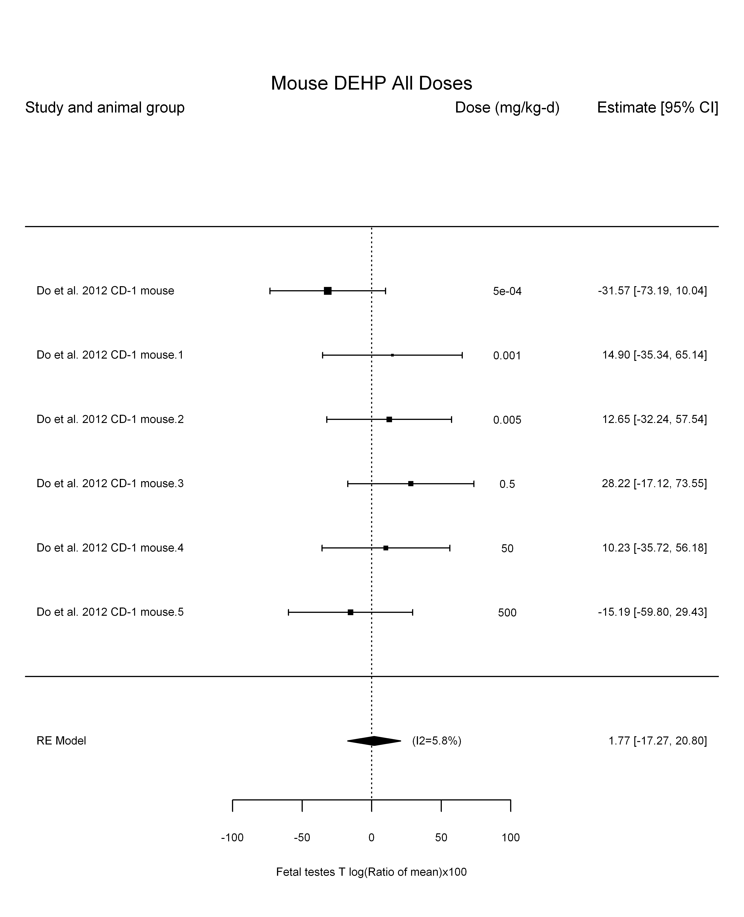

## [1] "Trend in log10(dose)---------------------"  
##   
## Mixed-Effects Model (k = 6; tau^2 estimator: REML)  
##   
## logLik deviance AIC BIC AICc   
## -18.6276 37.2551 43.2551 41.4140 67.2551   
##   
## tau^2 (estimated amount of residual heterogeneity): 147.8505 (SE = 484.2858)  
## tau (square root of estimated tau^2 value): 12.1594  
## I^2 (residual heterogeneity / unaccounted variability): 21.57%  
## H^2 (unaccounted variability / sampling variability): 1.28  
## R^2 (amount of heterogeneity accounted for): 0.00%  
##   
## Test for Residual Heterogeneity:   
## QE(df = 4) = 4.8898, p-val = 0.2988  
##   
## Test of Moderators (coefficient(s) 2):   
## QM(df = 1) = 0.0330, p-val = 0.8559  
##   
## Model Results:  
##   
## estimate se zval pval ci.lb ci.ub   
## intrcpt 2.6470 11.2047 0.2362 0.8132 -19.3138 24.6078   
## log10(dose) 0.8331 4.5887 0.1815 0.8559 -8.1607 9.8268   
##   
## ---  
## Signif. codes: 0 '***' 0.001 '**' 0.01 '*' 0.05 '.' 0.1 ' ' 1

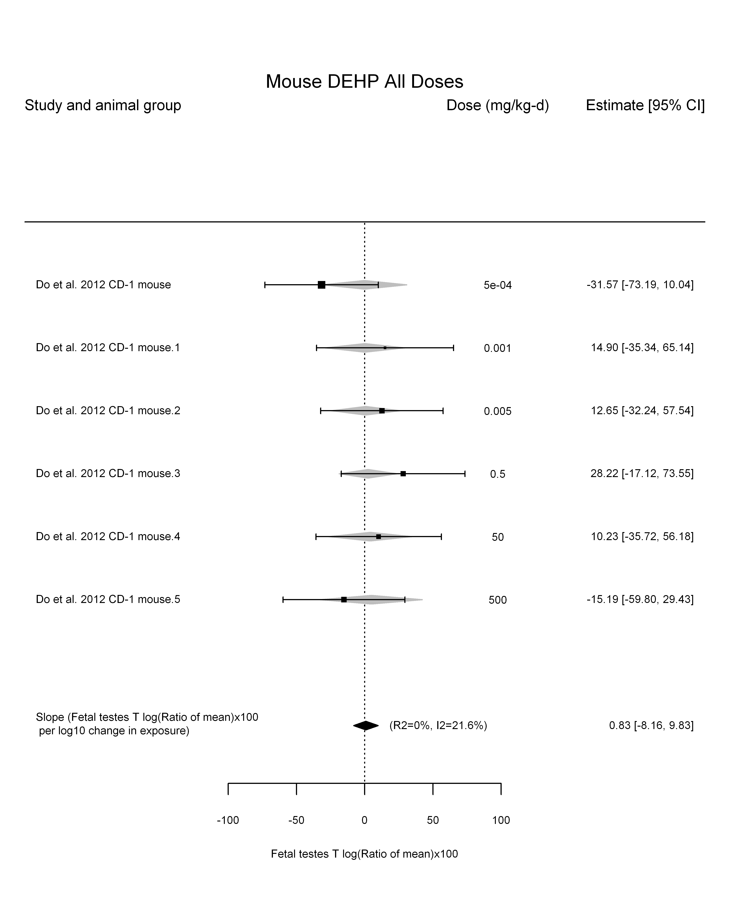

## [1] "Linear---------------------"  
##   
## Mixed-Effects Model (k = 6; tau^2 estimator: REML)  
##   
## logLik deviance AIC BIC AICc   
## -22.6171 45.2341 49.2341 48.4530 55.2341   
##   
## tau^2 (estimated amount of residual heterogeneity): 0 (SE = 336.3553)  
## tau (square root of estimated tau^2 value): 0  
## I^2 (residual heterogeneity / unaccounted variability): 0.00%  
## H^2 (unaccounted variability / sampling variability): 1.00  
##   
## Test for Residual Heterogeneity:   
## QE(df = 5) = 4.5923, p-val = 0.4676  
##   
## Model Results:  
##   
## estimate se zval pval ci.lb ci.ub   
## dose -0.0281 0.0453 -0.6206 0.5349 -0.1169 0.0607   
##   
## ---  
## Signif. codes: 0 '***' 0.001 '**' 0.01 '*' 0.05 '.' 0.1 ' ' 1

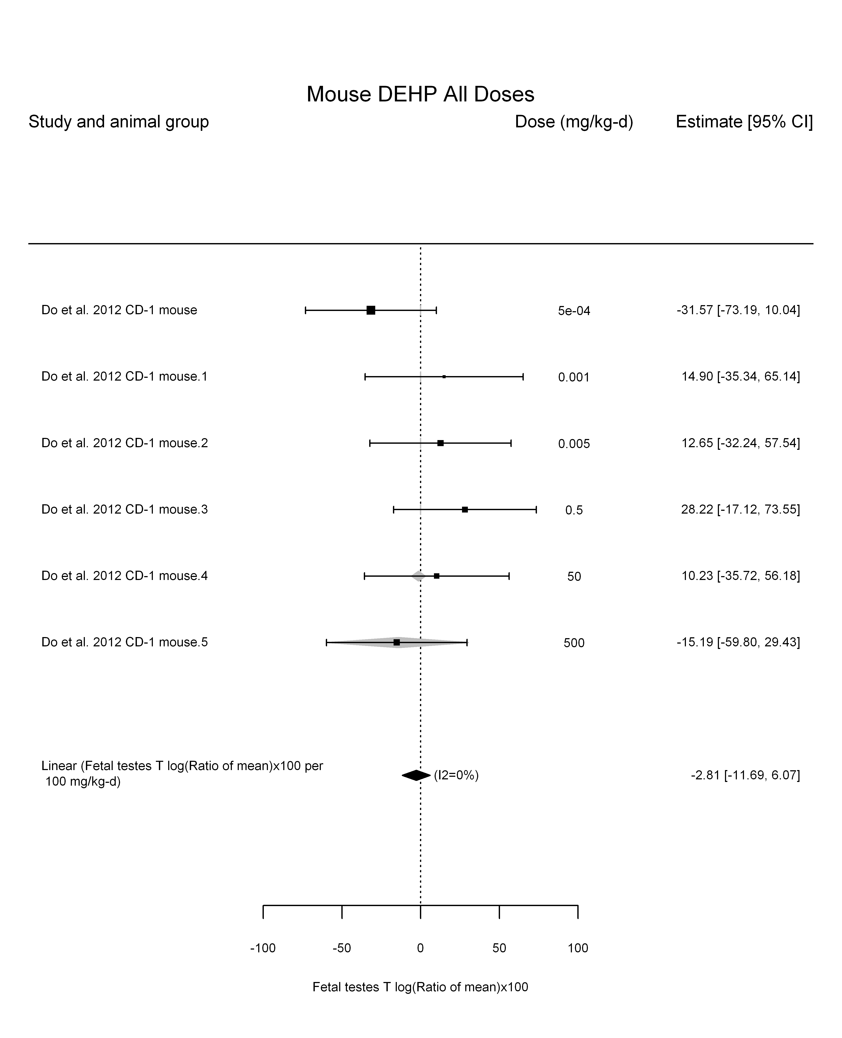

## [1] "LinearQuadratic---------------------"  
##   
## Mixed-Effects Model (k = 6; tau^2 estimator: REML)  
##   
## logLik deviance AIC BIC AICc   
## -18.3911 36.7822 42.7822 40.9411 66.7822   
##   
## tau^2 (estimated amount of residual heterogeneity): 75.9155 (SE = 428.0102)  
## tau (square root of estimated tau^2 value): 8.7130  
## I^2 (residual heterogeneity / unaccounted variability): 12.48%  
## H^2 (unaccounted variability / sampling variability): 1.14  
##   
## Test for Residual Heterogeneity:   
## QE(df = 4) = 4.3296, p-val = 0.3632  
##   
## Test of Moderators (coefficient(s) 1,2):   
## QM(df = 2) = 0.5663, p-val = 0.7534  
##   
## Model Results:  
##   
## estimate se zval pval ci.lb ci.ub   
## dose 0.2378 0.5558 0.4279 0.6687 -0.8514 1.3271   
## I(dose^2) -0.0005 0.0011 -0.4804 0.6310 -0.0027 0.0017   
##   
## ---  
## Signif. codes: 0 '***' 0.001 '**' 0.01 '*' 0.05 '.' 0.1 ' ' 1

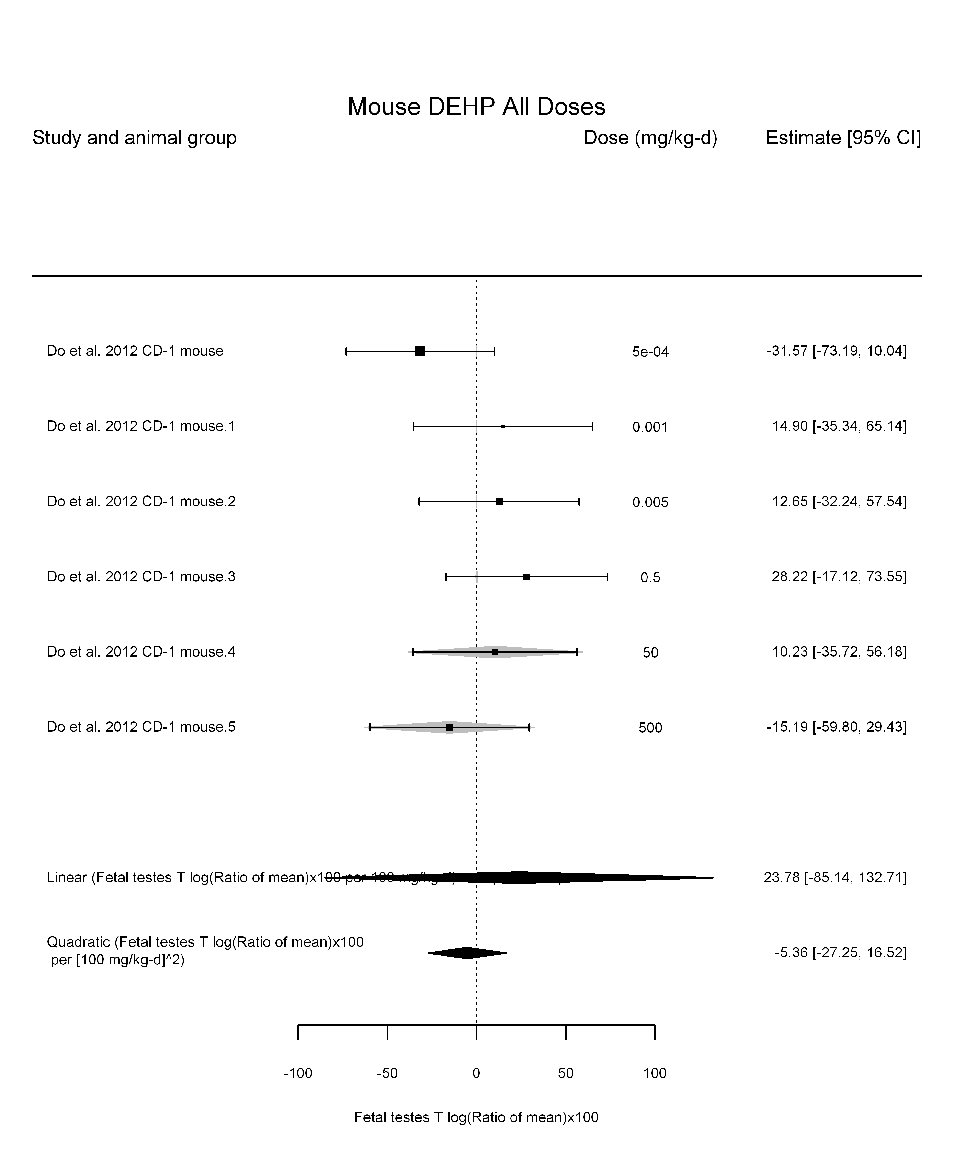

## [1] ""

## [1] ""  
## m ci.lb ci.ub bmr  
## 1 177.7899 42.75687 NA -5  
## m ci.lb ci.ub bmr  
## 1 NA 427.566 NA -50

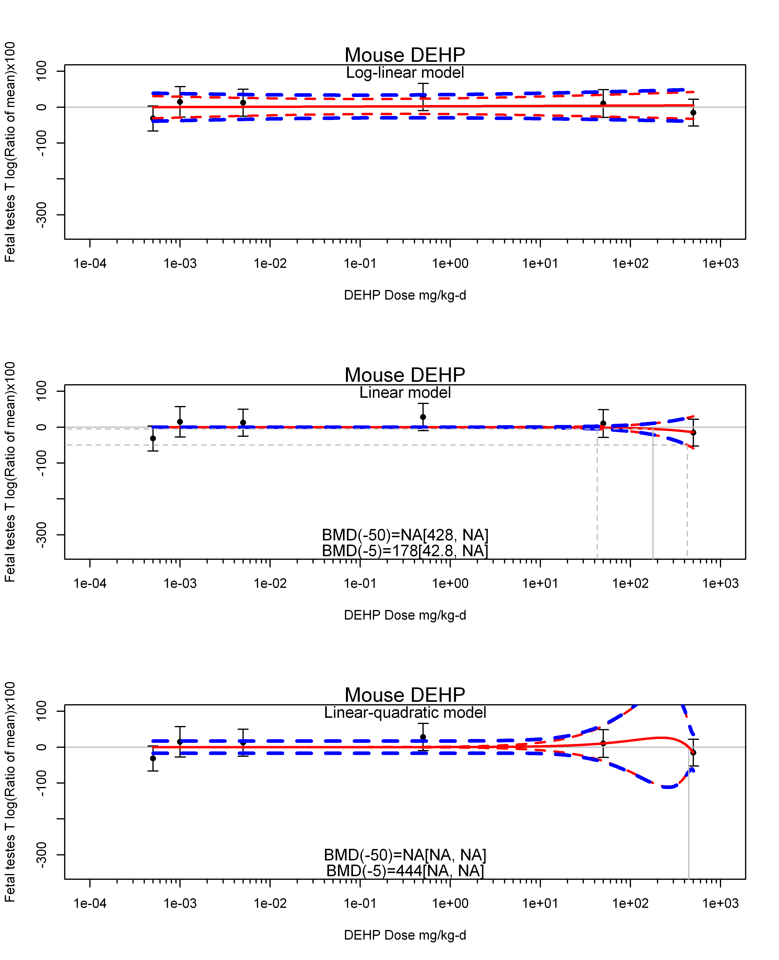

## [1] ""  
## m ci.lb ci.ub bmr  
## 1 444.0504 NA NA -5  
## m ci.lb ci.ub bmr  
## 1 NA NA NA -50  
## [1] "Fetal testes T log(Ratio of mean)x100 Mouse Highest Dose"

## T with subgroups

## [1] "Overall"

##   
## Random-Effects Model (k = 34; tau^2 estimator: REML)  
##   
## tau^2 (estimated amount of total heterogeneity): 5892.3665 (SE = 1539.1523)  
## tau (square root of estimated tau^2 value): 76.7618  
## I^2 (total heterogeneity / total variability): 98.49%  
## H^2 (total variability / sampling variability): 66.03  
##   
## Test for Heterogeneity:   
## Q(df = 33) = 894.2912, p-val < .0001  
##   
## Model Results:  
##   
## estimate se zval pval ci.lb ci.ub   
## -110.1373 13.5679 -8.1175 <.0001 -136.7299 -83.5447 ***   
##   
## ---  
## Signif. codes: 0 '***' 0.001 '**' 0.01 '*' 0.05 '.' 0.1 ' ' 1

## [1] "Leave one out"

##   
## Random-Effects Model (k = 31; tau^2 estimator: REML)  
##   
## tau^2 (estimated amount of total heterogeneity): 5460.4990 (SE = 1491.9024)  
## tau (square root of estimated tau^2 value): 73.8952  
## I^2 (total heterogeneity / total variability): 98.49%  
## H^2 (total variability / sampling variability): 66.34  
##   
## Test for Heterogeneity:   
## Q(df = 30) = 846.3912, p-val < .0001  
##   
## Model Results:  
##   
## estimate se zval pval ci.lb ci.ub   
## -117.2806 13.6588 -8.5864 <.0001 -144.0514 -90.5097 ***   
##   
## ---  
## Signif. codes: 0 '***' 0.001 '**' 0.01 '*' 0.05 '.' 0.1 ' ' 1   
##   
## pred se ci.lb ci.ub cr.lb cr.ub  
## -117.2806 13.6588 -144.0514 -90.5097 -264.5659 30.0047  
##   
## Random-Effects Model (k = 32; tau^2 estimator: REML)  
##   
## tau^2 (estimated amount of total heterogeneity): 5916.2341 (SE = 1599.1885)  
## tau (square root of estimated tau^2 value): 76.9171  
## I^2 (total heterogeneity / total variability): 98.40%  
## H^2 (total variability / sampling variability): 62.51  
##   
## Test for Heterogeneity:   
## Q(df = 31) = 715.2104, p-val < .0001  
##   
## Model Results:  
##   
## estimate se zval pval ci.lb ci.ub   
## -110.3097 14.0344 -7.8599 <.0001 -137.8166 -82.8027 ***   
##   
## ---  
## Signif. codes: 0 '***' 0.001 '**' 0.01 '*' 0.05 '.' 0.1 ' ' 1   
##   
## pred se ci.lb ci.ub cr.lb cr.ub  
## -110.3097 14.0344 -137.8166 -82.8027 -263.5533 42.9339  
##   
## Random-Effects Model (k = 26; tau^2 estimator: REML)  
##   
## tau^2 (estimated amount of total heterogeneity): 4495.5033 (SE = 1358.4897)  
## tau (square root of estimated tau^2 value): 67.0485  
## I^2 (total heterogeneity / total variability): 98.30%  
## H^2 (total variability / sampling variability): 58.75  
##   
## Test for Heterogeneity:   
## Q(df = 25) = 685.8455, p-val < .0001  
##   
## Model Results:  
##   
## estimate se zval pval ci.lb ci.ub   
## -92.9464 13.6033 -6.8327 <.0001 -119.6083 -66.2845 ***   
##   
## ---  
## Signif. codes: 0 '***' 0.001 '**' 0.01 '*' 0.05 '.' 0.1 ' ' 1   
##   
## pred se ci.lb ci.ub cr.lb cr.ub  
## -92.9464 13.6033 -119.6083 -66.2845 -227.0365 41.1436  
##   
## Random-Effects Model (k = 22; tau^2 estimator: REML)  
##   
## tau^2 (estimated amount of total heterogeneity): 7196.0237 (SE = 2370.6553)  
## tau (square root of estimated tau^2 value): 84.8294  
## I^2 (total heterogeneity / total variability): 96.74%  
## H^2 (total variability / sampling variability): 30.66  
##   
## Test for Heterogeneity:   
## Q(df = 21) = 515.6922, p-val < .0001  
##   
## Model Results:  
##   
## estimate se zval pval ci.lb ci.ub   
## -117.5662 18.6922 -6.2896 <.0001 -154.2023 -80.9302 ***   
##   
## ---  
## Signif. codes: 0 '***' 0.001 '**' 0.01 '*' 0.05 '.' 0.1 ' ' 1   
##   
## pred se ci.lb ci.ub cr.lb cr.ub  
## -117.5662 18.6922 -154.2023 -80.9302 -287.8173 52.6848  
##   
## Random-Effects Model (k = 30; tau^2 estimator: REML)  
##   
## tau^2 (estimated amount of total heterogeneity): 6288.1291 (SE = 1739.2730)  
## tau (square root of estimated tau^2 value): 79.2977  
## I^2 (total heterogeneity / total variability): 98.72%  
## H^2 (total variability / sampling variability): 78.11  
##   
## Test for Heterogeneity:   
## Q(df = 29) = 876.8712, p-val < .0001  
##   
## Model Results:  
##   
## estimate se zval pval ci.lb ci.ub   
## -114.3444 14.8657 -7.6918 <.0001 -143.4807 -85.2081 ***   
##   
## ---  
## Signif. codes: 0 '***' 0.001 '**' 0.01 '*' 0.05 '.' 0.1 ' ' 1   
##   
## pred se ci.lb ci.ub cr.lb cr.ub  
## -114.3444 14.8657 -143.4807 -85.2081 -272.4725 43.7838  
##   
## Random-Effects Model (k = 30; tau^2 estimator: REML)  
##   
## tau^2 (estimated amount of total heterogeneity): 6031.6219 (SE = 1679.7743)  
## tau (square root of estimated tau^2 value): 77.6635  
## I^2 (total heterogeneity / total variability): 98.64%  
## H^2 (total variability / sampling variability): 73.70  
##   
## Test for Heterogeneity:   
## Q(df = 29) = 815.9367, p-val < .0001  
##   
## Model Results:  
##   
## estimate se zval pval ci.lb ci.ub   
## -105.4581 14.6105 -7.2180 <.0001 -134.0940 -76.8221 ***   
##   
## ---  
## Signif. codes: 0 '***' 0.001 '**' 0.01 '*' 0.05 '.' 0.1 ' ' 1   
##   
## pred se ci.lb ci.ub cr.lb cr.ub  
## -105.4581 14.6105 -134.0940 -76.8221 -260.3459 49.4298  
##   
## Random-Effects Model (k = 33; tau^2 estimator: REML)  
##   
## tau^2 (estimated amount of total heterogeneity): 5909.5291 (SE = 1566.6519)  
## tau (square root of estimated tau^2 value): 76.8735  
## I^2 (total heterogeneity / total variability): 98.52%  
## H^2 (total variability / sampling variability): 67.78  
##   
## Test for Heterogeneity:   
## Q(df = 32) = 888.1214, p-val < .0001  
##   
## Model Results:  
##   
## estimate se zval pval ci.lb ci.ub   
## -112.3967 13.7881 -8.1517 <.0001 -139.4209 -85.3726 ***   
##   
## ---  
## Signif. codes: 0 '***' 0.001 '**' 0.01 '*' 0.05 '.' 0.1 ' ' 1   
##   
## pred se ci.lb ci.ub cr.lb cr.ub  
## -112.3967 13.7881 -139.4209 -85.3726 -265.4703 40.6768

## [1] "LE"

##   
## Random-Effects Model (k = 3; tau^2 estimator: REML)  
##   
## tau^2 (estimated amount of total heterogeneity): 5852.0242 (SE = 6704.4090)  
## tau (square root of estimated tau^2 value): 76.4985  
## I^2 (total heterogeneity / total variability): 88.37%  
## H^2 (total variability / sampling variability): 8.60  
##   
## Test for Heterogeneity:   
## Q(df = 2) = 20.9653, p-val < .0001  
##   
## Model Results:  
##   
## estimate se zval pval ci.lb ci.ub   
## -29.2872 47.2516 -0.6198 0.5354 -121.8986 63.3243   
##   
## ---  
## Signif. codes: 0 '***' 0.001 '**' 0.01 '*' 0.05 '.' 0.1 ' ' 1

## [1] "SD"

##   
## Random-Effects Model (k = 24; tau^2 estimator: REML)  
##   
## tau^2 (estimated amount of total heterogeneity): 5782.8658 (SE = 1803.4236)  
## tau (square root of estimated tau^2 value): 76.0452  
## I^2 (total heterogeneity / total variability): 98.08%  
## H^2 (total variability / sampling variability): 52.21  
##   
## Test for Heterogeneity:   
## Q(df = 23) = 652.8173, p-val < .0001  
##   
## Model Results:  
##   
## estimate se zval pval ci.lb ci.ub   
## -121.8074 15.9696 -7.6275 <.0001 -153.1073 -90.5076 ***   
##   
## ---  
## Signif. codes: 0 '***' 0.001 '**' 0.01 '*' 0.05 '.' 0.1 ' ' 1

## [1] "W"

##   
## Random-Effects Model (k = 7; tau^2 estimator: REML)  
##   
## tau^2 (estimated amount of total heterogeneity): 4871.8495 (SE = 2968.9150)  
## tau (square root of estimated tau^2 value): 69.7986  
## I^2 (total heterogeneity / total variability): 98.42%  
## H^2 (total variability / sampling variability): 63.15  
##   
## Test for Heterogeneity:   
## Q(df = 6) = 145.3378, p-val < .0001  
##   
## Model Results:  
##   
## estimate se zval pval ci.lb ci.ub   
## -102.0201 27.1120 -3.7629 0.0002 -155.1587 -48.8815 ***   
##   
## ---  
## Signif. codes: 0 '***' 0.001 '**' 0.01 '*' 0.05 '.' 0.1 ' ' 1

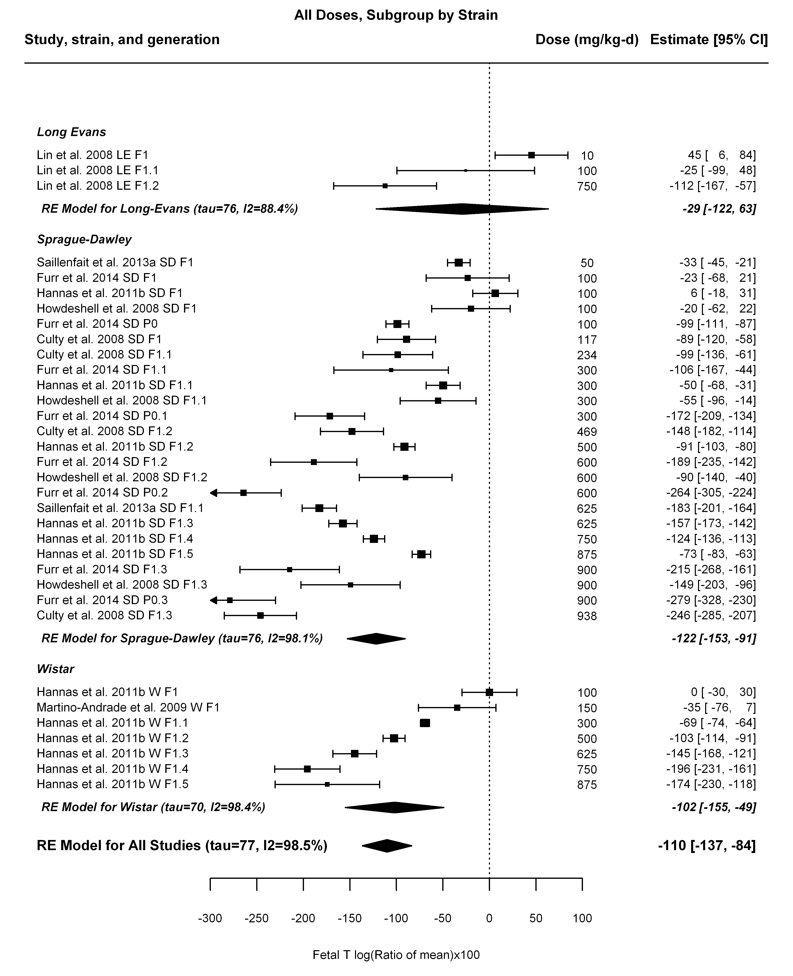

## [1] "Trend log10 dose"

##   
## Mixed-Effects Model (k = 34; tau^2 estimator: REML)  
##   
## tau^2 (estimated amount of residual heterogeneity): 2278.8316 (SE = 652.8308)  
## tau (square root of estimated tau^2 value): 47.7371  
## I^2 (residual heterogeneity / unaccounted variability): 96.06%  
## H^2 (unaccounted variability / sampling variability): 25.39  
## R^2 (amount of heterogeneity accounted for): 61.33%  
##   
## Test for Residual Heterogeneity:   
## QE(df = 32) = 575.3838, p-val < .0001  
##   
## Test of Moderators (coefficient(s) 2):   
## QM(df = 1) = 46.4497, p-val < .0001  
##   
## Model Results:  
##   
## estimate se zval pval ci.lb ci.ub   
## intrcpt 221.6650 49.3595 4.4908 <.0001 124.9221 318.4079 ***  
## log10(dose) -132.8275 19.4893 -6.8154 <.0001 -171.0259 -94.6291 ***  
##   
## ---  
## Signif. codes: 0 '***' 0.001 '**' 0.01 '*' 0.05 '.' 0.1 ' ' 1

## [1] "LE"

##   
## Mixed-Effects Model (k = 3; tau^2 estimator: REML)  
##   
## tau^2 (estimated amount of residual heterogeneity): 0 (SE = 1634.4586)  
## tau (square root of estimated tau^2 value): 0  
## I^2 (residual heterogeneity / unaccounted variability): 0.00%  
## H^2 (unaccounted variability / sampling variability): 1.00  
## R^2 (amount of heterogeneity accounted for): 100.00%  
##   
## Test for Residual Heterogeneity:   
## QE(df = 1) = 0.1005, p-val = 0.7512  
##   
## Test of Moderators (coefficient(s) 2):   
## QM(df = 1) = 20.8648, p-val < .0001  
##   
## Model Results:  
##   
## estimate se zval pval ci.lb ci.ub   
## intrcpt 129.7048 34.0456 3.8097 0.0001 62.9767 196.4329 ***  
## log10(dose) -82.9927 18.1691 -4.5678 <.0001 -118.6035 -47.3819 ***  
##   
## ---  
## Signif. codes: 0 '***' 0.001 '**' 0.01 '*' 0.05 '.' 0.1 ' ' 1

## [1] "SD"

##   
## Mixed-Effects Model (k = 24; tau^2 estimator: REML)  
##   
## tau^2 (estimated amount of residual heterogeneity): 2881.4804 (SE = 966.0361)  
## tau (square root of estimated tau^2 value): 53.6794  
## I^2 (residual heterogeneity / unaccounted variability): 95.91%  
## H^2 (unaccounted variability / sampling variability): 24.46  
## R^2 (amount of heterogeneity accounted for): 50.17%  
##   
## Test for Residual Heterogeneity:   
## QE(df = 22) = 465.9433, p-val < .0001  
##   
## Test of Moderators (coefficient(s) 2):   
## QM(df = 1) = 22.0745, p-val < .0001  
##   
## Model Results:  
##   
## estimate se zval pval ci.lb ci.ub   
## intrcpt 238.4069 77.3434 3.0824 0.0021 86.8166 389.9972 **  
## log10(dose) -141.7608 30.1725 -4.6983 <.0001 -200.8978 -82.6238 ***  
##   
## ---  
## Signif. codes: 0 '***' 0.001 '**' 0.01 '*' 0.05 '.' 0.1 ' ' 1

## [1] "W"

##   
## Mixed-Effects Model (k = 7; tau^2 estimator: REML)  
##   
## tau^2 (estimated amount of residual heterogeneity): 295.7178 (SE = 291.5989)  
## tau (square root of estimated tau^2 value): 17.1964  
## I^2 (residual heterogeneity / unaccounted variability): 77.43%  
## H^2 (unaccounted variability / sampling variability): 4.43  
## R^2 (amount of heterogeneity accounted for): 93.93%  
##   
## Test for Residual Heterogeneity:   
## QE(df = 5) = 15.0854, p-val = 0.0100  
##   
## Test of Moderators (coefficient(s) 2):   
## QM(df = 1) = 47.6720, p-val < .0001  
##   
## Model Results:  
##   
## estimate se zval pval ci.lb ci.ub  
## intrcpt 393.4833 71.4719 5.5054 <.0001 253.4009 533.5657  
## log10(dose) -191.7062 27.7654 -6.9045 <.0001 -246.1255 -137.2870  
##   
## intrcpt ***  
## log10(dose) ***  
##   
## ---  
## Signif. codes: 0 '***' 0.001 '**' 0.01 '*' 0.05 '.' 0.1 ' ' 1

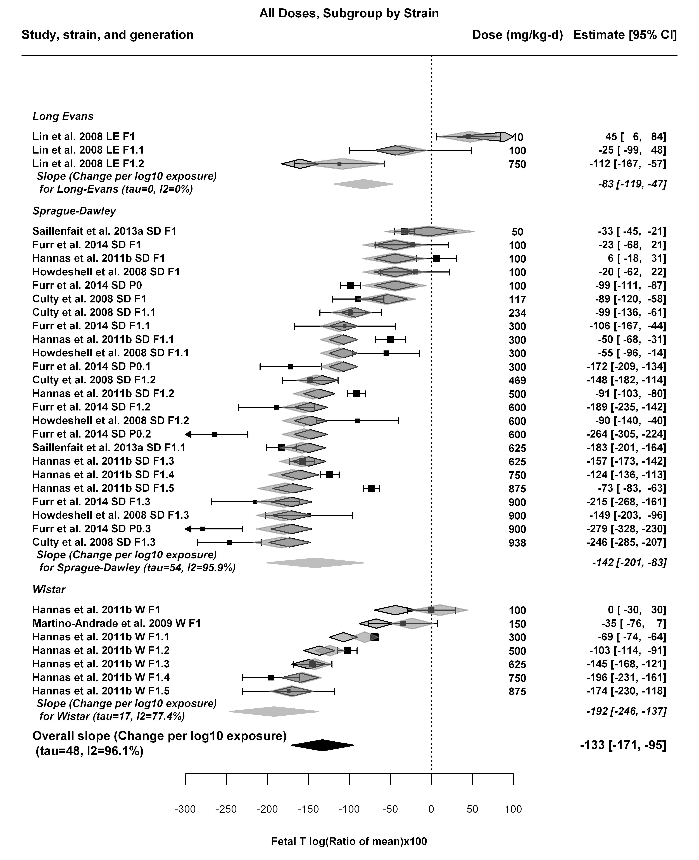

## [1] "Linear or LinearQuadratic"

##   
## Mixed-Effects Model (k = 34; tau^2 estimator: REML)  
##   
## tau^2 (estimated amount of residual heterogeneity): 2182.5721 (SE = 627.8910)  
## tau (square root of estimated tau^2 value): 46.7180  
## I^2 (residual heterogeneity / unaccounted variability): 95.49%  
## H^2 (unaccounted variability / sampling variability): 22.16  
##   
## Test for Residual Heterogeneity:   
## QE(df = 32) = 559.3346, p-val < .0001  
##   
## Test of Moderators (coefficient(s) 1,2):   
## QM(df = 2) = 210.2190, p-val < .0001  
##   
## Model Results:  
##   
## estimate se zval pval ci.lb ci.ub   
## dose100 -34.2277 6.5243 -5.2462 <.0001 -47.0151 -21.4403 ***  
## I(dose100^2) 1.5265 0.8596 1.7758 0.0758 -0.1583 3.2114 .  
##   
## ---  
## Signif. codes: 0 '***' 0.001 '**' 0.01 '*' 0.05 '.' 0.1 ' ' 1

## [1] "LE"

##   
## Mixed-Effects Model (k = 3; tau^2 estimator: REML)  
##   
## tau^2 (estimated amount of residual heterogeneity): 1010.8167 (SE = 1722.0399)  
## tau (square root of estimated tau^2 value): 31.7933  
## I^2 (residual heterogeneity / unaccounted variability): 61.96%  
## H^2 (unaccounted variability / sampling variability): 2.63  
##   
## Test for Residual Heterogeneity:   
## QE(df = 2) = 5.5857, p-val = 0.0612  
##   
## Model Results:  
##   
## estimate se zval pval ci.lb ci.ub   
## dose100 -14.9826 5.6299 -2.6613 0.0078 -26.0170 -3.9483 **  
##   
## ---  
## Signif. codes: 0 '***' 0.001 '**' 0.01 '*' 0.05 '.' 0.1 ' ' 1

## [1] "SD"

##   
## Mixed-Effects Model (k = 24; tau^2 estimator: REML)  
##   
## tau^2 (estimated amount of residual heterogeneity): 2842.5894 (SE = 951.8382)  
## tau (square root of estimated tau^2 value): 53.3159  
## I^2 (residual heterogeneity / unaccounted variability): 95.83%  
## H^2 (unaccounted variability / sampling variability): 23.98  
##   
## Test for Residual Heterogeneity:   
## QE(df = 22) = 463.4936, p-val < .0001  
##   
## Test of Moderators (coefficient(s) 1,2):   
## QM(df = 2) = 133.2508, p-val < .0001  
##   
## Model Results:  
##   
## estimate se zval pval ci.lb ci.ub   
## dose100 -38.1103 8.3316 -4.5742 <.0001 -54.4401 -21.7806 ***  
## I(dose100^2) 1.9222 1.0790 1.7815 0.0748 -0.1926 4.0370 .  
##   
## ---  
## Signif. codes: 0 '***' 0.001 '**' 0.01 '*' 0.05 '.' 0.1 ' ' 1

## [1] "W"

##   
## Mixed-Effects Model (k = 7; tau^2 estimator: REML)  
##   
## tau^2 (estimated amount of residual heterogeneity): 14.5292 (SE = 35.1594)  
## tau (square root of estimated tau^2 value): 3.8117  
## I^2 (residual heterogeneity / unaccounted variability): 21.25%  
## H^2 (unaccounted variability / sampling variability): 1.27  
##   
## Test for Residual Heterogeneity:   
## QE(df = 6) = 8.5046, p-val = 0.2034  
##   
## Model Results:  
##   
## estimate se zval pval ci.lb ci.ub   
## dose100 -22.3160 0.8334 -26.7769 <.0001 -23.9494 -20.6825 ***  
##   
## ---  
## Signif. codes: 0 '***' 0.001 '**' 0.01 '*' 0.05 '.' 0.1 ' ' 1

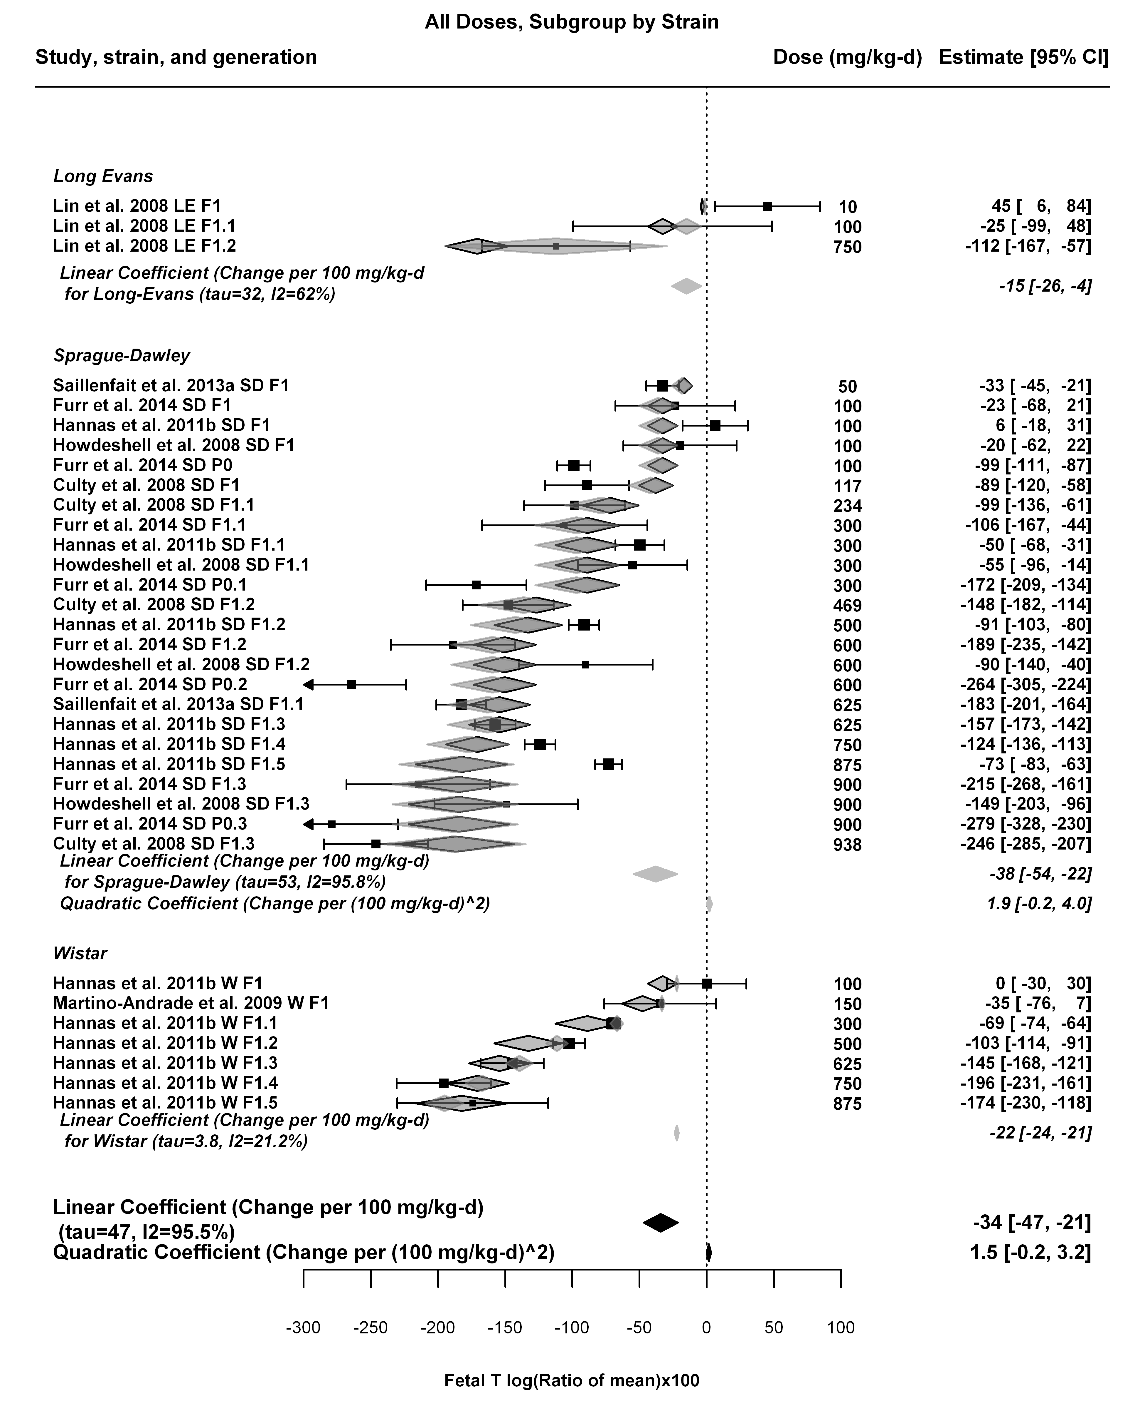

## [1] ""

## m ci.lb ci.ub bmr  
## 1 15.00049 10.92781 23.75909 -5.1

## [1] ""

## m ci.lb ci.ub bmr  
## 1 34.03922 19.60254 129.1697 -5.1

## [1] ""

## m ci.lb ci.ub bmr  
## 1 13.47369 9.432922 23.38427 -5.1

## [1] ""

## m ci.lb ci.ub bmr  
## 1 22.85344 21.29486 24.65835 -5.1

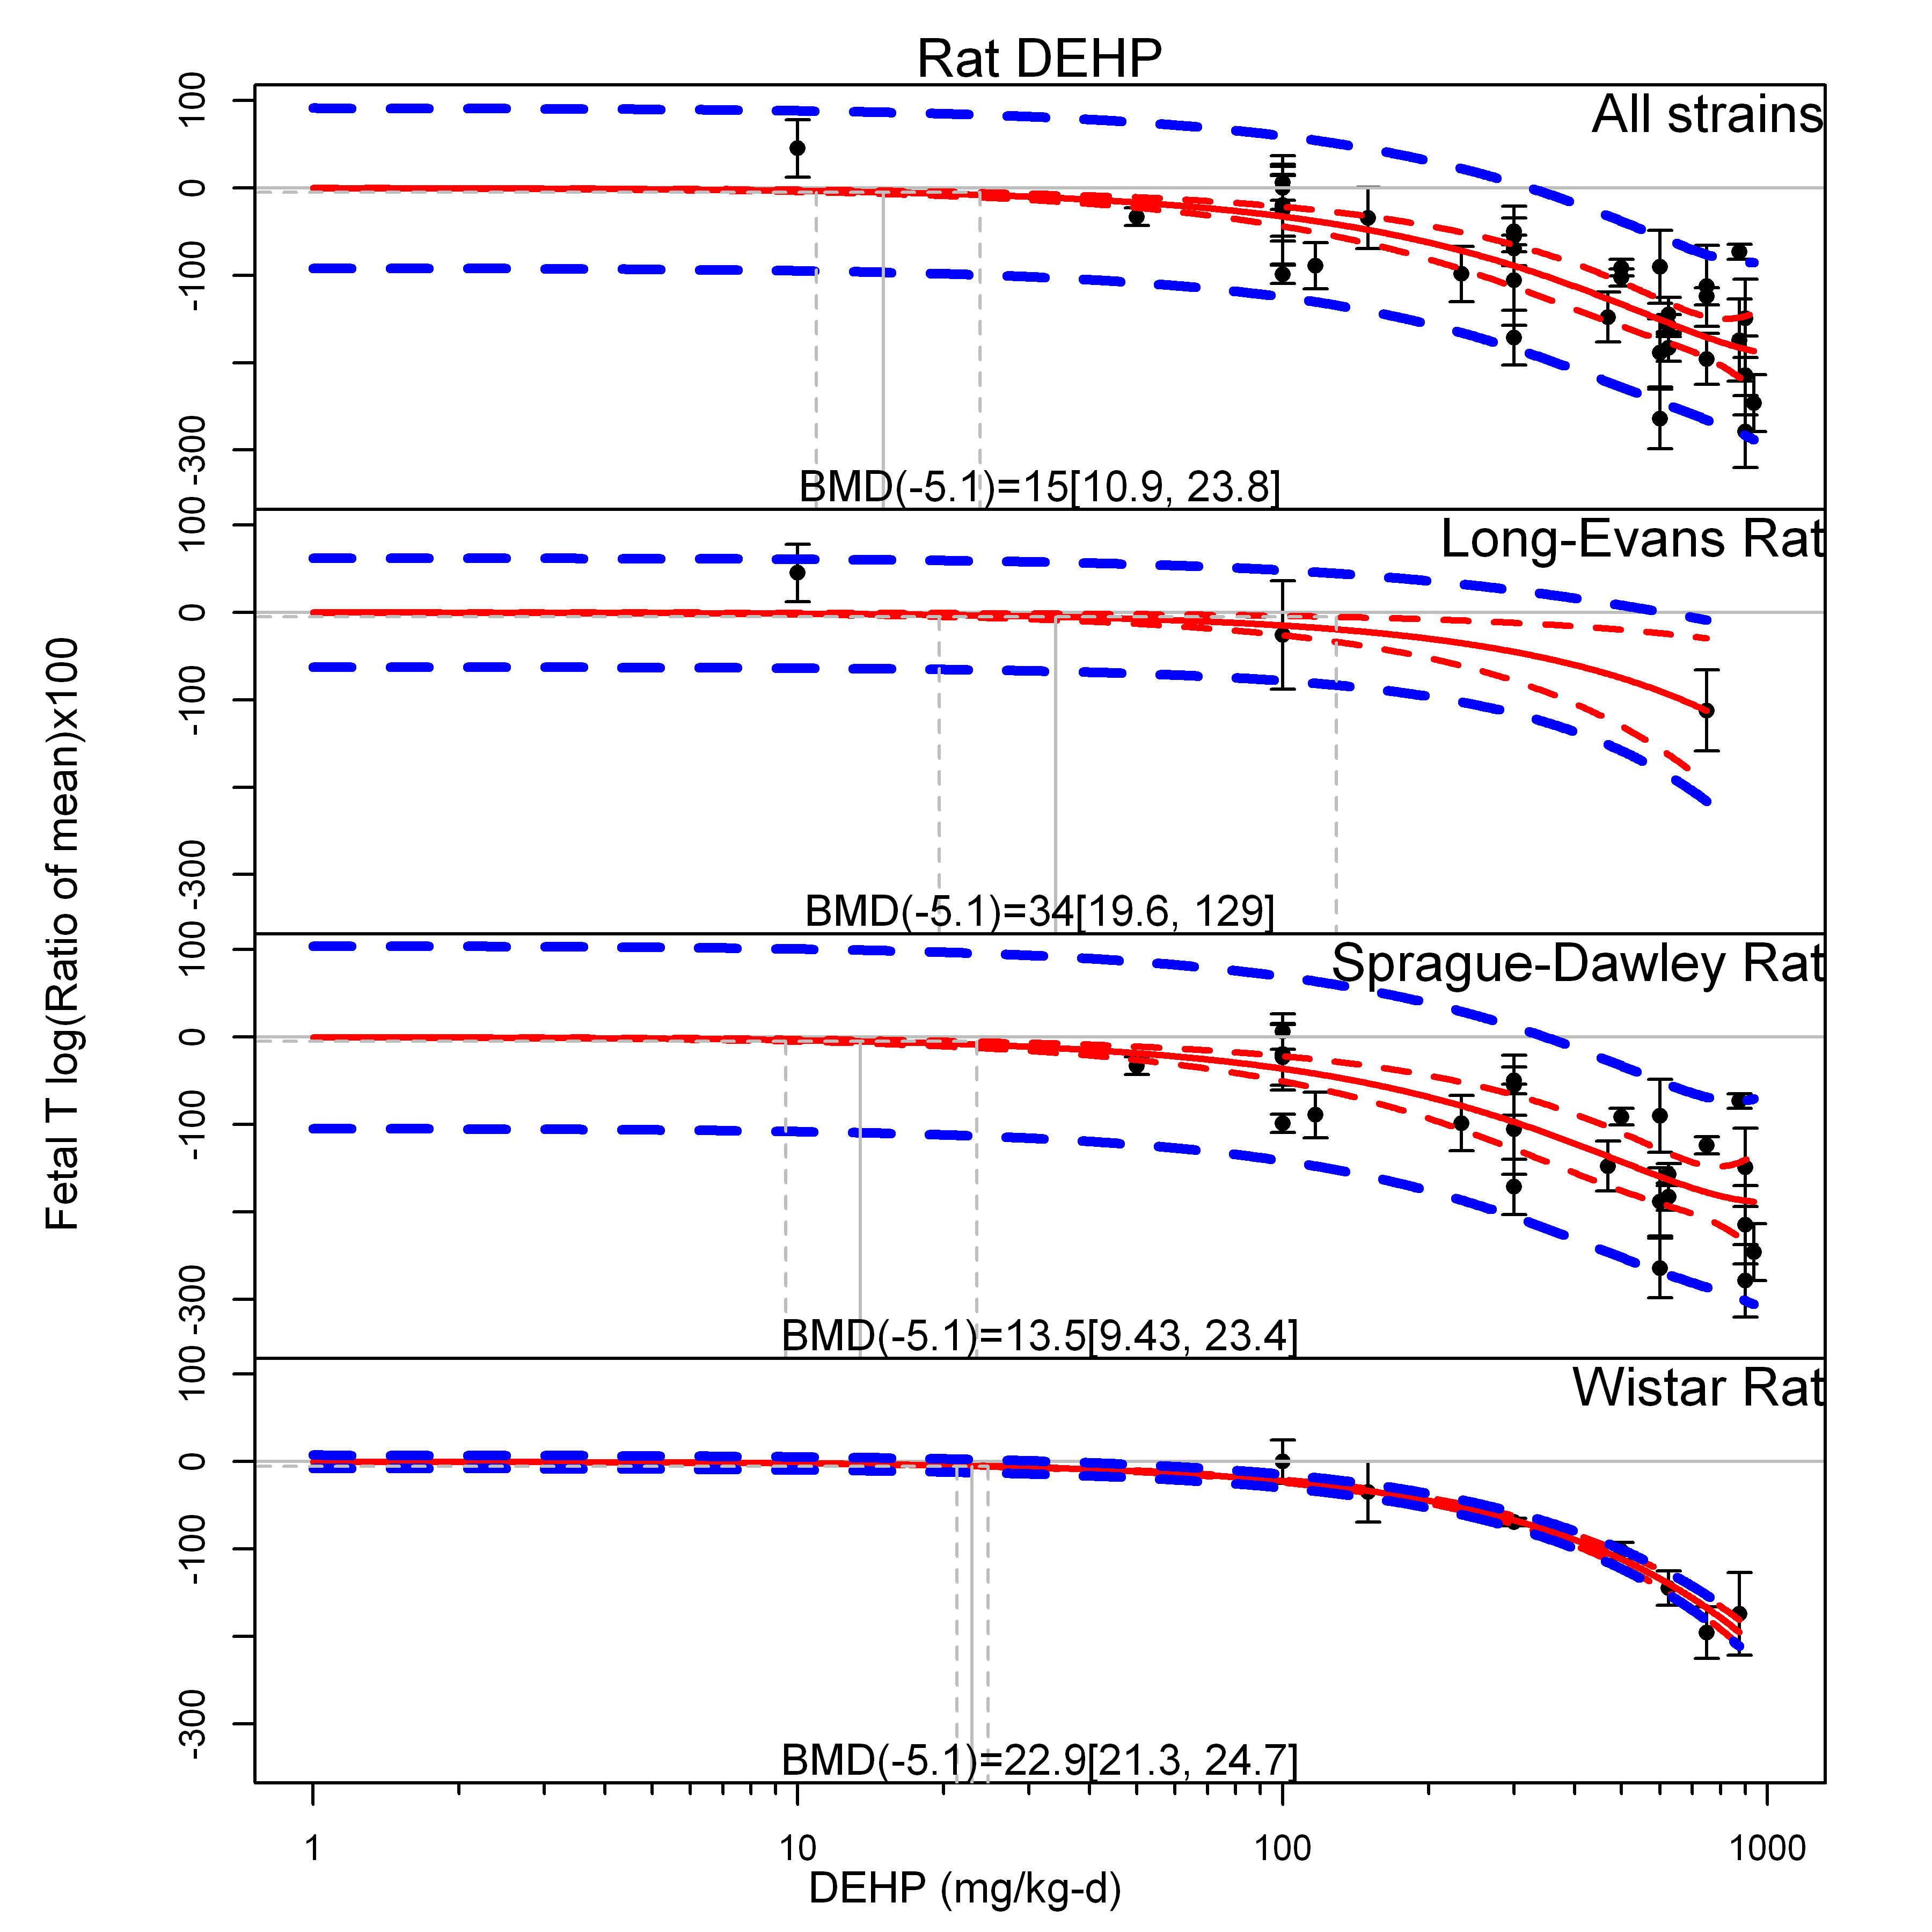

## [1] ""

## m ci.lb ci.ub bmr  
## 1 160.4888 117.7709 235.6767 -51

## [1] ""

## m ci.lb ci.ub bmr  
## 1 340.3926 196.0245 NA -51

## [1] ""

## m ci.lb ci.ub bmr  
## 1 144.328 101.1186 231.7434 -51

## [1] ""

## m ci.lb ci.ub bmr  
## 1 228.5357 212.9476 246.5838 -51

